FOR IMMEDIATE RELEASE
SEPTEMBER 7, 2023

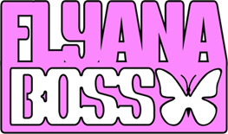

CUTE GIRL RAP DUO FLYANA BOSS JOIN FORCES WITH
HIP HOP ICON MISSY ELLIOTT AND RISING IT-GIRL KALIII
FOR NEW SPIN ON WORLDWIDE VIRAL HIT, “YOU WISH”

VIRAL DUO SENSATION BRING THEIR BLACK GIRL MAGIC TO THE STAGE
AS SPECIAL GUESTS ON JANELLE MONÁE’S THE AGE OF PLEASURE TOUR

“YOU WISH (WITH MISSY ELLIOTT & KALIII) - REMIX" AVAILABLE NOW HERE
VIA VNCLM_ X ATLANTIC RECORDS

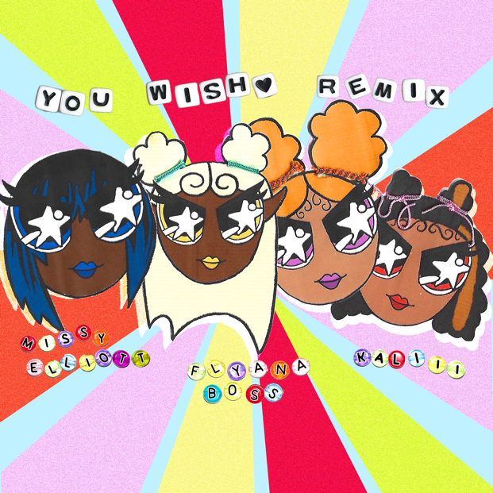
DOWNLOAD HI-RES ARTWORK HERE

“Flyana Boss has taken the digital world by storm, captivating audiences with their dynamic rap verses and quirky personalities.” – COMPLEX

“An infusion of girl power and confidence reminiscent of groups like the Spice Girls and TLC.” – NYLON

“Cute girl rap” duo Flyana Boss have joined forces with the icon herself Missy Elliott and rising it-girl Kaliii for a star-studded new spin on their worldwide viral hit single, “You Wish,” available everywhere now via vnclm_ x Atlantic Records HERE. "You Wish (with Missy Elliott & Kaliii) - Remix", includes brand new fire verses from Flyana Boss and guest stars Missy and Kaliii, can be streamed HERE.

Missy has been an outspoken fan of the duo, coming to their defense against haters and drawing similarities between Flyana Boss and herself on Twitter. The hip-hop icon took her stamp of approval one step further by sharing a clip of her take on the signature Flyana Boss “runner” video, tagging @flyanaboss along with it.

“Flyana Boss’ style is a breath of fresh air. They are relatable….like some cool girls from around the way—just being themselves! That’s the best way to have staying power. They are creating their own lane!” -Missy Elliott

“Anytime I have the chance to explore a new sound, I’m down. Especially if it’s a bop like this.” -Kaliii

“Wow!! We’re so excited about the ‘You Wish’ remix! This is our first ever remix. We love Kaliii, we are so happy she was able to be on it. And we still don’t know how we manifested Queen Missy herself to bless us with her iconic vocals!” -Flyana Boss

Flyana Boss recently raised the curtain on the “You Wish – DJ Smallz 732 – Jersey Club Remix” –an additional spin on the hit track—available everywhere HERE.

Flyana Boss – a.k.a. multi-instrumentalist/MCs Bobbi LaNea and Folayan – are currently celebrating the explosive success of “You Wish” as special guests on Janelle Monáe’s hugely anticipated The Age of Pleasure Tour, making stops across North America through mid-October. Highlights include visits to such historic venues as Toronto, ON’s Massey Hall (September 21, 22), New York City’s Radio City Music Hall (September 26), and Atlanta, GA’s Fox Theatre (October 6).

Hailing from Detroit, MI and Dallas, TX respectively, Bobbi and Folayan met at a music college in Los Angeles where they immediately hit it off and began collaborating. The fierce duo adopted the name Flyana Boss (rhymes with Diana Ross), repping the Vagina Dynasty while simultaneously embodying the spirit of flyness and bossness. Together, Bobbi and Folayan form a formidable union that pushes the boundaries of contemporary Hip-Hop, seamlessly blending their individual strengths to create a sound that is distinctively Flyana Boss. Bobbi brings a knack for storytelling and infuses her music with authenticity and vulnerability as Folayan effortlessly switches between different styles and genres, adding depth and dimension to Flyana Boss’ one-of-a-kind music.

Flyana Boss burst onto the scene with their breakout single, “You Wish,” which debuted at # 1 on Spotify’s “Viral 100” amidst worldwide attention from Hip-Hop legends Missy Elliott and Timbaland as well as such high-profile media outlets as Variety, Complex, NYLON, Vulture, UPROXX, Ones To Watch, and Rolling Stone, among many others. Produced by hitmaker Marky Style – the song featured on a two-track release titled “You Wish + Trashboi” – quickly proved a sensation, earning over 30M global streams to date while rocketing the duo into the spotlight (and kickstarting a spirited viral discussion regarding the word “Kanekalon”).

Increasingly known for their unforgettable live performances – including a spectacular set at New Orleans’s Essence Festival of Culture highlighted by a twerkable onstage moment with Megan Thee Stallion – the duo are focused on creating music that reflects their experiences and resonates with their listeners, embracing their uniqueness and uplifting others through their art.
With talent, ambition, and more impossible-to-resist tracks to come, Flyana Boss is poised to leave an indelible mark on the hearts and minds of music lovers worldwide.

# # #

FLYANA BOSS
ON TOUR 2023
DOWNLOAD ADMAT HERE

ALL DATES w/ JANELLE MONÁE’S THE AGE OF PLEASURE TOUR

SEPTEMBER
13 – St. Louis, MO – Stifel Theatre
14 – Chicago, IL – Byline Bank Aragon Ballroom
15 – Columbus, OH – Mershon Auditorium
17 – Boston, MA – MGM Music Hall at Fenway
18 – Philadelphia, PA – The Met
20 – Montreal, QC – Mtelus
21 – Toronto, ON – Massey Hall
22 – Toronto, ON – Massey Hall
24 – Washington, DC – The Anthem
25 – Washington, DC – The Anthem
26 – New York City, NY – Radio City Music Hall
28 – Brooklyn, NY – Kings Theatre

OCTOBER
2 – Charlotte, NC – Skyla Credit Union Amphitheatre
3 – Nashville, TN – Ryman Auditorium
4 – Birmingham, AL – Avondale Brewing Company
6 – Atlanta, GA – Fox Theatre Atlanta
7 – New Orleans, LA – Orpheum Theatre

# # #

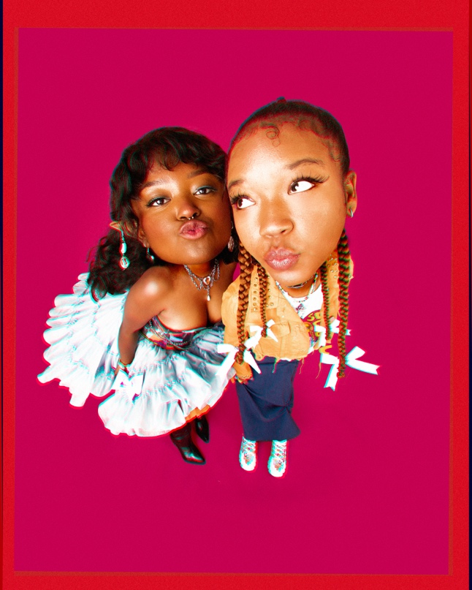
DOWNLOAD PRESS PHOTO HERE // PHOTO CREDIT: SJ SPRENG

CONNECT WITH FLYANA BOSS
FLYANABOSS.COM | INSTAGRAM | TIKTOK | TWITTER | YOUTUBE

FLYANA BOSS + MISSY ELLIOTT PRESS CONTACT
FAIRLEY MCCASKILL | FAIRLEY.MCCASKILL@ATLANTICRECORDS.COM

KALIII PRESS CONTACT
ARIANA WHITE | ARIANA.WHITE@ATLANTICRECORDS.COM

