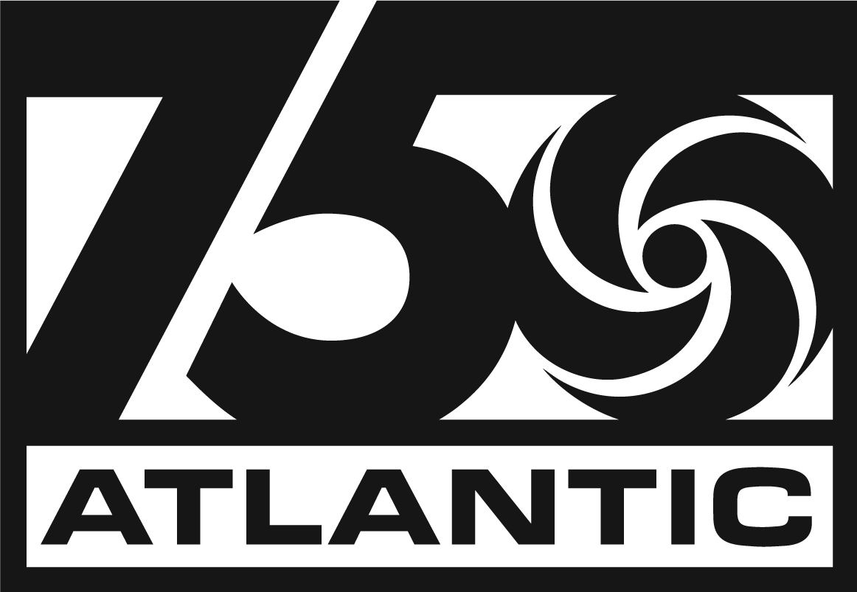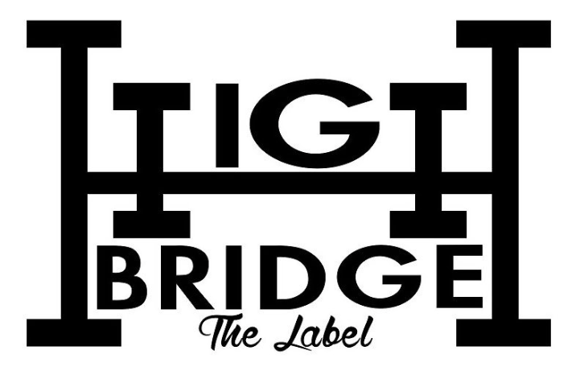

GLOBAL SUPERSTAR A BOOGIE WIT DA HOODIE RELEASES ‘B4 BOA EP’
OUT TODAY VIA ATLANTIC RECORDS/HIGHBRIDGE THE LABEL

DOWNLOAD STREAM 'B4 BOA'

NEW EP ARRIVES AHEAD OF FORTHCOMING ALBUM BOA DUE OUT LATER THIS YEAR

OFFICIAL MUSIC VIDEO FOR “HER BIRTHDAY” ARRIVES LATER TODAY AT 12PM EST

LAST MONTH, BRONX-BRED PHENOM TOOK THE STAGE AT YANKEE STADIUM BEFORE EMBARKING ON UPCOMING “ME VS MYSELF THE COLLEGE TOUR” ON SEPTEMBER 19

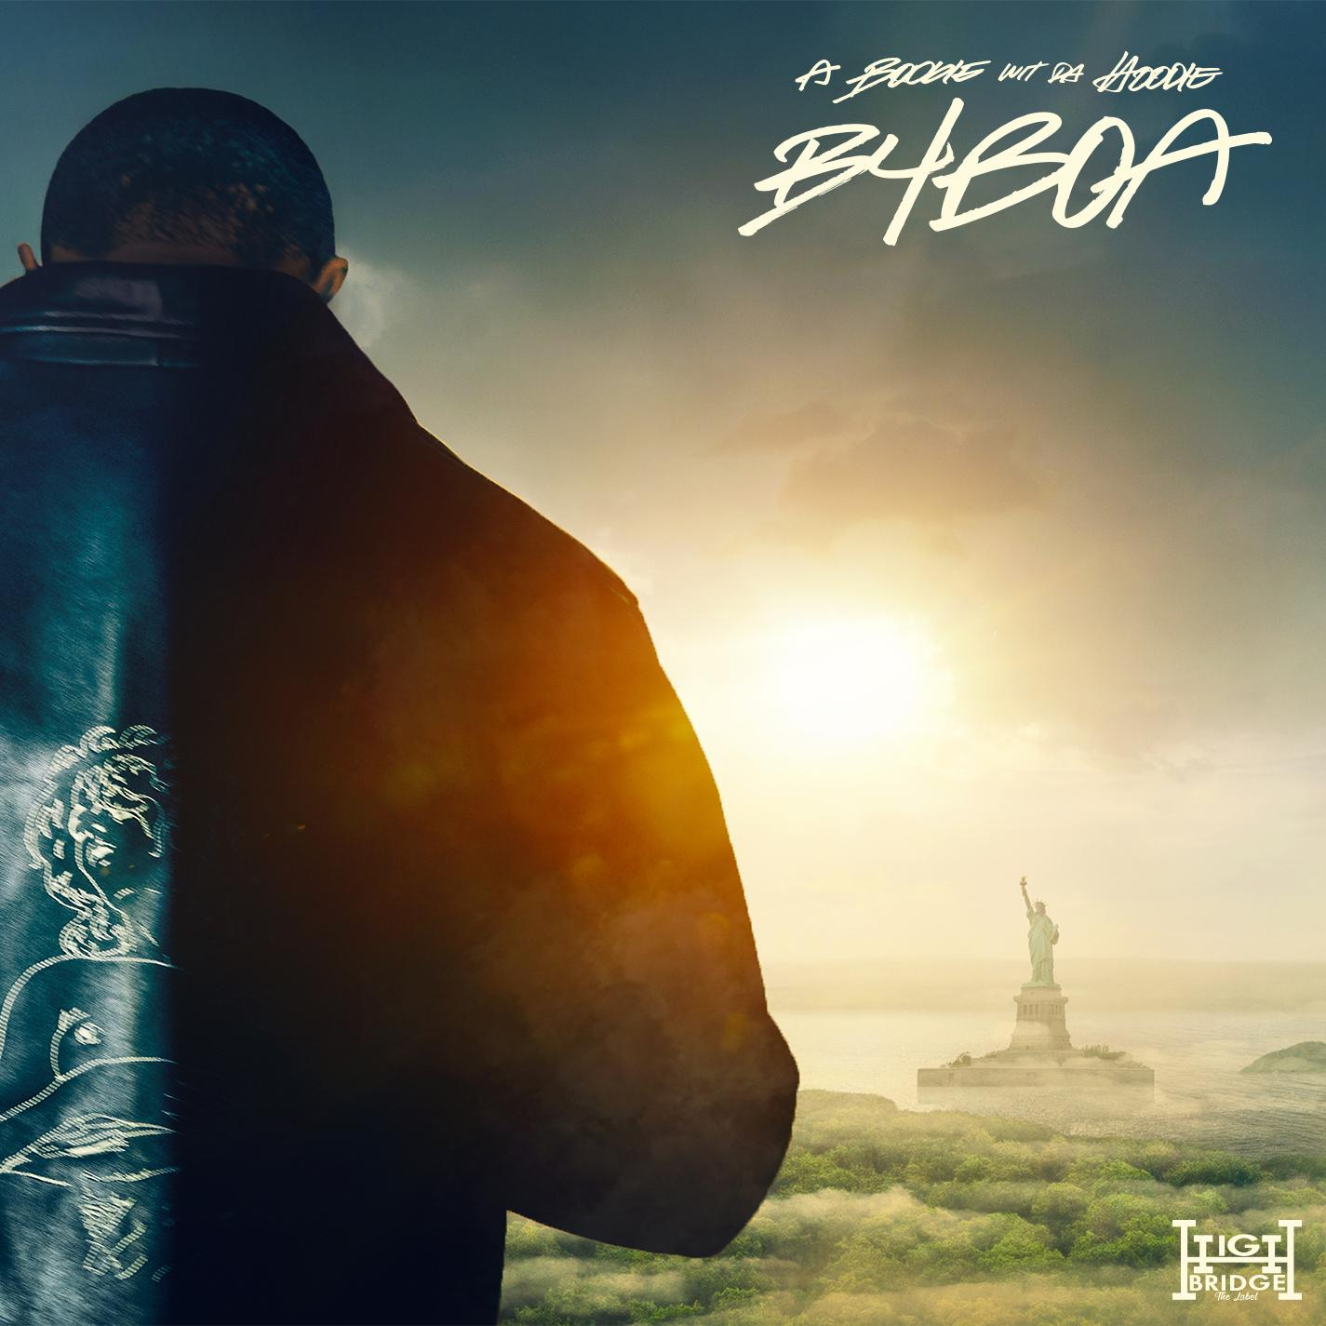
DOWNLOAD PRESS ASSETS

New York, New York – September 8, 2023 – Global superstar A Boogie Wit da Hoodie’s new EP, ‘B4 BOA,’ arrives today via Atlantic Records/Highbridge The Label – DOWNLOAD/STREAM. The Bronx native’s new project will be accompanied by a XX-directed official music video for “Her Birthday,” which will be released later today at 12pm EST.

‘B4 BOA’ arrives ahead of the chart-topper’s forthcoming new album ‘BOA,’ due out later this year.

‘B4 BOA’ TRACKLIST
“Her Birthday”
“Booby Trap”
“Did Me Wrong”

A Boogie will bring his electric live performance as he embarks on his “ME VS MYSELF THE COLLEGE TOUR,” making stops at cities throughout the US. All tour dates below and more information available here – https://www.aboogiehbtl.com/tour.

“ME VS MYSELF TOUR”
9/19 - University of New Hampshire - Durham, NH
9/21 - Penn State - State College, PA
9/23 - Cleveland State University - Cleveland, OH
9/26 - University of Illinois - Champaign, IL
9/28 - Indiana University - Bloomington, IN
9/29 - University of Kentucky - Lexington, KY
9/30 - Saint Louis University - St. Louis, MI
10/5 - University of Nebraska - Lincoln, NE
10/7 - University of Pittsburgh - Pittsburgh, PA
10/14 - University of Albany - Albany, NY
10/15 - Syracuse University - Syracuse, NY
10/17 - UMASS Amherst, MA

For all A Boogie wit da Hoodie press inquiries, please contact:
Jason Davis – Jason.Davis@atlanticrecords.com

Connect with A Boogie wit da Hoodie: Instagram | Twitter | Facebook | YouTube | Website

***
ABOUT A BOOGIE WIT DA HOODIE
Multi-platinum global superstar, A Boogie wit da Hoodie has been a force to be reckoned with since arriving on the scene in 2016. Credited for bringing the new sound of New York City to the masses, the Bronx, NY-native has been proclaimed “the most promising young rapper the city has produced in some time” by The New York Times, while boasting nearly 18B global streams and over 50 RIAA platinum and gold certifications to date.

With a dynamic catalog of world-renowned hit songs (“My Shit,” “Drowning (feat. Kodak Black),” “Swervin,” “Look Back At It” and more) and 3 critically-acclaimed albums under his belt (HOODIE SZN, THE BIGGER ARTIST and ARTIST 2.0), A Boogie has proven he is one of the music industry’s brightest generational stars.

A Boogie has also become one of music’s most in-demand collaborators, working with a wide variety of artists ranging from Ed Sheeran, Maroon 5 and Khalid to Chris Brown, DJ Khaled, Paulo Londra, Meek Mill, Pop Smoke and more.

***

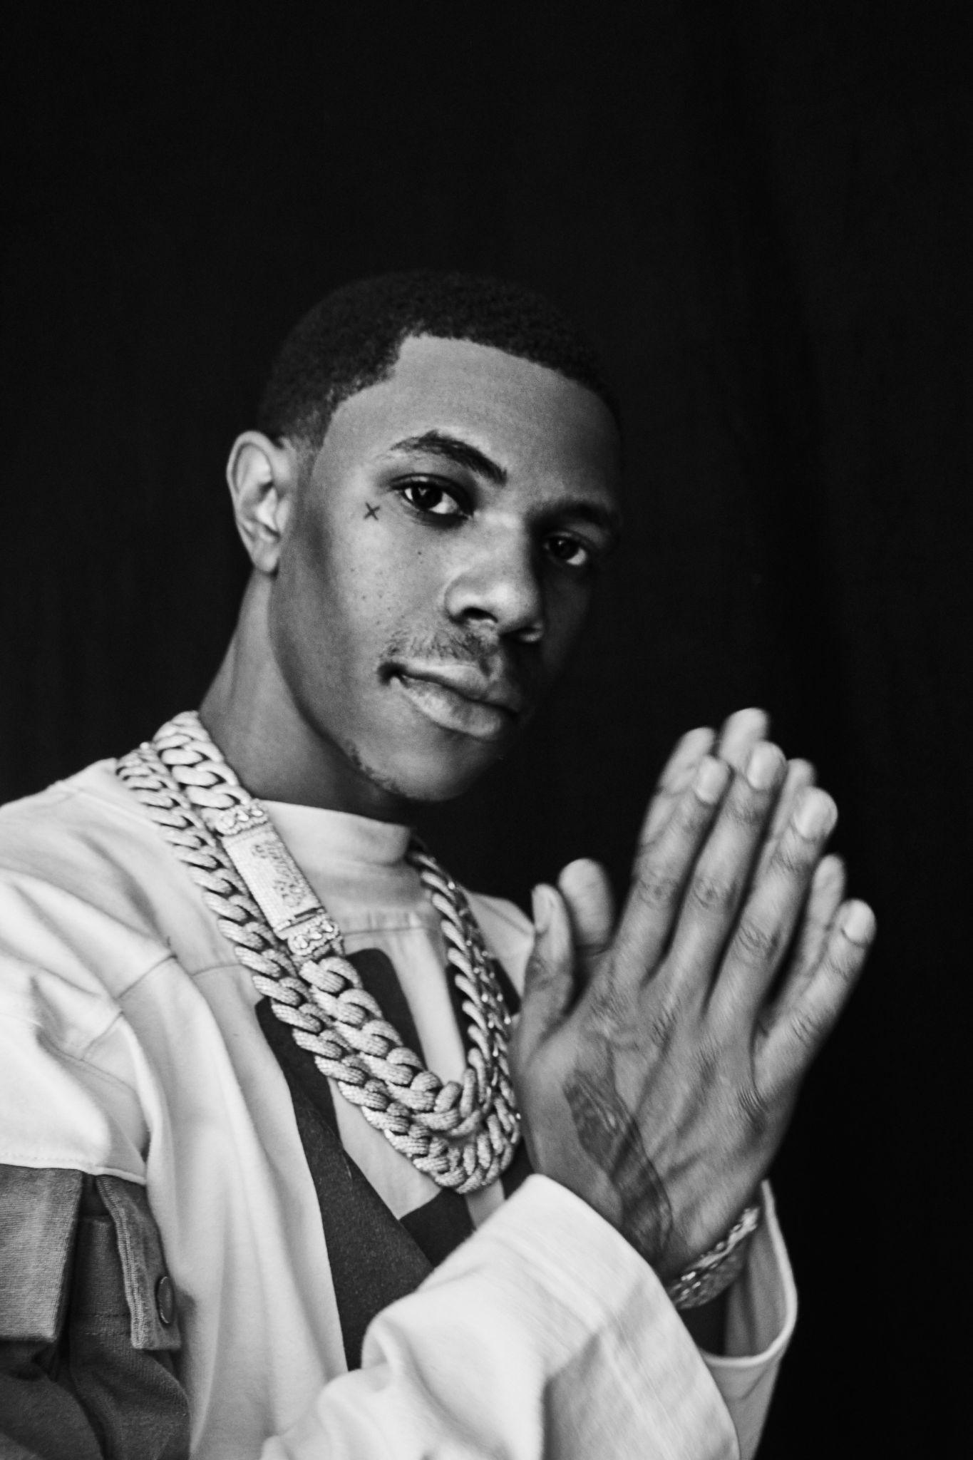
DOWNLOAD PRESS ASSETS
Photo Credit: Jimmy Fontaine

###

