FOR IMMEDIATE RELEASE
SEPTEMBER 8, 2023

ABSOFACTO GETS PERSONAL WITH “I JUST THINK ABOUT YOU”

RIAA PLATINUM-CERTIFIED PRODUCER/ARTIST CELEBRATES LOVE AND MARRIAGE
WITH MOST ROMANTIC TRACK TO DATE

LISTEN TO “I JUST THINK ABOUT YOU” HERE

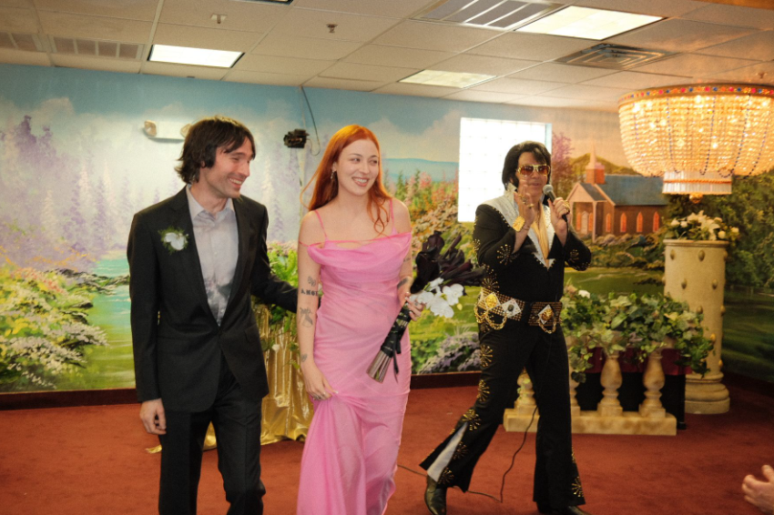
DOWNLOAD HI-RES IMAGES HERE
PHOTO CREDIT (RIGHT): SEAH BEHR

RIAA Platinum-certified artist, producer, and creator Absofacto has shared his most romantic and deeply personal single to date, “I Just Think About You” – Listen HERE.

“I Just Think About You” marks both a musical and personal milestone for Absofacto – a.k.a. Los Angeles, CA-based musician/artist Jonathan Visger – who initially wrote the song inspired by an undisclosed crush on Kulla, his longtime collaborator, creative partner on a series of cinematic videos, and self-declared “favorite director.” The two eventually began dating and soon moved to Kulla’s hometown of Las Vegas, where they were later wed by an Elvis impersonator. When the newlywed couple decided to return to LA, they went out late one night to say farewell to the city through Kulla’s eyes, soundtracked by the song Absofacto had written about her long before their love had bloomed.

“I can’t even explain how special this song is for me,” says Absofacto. “I wrote ‘I Just Think About You’ about Jacqueline long before we started dating. I had a huge crush on her but never thought anything would happen. It was the first song I’d written in a long time that arrived in a burst of inspiration, and really captures how I felt. A year later, we started dating, moved to her beloved hometown of Las Vegas together, and got married 8 months after that (by an Elvis impersonator). There’s so much transient energy in the song... It was the culmination of a year of seeing each other through each other’s lens, and navigating that unstable space between us. It also explores the texture and feeling of Vegas through Jacqueline’s eye, which served as a distinctive visual backdrop to such an important time in my life.”

Absofacto initially achieved global impact with the RIAA Platinum-certified viral hit “Dissolve,” tallying more than 500M streams and more than 3M TikTok creates. Named SiriusXM Alt Nation’s #1 song of 2019, “Dissolve” paved the way for future fan favorite singles such as “Rewind” and “Someone Else’s Dream.”

As his profile rose, Absofacto opened the door to the mysterious world of NITESHIFT – a multi-dimensional, ongoing creative experience comprising singles, visuals, films, interactive elements, and much more. The one-of-a-kind project got underway with “VIBE TIL I DIE,” featuring love-sadKID and LIMBO, mixed by Jeff Ellis (Frank Ocean, Joji, Omar Apollo), and available HERE. Featured on Sirius XM Alt Nation’s “Advanced Placement” upon its late 2022 debut, “VIBE TIL I DIE” arrived alongside a cinematic companion video – created by Kulla and Absofacto – streaming now at the official Absofacto Presents: NITESHIFT YouTube channel HERE.

The NITESHIFT project continued this year with the arrival of one of Absofacto’s most exquisitely nostalgic songs, “Unquit You,” joined by a haunting, 70s horror-inspired visual, streaming now at YouTube HERE.

# # #

DOWNLOAD HI-RES IMAGES HERE
PHOTO CREDIT: JACQUELINE KULLA

CONNECT WITH ABSOFACTO
OFFICIAL | FACEBOOK | INSTAGRAM | TWITTER | YOUTUBE

CONTACT
Jessica Nall // Jessica.Nall@atlanticrecords.com

