FOR IMMEDIATE RELEASE
SEPTEMBER 15, 2023

ABSOFACTO SHARES OFFICIAL MUSIC VIDEO FOR LATEST RELEASE
“I JUST THINK ABOUT YOU”

RIAA PLATINUM-CERTIFIED PRODUCER/ARTIST CELEBRATES LOVE AND MARRIAGE
WITH MOST ROMANTIC TRACK TO DATE

OFFICIAL MUSIC VIDEO FILMED IN LAS VEGAS
CAPTURED THROUGH THE EYES OF HIS WIFE, JACQUELINE KULLA

LISTEN TO “I JUST THINK ABOUT YOU” HERE | WATCH OFFICIAL MUSIC VIDEO HERE

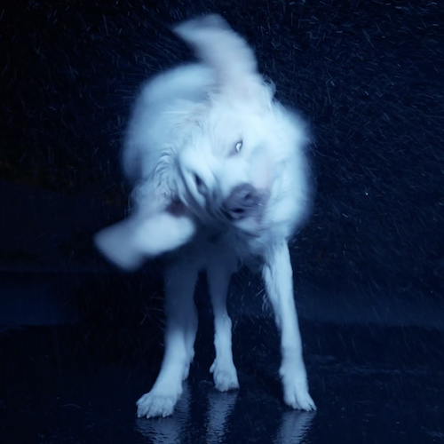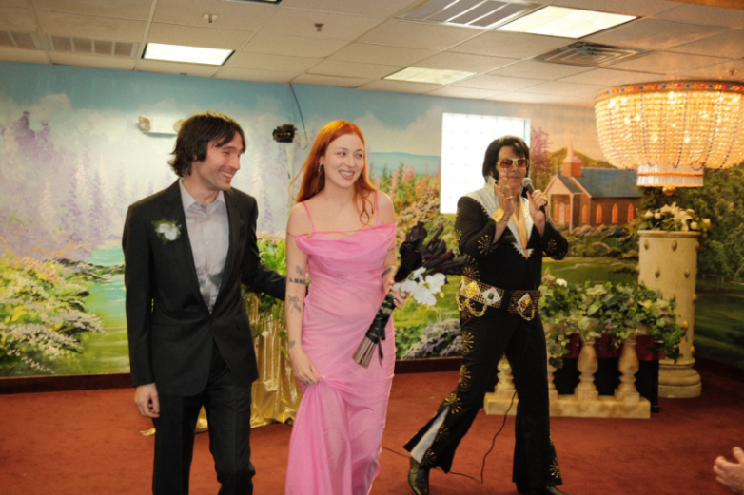
DOWNLOAD HI-RES IMAGES HERE
PHOTO CREDIT (RIGHT): SEAH BEHR

RIAA Platinum-certified artist, producer, and creator Absofacto recently shared his most romantic and deeply personal single to date, “I Just Think About You” – Listen HERE. Now, he shares the official music video that was filmed in Las Vegas, where his wife, Jacqueline Kulla, is from. The video was filmed before the two moved back to LA and created this visual to capture the city through her eyes – Watch HERE.

“I Just Think About You” marks both a musical and personal milestone for Absofacto – a.k.a. Los Angeles, CA-based musician/artist Jonathan Visger – who initially wrote the song inspired by an undisclosed crush on Kulla, his longtime collaborator, creative partner on a series of cinematic videos, and self-declared “favorite director.” The two eventually began dating and soon moved to Kulla’s hometown of Las Vegas, where they were later wed by an Elvis impersonator. When the newlywed couple decided to return to LA, they went out late one night to say farewell to the city through Kulla’s eyes, soundtracked by the song Absofacto had written about her long before their love had bloomed.

“I can’t even explain how special this song and video are for me,” says Absofacto. “When we were about to move back to Los Angeles, we would pack up boxes all day and go out at night to film this video throughout Vegas. There’s so much transient energy in the song and video both... It was the culmination of a year of seeing each other through each other’s lens, and navigating that unstable space between us. It also explores the texture and feeling of Vegas through Jacqueline’s eye, which served as a distinctive visual backdrop to such an important time in my life.”

“Vegas is incredibly special to me,” says Jacqueline Kulla. “I grew up there and it’s such a rapidly evolving and expanding place; always has been. Each time I go back it feels different, and it makes satisfying any homesickness impossible. Jon and I spent a year in Vegas and this video is how we spent the last few days of our time there. With the inevitable infestation of Vegas by LA expats looming in the near future, in many ways this video (and that entire year) was a last ditch attempt at connecting with my sense of home before it is propelled by inertia into its next unrecognizable form. There are shots from a parking lot I spent a lot of time in while going to silversmith school. My father spent a lot of time in that same parking lot in the early 60s as a kid. There are shots of one of my closest friend’s dogs on my driveway at night, the parking garage of my favorite casino as a child, the garage I parked in for work every day for years on the strip in my early twenties. The day shots are drenched in burning Vegas sun, and night shots are an indulgent reprieve from the burning. Whatever the future of Las Vegas is, I wish it well. We all can and should change... staying the same is the absence of life.”

Absofacto initially achieved global impact with the RIAA Platinum-certified viral hit “Dissolve,” tallying more than 500M streams and more than 3M TikTok creates. Named SiriusXM Alt Nation’s #1 song of 2019, “Dissolve” paved the way for future fan favorite singles such as “Rewind” and “Someone Else’s Dream.”

As his profile rose, Absofacto opened the door to the mysterious world of NITESHIFT – a multi-dimensional, ongoing creative experience comprising singles, visuals, films, interactive elements, and much more. The one-of-a-kind project got underway with “VIBE TIL I DIE,” featuring love-sadKID and LIMBO, mixed by Jeff Ellis (Frank Ocean, Joji, Omar Apollo), and available HERE. Featured on Sirius XM Alt Nation’s “Advanced Placement” upon its late 2022 debut, “VIBE TIL I DIE” arrived alongside a cinematic companion video – created by Kulla and Absofacto – streaming now at the official Absofacto Presents: NITESHIFT YouTube channel HERE.

The NITESHIFT project continued this year with the arrival of one of Absofacto’s most exquisitely nostalgic songs, “Unquit You,” joined by a haunting, 70s horror-inspired visual, streaming now at YouTube HERE.

# # #

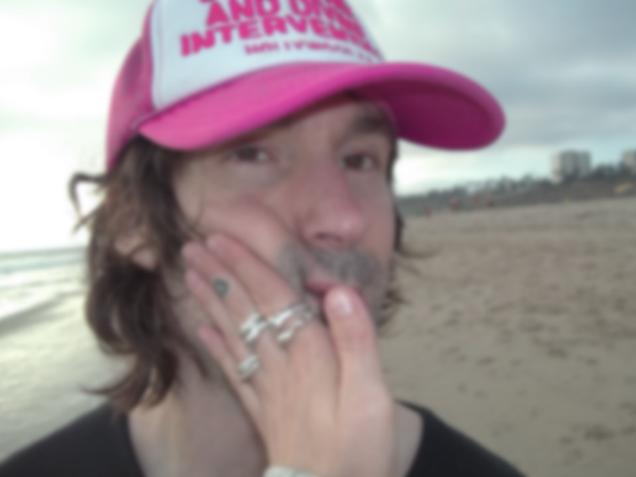
DOWNLOAD HI-RES IMAGES HERE
PHOTO CREDIT: JACQUELINE KULLA

CONNECT WITH ABSOFACTO
OFFICIAL | FACEBOOK | INSTAGRAM | TWITTER | YOUTUBE

CONTACT
Jessica Nall // Jessica.Nall@atlanticrecords.com

