FOR IMMEDIATE RELEASE
SEPTEMBER 22, 2023
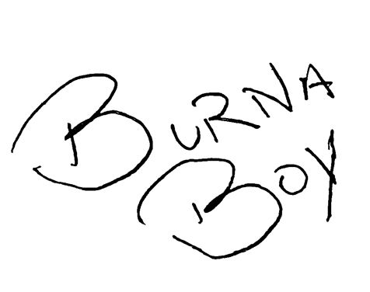

BURNA BOY RELEASES OFFICIAL MUSIC VIDEO FOR FAN FAVORITE “CITY BOYS”

FROM ACCLAIMED, SEVENTH STUDIO ALBUM I TOLD THEM…
“SITTIN’ ON TOP OF THE WORLD” FEATURING 21 SAVAGE EARNS #1 SPOT AT
RHYTHMIC RADIO

I TOLD THEM… SECURES A HISTORIC #1 ON THE UK ALBUM’S CHART

RECENTLY EARNED SEVEN NOMINATIONS AT THE 2023 BET HIP HOP AWARDS

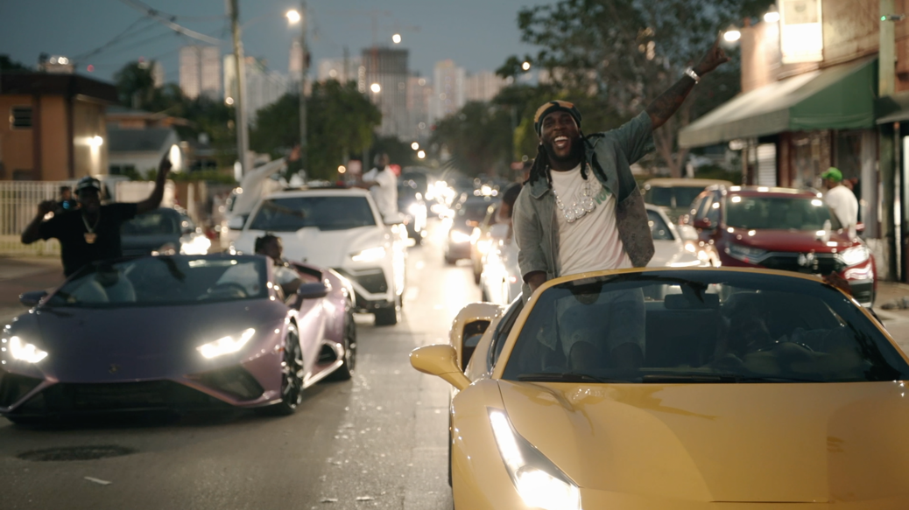
WATCH “CITY BOYS" MUSIC VIDEO
DOWNLOAD/STREAM ‘I TOLD THEM…’

GRAMMY® Award-winning global superstar Burna Boy shares the official music video for fan favorite song “City Boys” from his acclaimed, seventh studio album I Told Them… and directed by 20K with a quick cameo from Quavo — watch HERE. The song sparked a viral movement after the introduction of the signature dance (see original post here) that Dave Chapelle was later seen learning backstage after Burna closed out opening night of Dave’s ‘It’s a Celebration B!%?#&$! Tour’ with standout records “Ye” and “Last Last.”

The global giant once again made history with the release of last month’s 15-track album I Told Them... after it debuted at #1 on the Official U.K. Albums chart, becoming the first international African artist to earn the title, and debuting at #1 in 55 countries on Apple Music. He also went on to make his third appearance on the Billboard Hot 100 with the summer anthem “Talibans II” with Byron Messia. Most recently, the album’s lead single “Sittin’ On Top Of The World” feat 21 Savage recently earned the #1 spot at Rhythmic radio.
Burna Boy’s immense success and impact on the global music scene throughout 2023 is highlighted by his recent seven nominations atthe 2023 BET Hip-Hop Awards including Hip-Hop Artist of the Year, Best Live Performer, Lyricist of the Year, Best Hip Hop Video, Best Collaboration, Song Of The Year, and Hustler Of The Year.

I Told Them… was also accompanied by a special edition magazine. The exclusive piece is meant to serve as a collector’s item/special keepsake for fans. From front to back, the magazine featured never-before-seen content including a conversation between Burna Boy and RZA (of the Wu-Tang Clan), articles written by his grandfather (former manager of the legendary Fela Kuti), photos from throughout the making of the album, and more. The “I Told Them” Magazine is available for purchase here.

Earlier this year, Burna Boy made history once again with his sold-out show at New York City’s Citi Field stadium. Becoming the first African artist in history to sell out a stadium in the U.S., the Nigerian showman commanded a crowd of more than 40,000 fans, including celebs like Busta Rhymes, SZA, NBA star Mo Bamba, NFL star Larry Ogunjobi, and British rapper Dave, who also joined Burna on stage for a special performance of their hit song “Location.” This history-making performance shortly followed his landmark London stadium performance where he became the first African to headline a stadium in the U.K. Viewers were able to enjoy this monumental show via an exclusive Apple Music Live stream.

---
“His seventh album has a title that promises the victory lap for which he’s long-overdue: It’s called I Told Them… The record continues to expand Burna Boy’s Afro-fusion palette, as he draws inspiration from ‘90s hip-hop and R&B – and sounds more assured than ever in the process.” –NPR

“I Told Them… is a delectably crafted Afropop album. The songs on I Told Them… are sharply written but at times also tender, balancing seriousness with moments of levity.” – ROLLING STONE

“Burna Boy ushered in his current era in June with the Barack Obama favorite “Sittin’ on Top of the World,” an R&B earworm with the nostalgic air of a 1990s summer.” – PITCHFORK
---

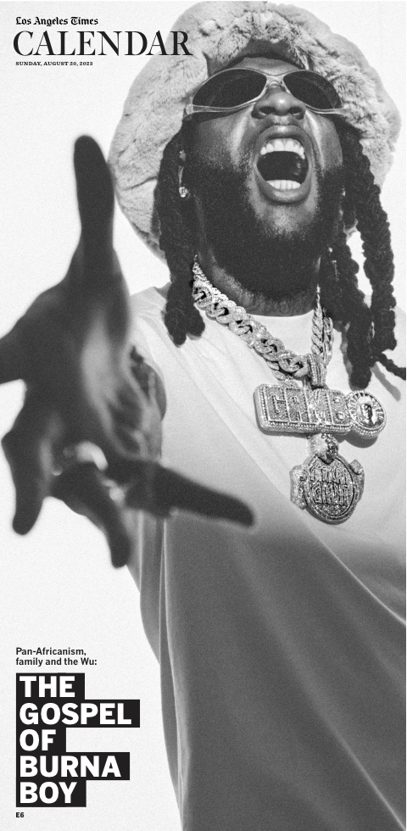
READ BURNA BOY’S EXCLUSIVE COVER STORY WITH LA TIMES

---

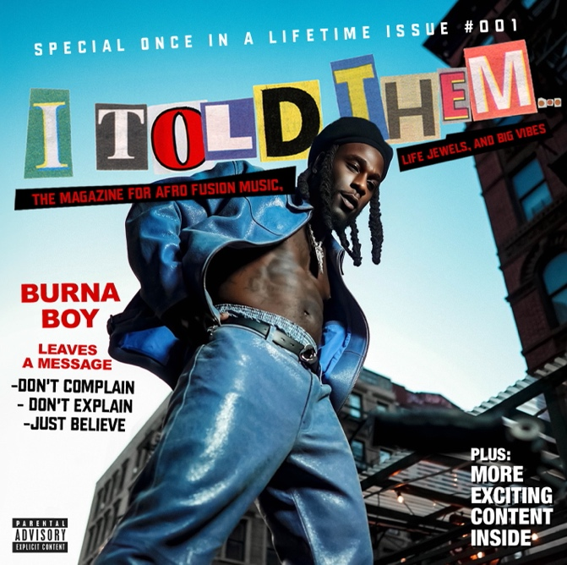
DOWNLOAD HI-RES ARTWORK
(ALBUM PHOTO SHOT BY APM + COVER DESIGN BY FLASHGRFX)

---

CONNECT WITH BURNA BOY
TWITTER | FACEBOOK | INSTAGRAM | YOUTUBE |TIKTOK

PRESS CONTACTS
Corey Brewer | Corey.Brewer@atlanticrecords.com
Selam Belay | Selam.Belay@atlanticrecords.com

