FOR IMMEDIATE RELEASE
AUGUST 22, 2023

DANIEL SEAVEY ANNOUNCES DANCING IN THE LIGHT TOUR

Multi-platinum singer/songwriter, multi-instrumentalist and producer CELEBRATES
DEBUT SOLO EP WITH NORTH AMERICAN HEADLINE TOUR

DANCING IN THE DARK EP AVAILABLE NOW

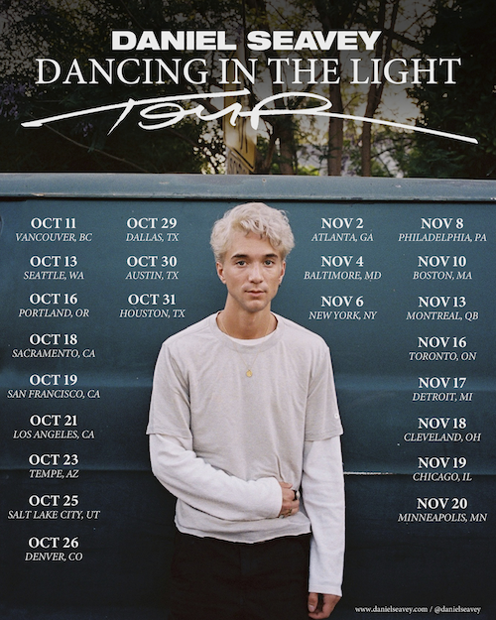
DOWNLOAD HI-RES ART/IMAGES

STREAM DANCING IN THE DARK EP: LINK

Multi-platinum singer/songwriter, multi-instrumentalist and producer Daniel Seavey has announced his North American Dancing in the Light tour, kicking off October 11th in Vancouver, BC. The 23-date run marks his second solo headline outing, following his sold-out Introducing Daniel Seavey tour earlier this year. Ticket pre-sales begin tomorrow, August 23rd at 10am local time with general on-sale this Friday, August 25th – for full routing and ticketing information please visit danielseavey.com.
The Dancing in the Light tour celebrates the surprise arrival of Seavey’s debut solo EP, Dancing in the Dark, available now (listen here). The 7-track collection features Seavey’s most recent single “I Tried,” which was named among The Best Songs of 2023 So Far by Rolling Stone, following his debut solo releases “Can We Pretend That We’re Good?” and “Runaway.” The explosive self-penned/produced songs were deemed “punchy and experimental” by Billboard, while Rolling Stone further praised Seavey for his “impeccable production skills, stellar vocals, and personal artistry.” Initially premiered on the road, Dancing in the Dark also includes hotly anticipated fan-favorites “Leave Me Alone” and “Fall Into You.” Collectively the songs have tallied over 40 million global streams collectively since release, further highlighted by alternate versions showcasing the artist’s versatile musicality across over 20 instruments.

In 2016, Seavey co-founded Why Don’t We and embarked upon an unbelievable six-year journey highlighted by over 4 billion global career streams, two RIAA Platinum-certified singles, five RIAA Gold-certified singles, two Top 10 albums on the Billboard 200 chart, and sold out tours with multiple stops at legendary venues such as Radio City Music Hall and more. On the road, he often penned and produced nascent ideas that would eventually become the foundation of his own unique sound. In 2022, he hunkered down in his home studio and wrote and recorded what he anticipated would become his debut album. He not only sang and produced, but he also played every instrument, infusing a piece of himself upon each facet. Now following an excruciating legal process, Seavey is prepped to enter 2024 as a free artist. By releasing his work thus far on Dancing in the Dark, he hopes to hold fans over as he begins creating an album he describes as “full of more experience, more joy, and more weightlessness than ever before.”

DANCING IN THE LIGHT TOUR 2023

OCTOBER
11 – Vancouver, BC @ Vogue Theatre
13 – Seattle, WA @ The Showbox
16 – Portland, OR @ Wonder Ballroom
18 – Sacramento, CA @ Ace of Spades
19 – San Francisco, CA @ The Fillmore
21 – Los Angeles, CA @The Wiltern
23 – Phoenix, AZ @ The Marquee
25 – Salt Lake City, UT @ The Depot @ The Complex
26 – Denver, CO @ The Summit
29 – Dallas, TX @ The Echo Lounge
30 – Austin, TX @ Emo’s
31 – Houston, TX @ House of Blues

NOVEMBER
2 – Atlanta, GA @ Masquerade
4 – Baltimore, MD @ Rams Head Live!
6 – New York, NY @ Webster Hall
8 – Philadelphia, PA @ TLA
10 – Boston, MA @ Paradise Rock Club
13 – Montreal, QB @ Corona Theatre
16 – Toronto, ON @ Opera House
17 – Detroit, MI @ St Andrew’s
18 – Cleveland, OH @ House of Blues
19 – Chicago, IL @ House of Blues
20 – Minneapolis, MN @ The Varsity

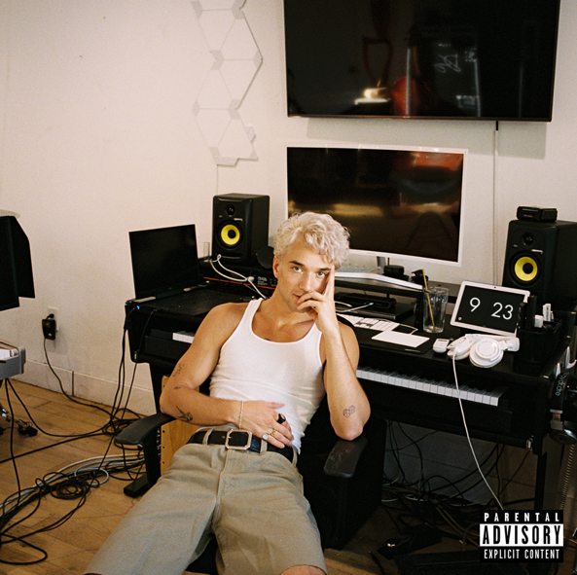
DOWNLOAD HI-RES ART/IMAGES

CONNECT:
DanielSeavey.com | Instagram | TikTok | Twitter | YouTube | SoundCloud | Press Assets

CONTACT:
Ted Sullivan (Atlantic Records) | ted.sullivan@atlanticrecords.com

