FOR IMMEDIATE RELEASE
SEPTEMBER 8, 2023

FAOUZIA SHARES “IL0V3Y0U”

INTERNATIONALLY ACCLAIMED ARTIST CONTINUES ICONIC DOLL SUMMER
WITH LUMINOUS NEW SINGLE

LISTEN TO “IL0V3Y0U” | WATCH OFFICIAL LYRIC VIDEO

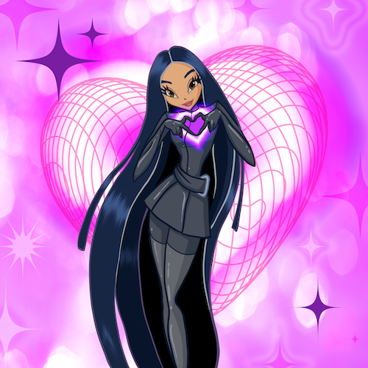
DOWNLOAD HI-RES ARTWORK HERE

“One of the most powerful new voices you’ll hear this year.” – BILLBOARD

“Faouzia is the Next Big Thing” – BUSTLE

Internationally acclaimed Moroccan-Canadian singer/songwriter/multi-instrumentalist Faouzia has shared her luminous new single, “IL0V3Y0U” – Listen HERE. The track is released alongside an official lyric video – Watch HERE.

“IL0V3Y0U” marks the latest chapter in Faouzia’s iconic new era of “DOLL SUMMER” following the fiercely energetic “La La La” and its equally vibrant Ty Sunderland Remix. Both tracks continue a string of spectacular new dance-pop hits that includes the recently released “Don’t Call Me” and “Plastic Therapy,” both produced by Ryan McMahon (Marina, Addison Rae). In addition, Faouzia recently joined forces with superstar DJ Martin Solvieg for the international favorite, “Now Or Never.”

“Don’t Call Me” and “Plastic Therapy” in turn followed this spring’s “I’m Blue.” A haunting and ethereal new rendition of Eiffel 65’s worldwide #1 hit, “Blue (Da Ba Dee),” the track was first recorded by Faouzia more than three years ago, earning millions of worldwide streams and 5M video views via YouTube HERE. “I’m Blue” was also featured in the smash Netflix series, Red Rose, rocketing it to Shazam’s “Top 200” in Germany, France, and the UK.

With collaborations with John Legend, Kelly Clarkson, David Guetta, and more, Faouzia has been named an “Artist to Watch” by Variety, Entertainment Weekly, and PEOPLE Magazine, as well as a “Style Star to Watch” by Vogue. With over 1.1B global streams and a combined social reach of over 11M followers – including over 2.26M YouTube subscribers, 2M Instagram followers and more than 3.4M Tik Tok followers – Faouzia has cemented herself as a surefire artist to watch.

CONNECT WITH FAOUZIA
WEBSITE | FACEBOOK | INSTAGRAM | TIK TOK | TWITTER | YOUTUBE

PRESS CONTACTS:

FOR ATLANTIC RECORDS
Jessica Nall // Jessica.Nall@AtlanticRecords.com

FOR ALIGN PR
Lauren Morris // lmorris@align-pr.com
Sarah Cramer // sarah@align-pr.com
Tatum Norton // tnorton@align-pr.com

