FOR IMMEDIATE RELEASE
JUNE 23, 2023

Forest Blakk celebrates nuptials with “I Choose You”

Acclaimed singer/songwriter soundtracks his own love story
with special new single, available now via Atlantic Records

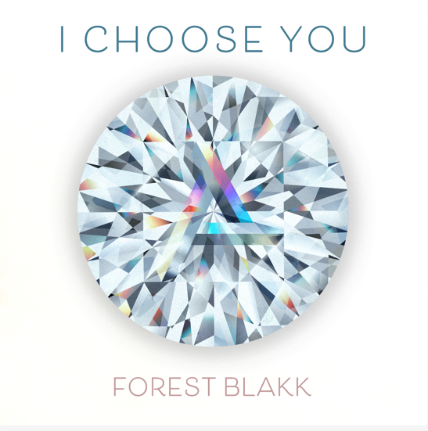
DOWNLOAD HIGH-RES ARTWORK HERE

STREAM “I CHOOSE YOU”: LINK

Acclaimed singer/songwriter Forest Blakk soundtracks his own love story with new single “I Choose You” – available now via Atlantic Records. The touching song arrives just two days after Blakk’s Nashville wedding to Tooley Jones, a beautiful ceremony covered exclusively by PEOPLE Magazine (read here).

“I Choose You” marks the first new music from Blakk since his intimate and relatable Every Little Detail EP last year. The 8-track collection included his breakout Platinum-certified smash single “If You Love Her,” which alone has amassed over 310 million total global streams, earned Blakk his official US chart debut on Billboard’s Emerging Artists chart, his national US TV debut on ABC’s Live with Kelly & Ryan, top 30 placement on the Hot AC radio chart & saw the singer/songwriter collaborate with Meghan Trainor on a stunning duet version. Meanwhile, Blakk’s follow-up single “Fall Into Me” (co-written alongside Matchbox Twenty front man Rob Thomas and Gregg Wattenberg) reached top 30 on the Hot AC radio chart and Gold-certification status in his native Canada, in addition to being featured in a perfectly fitting ad campaign for Kay Jewelers.

Highlighted as one of PEOPLE Magazine’s “talented emerging artists making their mark on the musical landscape” and deemed an “artist on the rise” by Billboard, Blakk made his debut with his 2018 EP Minutes and follow-up 2020 sophomore EP Sideways – the latter of which saw Blakk collaborate with the likes of Will IDAP (Train, Florida Georgia Line), Nick Long (King Princess), Carl Ryden (Ricky Martin, David Guetta), Ollie Green (Freya Ridings, Gavin James) & more to tell a love story through an incredibly realistic and candid lens. The 6-track collection featured singles “I Wish I Knew” (deemed an “introspective look at love and love lost” by American Songwriter) and uplifting anthem of resilience “Put Your Hands Up,” which debuted on an episode of ABC’s Grey’s Anatomy. A compelling live performer, Blakk has toured extensively supporting NEEDTOBREATHE, Gavin James, Dean Lewis & earlier this year embarked on a sold out 17-date North American headline tour.

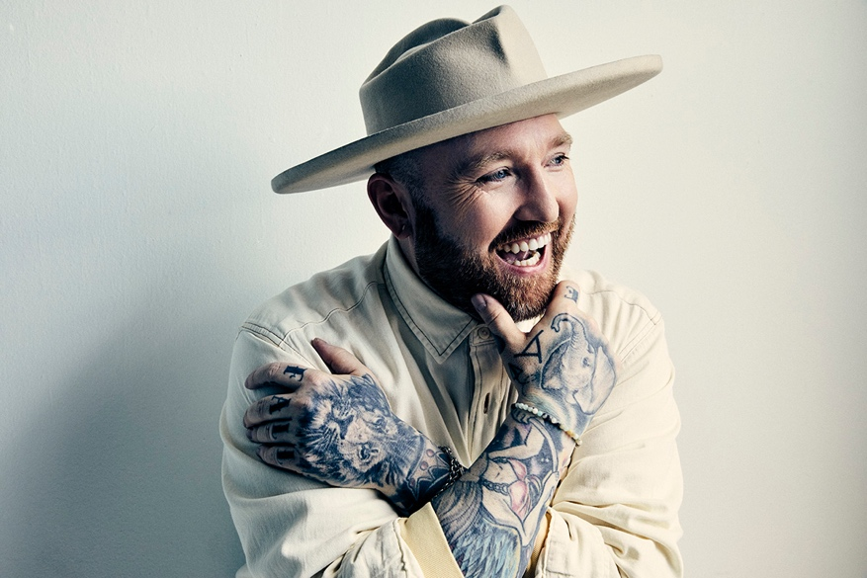
DOWNLOAD HIGH-RES IMAGES

CONNECT WITH FOREST BLAKK:
TIKTOK | TWITTER | FACEBOOK | INSTAGRAM | YOUTUBE | FORESTBLAKK.COM

CONTACT:
ted.sullivan@atlanticrecords.com

