FOR IMMEDIATE RELEASE
SEPTEMBER 1, 2023

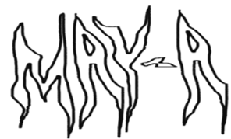
MAY-A UNVEILS ANALYSIS PARALYSIS

EAGERLY AWAITED EP INCLUDES BRAND-NEW SINGLE, “GUILTY CONSCIENCE”

US TOUR ALONGSIDE NESSA BARRETT BEGINS OCTOBER 9 IN ORLANDO, FL

ANALYSIS PARALYSIS AVAILABLE NOW VIA ATLANTIC RECORDS
LISTEN TO ANALYSIS PARALYSIS

WATCH “GUILTY CONSCIENCE” OFFICIAL MUSIC VIDEO

DOWNLOAD HI-RES ARTWORK

Australian alt-pop sensation MAY-A has shared her eagerly awaited new EP, ANALYSIS PARALYSIS, available everywhere now via Atlantic Records – Listen HERE. MAY-A will be celebrating the EP this fall as she joins Nessa Barrett’s upcoming Church Club For The Lonely Tour, which beings October 9 at Orlando, FL’s House of Blues and then continues through mid-November. For complete details and ticket information, please visit www.may-amusic.com/tour.

ANALYSIS PARALYSIS includes the brand-new single, “Guilty Conscience,” joined by an official music video – Watch HERE. The 7-track project further sees MAY-A exploring and experimenting with new sounds and experiences, highlighted on such recent singles as “Something Familiar,” “LOLA,” “Your Funeral,” “Sweat You Out My System,” and “ifyoulikeitlikethat.” The new music follows an impressive run of sold-out shows in Australia including headline dates for her Never Going Back Tour and an appearance at famed Splendour in the Grass – See tour recap HERE.

“Your Funeral” and “Sweat You Out My System” were both met by global applause upon their release this spring, with PAPER praising the latter track as “anthemic ‘90s-style rock…a heated breakup track, which likens a split to going cold turkey and captures all the anxiety and intensity that implies.” “The new pop/rock-meets-semi-rap track brilliantly recontextualizes the indie-pop stylings fans have grown accustomed to from the Australian phenom,” agreed Billboard. “MAY-A leans all the way in with punchy guitars and blown-out drums. Her lyricism remains top-shelf.” “The self-deprecating ‘Your Funeral’ finds (MAY-A) leaning into more alt-pop-based sonics,” declared Ones To Watch, “as she unpacks her relationship habits with satirical lyricism flowing above a driving beat.”

The busy rush of activity follows an incredibly successful 2022 for MAY-A, which included her ARIA Award-nominated collaboration with Australian electronic superstar Flume, “Say Nothing (Feat. MAY-A),” which reached #12 on Billboard’s “Hot Dance/Electronic Songs” chart amidst a storm of high-profile media attention from Billboard, Complex and more. MAY-A joined Flume for performances of “Say Nothing” during show-stopping sets at last year’s Coachella and Governors Ball as well as on his sold-out US and Australian headline tours. MAY-A also unveiled her own unique rendition, “Say Nothing (MAY-A’s Version),” hailed by NME as “a total tone shift from the duo’s original, stripping out the song’s driving beat and Flume’s electronic elements. Instead, MAY-A opts for hauntingly hazy vocals, acoustic guitar and spacious, lo-fi production, letting the vulnerability of the song’s lyrics shine through.”

Nominated for Rolling Stone Australia’s “Best New Artist” award and hailed by Billboard as “a master class in indie pop,” MAY-A made her extraordinary debut with 2021’s acclaimed Don’t Kiss Ur Friends. The EP – which received a prestigious ARIA Award nomination for “Breakthrough Artist - Release” in MAY-A’s home country of Australia – includes such inventive and self-assured tracks as “Swing Of Things,” “Time I Love To Waste,” “Green,” and “Central Station.“

MAY-A – who supported 5 Seconds of Summer on their recent Australian headline tour and joined Wallows on the UK/EU leg of their landmark Tell Me That It’s Over World Tour, earning praise by DORK as “an artist bringing all their anticipated hype to life” – will next join Post Malone, Latto, and an array of other stars on Australia’s Spilt Milk festival tour, visiting Gold Coast, Ballarat, and Perth in late November/early December.

# # #

MAY-A
US TOUR 2023

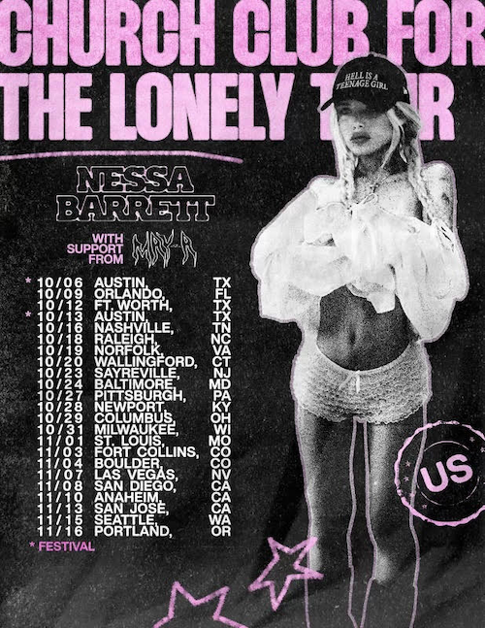

OCTOBER
9 – Orlando, FL – House of Blues
12 – Fort Worth, TX – Tannahill’s Tavern & Music Hall
16 – Nashville, TN – Marathon Music Works
18 – Raleigh, NC – The Ritz
19 – Norfolk, VA – The NorVa
20 – Wallingford, CT – The Dome
23 – Sayreville, NJ – Starland Ballroom
24 – Baltimore, MD – Rams Head Live
27 – Pittsburgh, PA – Stage AE
28 – Newport, KY – MegaCorp Pavilion
29 – Columbus, OH – KEMBA Live
31 – Milwaukee, WI – The Rave

NOVEMBER
1 – St. Louis, MO – The Pageant
3 – Fort Collins, CO – The Aggie
4 – Boulder, CO – Boulder Theater
7 – Las Vegas, NV – House of Blues
8 – San Diego, CA – Observatory North Park
10 – Anaheim, CA – House of Blues Anaheim
13 – San Jose, CA – San Jose Civic
15 – Seattle, WA – Showbox SODO
16 – Portland, OR – Crystal Ballroom

* ALL DATES WITH NESSA BARRETT CHURCH CLUB FOR THE LONELY TOUR

# # #

MAY-A
ANALYSIS PARALYSIS
(Atlantic Records)

TRACKLIST
Something Familiar
Your Funeral
LOLA
Sweat You Out My System
ifyoulikeitlikethat
Guilty Conscience
SUPERIOR LIAR

# # #
CONNECT WITH MAY-A
WEBSITE | FACEBOOK | INSTAGRAM | TIKTOK | TWITTER | YOUTUBE

For more information, please contact:
Kelly McWilliam // Kelly.McWilliam@atlanticrecords.com
“

