MASON RAMSEY ANNOUNCES
COMING-OF-AGE FALLS INTO PLACE EP

CONTINUES HIS EVOLUTION ON OCTOBER 20

SAVE THE DATE: ALBUM RELEASE SHOW SET FOR NYC – TICKETS ON SALE

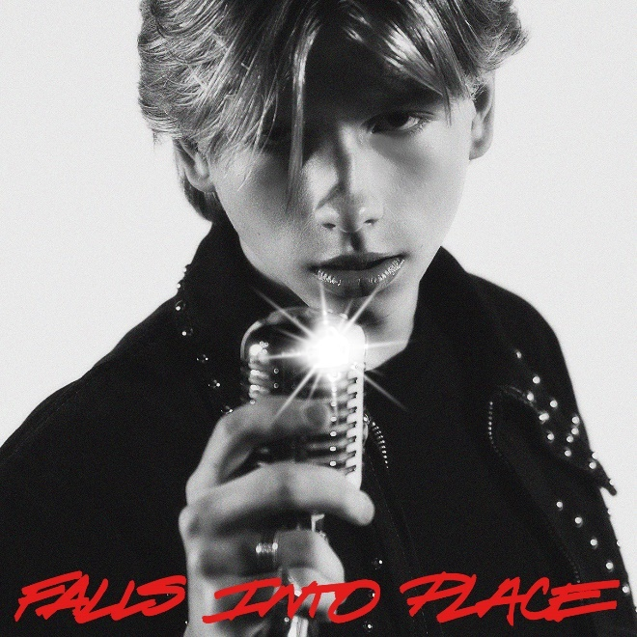
DOWNLOAD HI-RES ARTWORK

(NEW YORK, NY AND NASHVILLE, TN – September 22, 2023) — Fueling his next creative chapter, 16-year-old Country phenom Mason Ramsey announces his much-anticipated Falls Into Place EP today (9/22) via Atlantic Records. Releasing October 20, pre-save/pre-add here.
“I took some time to settle back in at home in Golconda the past few years where I was able to do some big life things like get my first job, go to prom, and work on remodeling my truck. I also was able to spend time playing the guitar, focus on my songwriting, and figure out what I really wanted to say with my music,” shares Ramsey. “My fans have never forgotten about me, and this EP is for them. The support I’ve felt since the beginning has changed my life, and I’m so excited to connect with everyone back out on the road with these new songs. It really feels like things are beginning to fall into place just how they should be. Buckle up everybody, there’s so much more to come!”
“Mason Ramsey is gearing up to make the internet go crazy—again,” hails Parade, as the five-song Falls Into Place EP marks his first new studio collection since 2019, and a new era for the breakout singer-songwriter. Ramsey’s “sharpened his chops and returned with a deeper voice and some deeper lyrics,” applauds PEOPLE, as proven in early releases like the heartfelt hometown ballad “Reasons To Come Home,” the up-tempo romantic fun of “She Got It Outta Me,” and optimistic honky-tonk rocker “Next Right Thing.” Matching coming-of-age themes and personal growth with Ramsey’s famous pure-Country charm, the global star now “older and more reflective,” according to Billboard, is credited as a co-writer on all but one track.

MASON RAMSEY’S FALLS INTO PLACE EP TRACK LIST
1. “Next Right Thing” (Mason Ramsey, Kendall Goodman, Brandon Day)**
2. “Falls Into Place” (Mason Ramsey, Lauren McLamb, Jenna Paulette)*
3. “All I Wanna Be” (Mason Ramsey, Taylor Phillips, Ben Stennis)*
4. “She Got It Outta Me” (Tofer Brown, Griffen Palmer, Liz Rose, Geoff Warburton)*
5. “Reasons To Come Home” (Mason Ramsey, Jeff Middleton, Rob Pennington)*
* Produced by Aaron Eshuis
** Produced by Brandon Day

Hosting three celebrations to hear his new music, Ramsey's album release show is set for October 20 at Mercury Lounge in New York, NY. Tickets are available here. He’ll also make his anticipated return to the Grand Ole Opry on October 28. Find the full lineup and tickets here. In addition, he’s currently creating a buzz among teens nationwide as submissions are being accepted for “The Next Right Thing is Homecoming with Mason Ramsey” contest. Fans can enter here through September 29 for a chance to have him be your date to homecoming and perform at your school!
Since catapulting onto the Country music scene as the youngest major label Country artist signed in the genre in nearly two decades at 11, Ramsey has already delivered two acclaimed EPs, earned a GOLD-certified single, headlined two tours in addition to supporting a Las Vegas residency, and surpassed 300 MILLION global streams since 2018.

CONNECT WITH MASON RAMSEY
INSTAGRAM | TWITTER | FACEBOOK | TIKTOK

ABOUT MASON RAMSEY:
As the youngest major label Country artist signed in the genre in nearly two decades, MASON RAMSEY continues his fast-track to stardom after being discovered singing in an aisle at his local Walmart. Ramsey’s new music illustrates how far he’s come – the differences prove instantly apparent as his voice boasts with the kind of confidence only gained through experience and his songwriting brims with unfiltered truth buoyed by intimate creativity.
Praised by THE NEW YORK TIMES as delivering "a stylistically diverse country and roots music EP,” the ATLANTIC RECORDS artist’s debut FAMOUS EP (Atlantic Records/Big Loud Records) spawned a hit single of the same name which scored a #4 spot on Billboard’s Hot Country Songs Chart. In addition to making his debut at the famed Grand Ole Opry, the Golconda, IL-bred phenom has also performed at several high-profile festivals including CMA FEST, COACHELLA, iHEARTCOUNTRY FESTIVAL, and STAGECOACH. He has made high-profile TV performances on ELLEN, GOOD MORNING AMERICA, and TODAY; as well as esteemed award show appearances on the CCMA AWARDS, CMA AWARDS, CMT MUSIC AWARDS, and GRAMMY AWARDS.

# # #

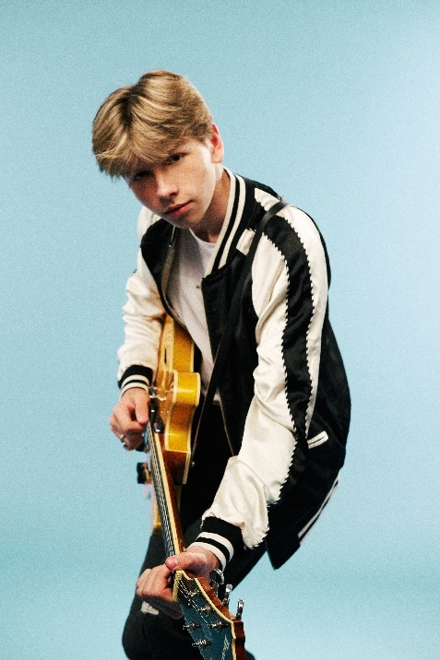

DOWNLOAD PRESS PHOTO // PHOTO CREDIT: LIBBY DANFORTH

FOR MASON RAMSEY PRESS INQUIRIES, PLEASE CONTACT:
Jason Davis (Atlantic Records) – jason.davis@atlanticrecords.com
Jensen Sussman (Sweet Talk Publicity) – jensen@sweettalkpr.com
Julianne Cassidy (Sweet Talk Publicity) – jcassidy@sweettalkpr.com

