FOR IMMEDIATE RELEASE
SEPTEMBER 1, 2023
ATLANTIC RECORDS ANNOUNCES THE SIGNING OF
INCREDIBLE SINGER-SONGWRITER, NOLAN TAYLOR

TAYLOR SHARES CHILLING LIVE VERSION OF HAUNTING TRACK “DOUBLE LIFE”
& MAKES ATLANTIC RECORDS DEBUT WITH “WICKED WAYS”

CHART-TOPPING PEER OLIVER ANTHONY PRAISES NOLAN DURING A RECENT VISIT TO THE JOE ROGAN EXPERIENCE, WATCH HERE

UPCOMING GIGS WITH SAM BARBER, CHARLES WESLEY GODWIN, DRAYTON FARLEY, AS WELL AS HEADLINE SHOWS, FESTIVAL PERFORMANCES, AND MORE

LISTEN TO “DOUBLE LIFE (LIVE)” | WATCH THE VIDEO FOR “DOUBLE LIFE (LIVE)”
LISTEN TO “WICKED WAYS”
WATCH LIVE PERFORMANCE OF VIRAL TRACK “68”

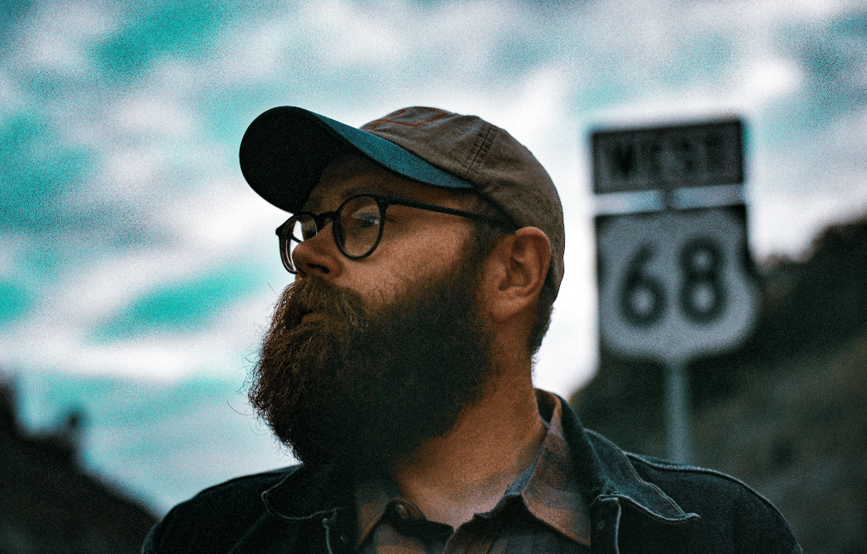
DOWNLOAD HI-RES IMAGE + ARTWORK
(PHOTO CREDIT: Phill Barnett)

“Nolan Taylor’s brutally honest lyrics, his raw, raspy vocals, and his passionate delivery have won over fans everywhere.” – WHISKEY RIFF

Today, Atlantic Records has announced the signing of the incredibly talented singer-songwriter, Nolan Taylor. The announcement comes with an extraordinarily chilling live version of Taylor’s fan-favorite, “Double Life,” available now HERE. The Ohio-native, who is celebrating his birthday today, also makes his Atlantic Records debut with his raw-boned and gripping new single, “Wicked Ways,” available now HERE. The track is joined by a live performance video streaming HERE.

“’Double Life’ is actually about someone I used to play music with,” says Taylor. “He and a married lady were in a bit of a relationship, and she would come around to watch us play. I could tell how much he really loved her but obviously that was a messy situation and it dissolved after a little while, but I thought it was a pretty love song. It’s a fun one for me to play and I absolutely love to sing it. I think my piano version is my favorite one yet.”

“Nolan Taylor is an incredible songwriter with a powerful voice,” says Ian Cripps, senior vp, A&R Atlantic Records. “His unique ability to tell stories through his music immediately drew us in. We are extremely excited to welcome him to the Atlantic family.”

In addition to the new announcement and releases, Taylor recently received praise from his chart-topping peer Oliver Anthony during his recent visit to the Joe Rogan Experience. You can see the “Rich Men North of Richmond” singer’s clip HERE.

Nolan Taylor has drawn critical applause and growing fan following with a voice that ranges from the soft fall of rain to a heavy crack of thunder, underlining songs of hard times, wild nights, and heartbreak. Themes of longing, desperation, joy, and sorrow ring true and genuine from his lips, fueling such strikingly powerful songs as “68,” which has earned the gifted troubadour over 5M worldwide streams thus far.

Taylor will celebrate his new partnership and more new music to come with a busy live schedule that includes headline shows, festival appearances, and dates alongside such like-minded artists as The Red Clay Strays, Charley Crockett, 49 Winchester, Morgan Wade, and Charles Wesley Godwin. For complete details and ticket availability, please visit www.nolantaylormusic.com/tour.

The backroads of America tell its truest stories. The heartbreak and heartbeat of the country thumps the loudest in the cracks between its big cities. A 2021 census in Blanchester, OH registers the village’s population at around 4,230 people. Nolan Taylor isn’t quite sure of the exact number, but he knows it’s small from growing up in this place with his dad and older brother. His father managed plants and factories, yet money was scarce, and the winters were brutal. Mom battled addiction and mental struggles, eventually estranging her from the boys. When he could finally afford a left-handed guitar, he started to write and record music of his own, grafting hard-earned wisdom, heart-wrenching memories, and hypnotic melodies to rustic and ruddy acoustic phrasing. As a kid, he found solace in music. He discovered The Grateful Dead through his dad and developed an appreciation for Pinegrove. Throughout junior high, he studied classic MTV Unplugged concerts by the likes of Alice In Chains, Pearl Jam, and Nirvana. Even though he primarily focused on wrestling, working out, football, and baseball, he finally picked up a left-handed guitar in high school. After graduating, he spent years gigging around West Virginia, Virginia, and Kentucky, playing anywhere and everywhere. In 2023, a video of Nolan performing “68” in the woods went viral with 2.6 million YouTube views on the Radio WV YouTube Channel. Achieving virality from obscurity and gathering millions of streams, he tells a true story all his own via a series of 2023 singles for Atlantic Records, beginning with “Wicked Ways” and the live recording of “Double Life.”

NOLAN TAYLOR
ON TOUR 2023

SEPTEMBER
2 – Chillicothe, OH – Ross County Fair
8 – Port Crane, NY– Fat Cowboys Hitching Post LOW TICKETS
9 – Cold Spring, NY – Chapel Restoration SOLD OUT
10 – Portsmouth, NH – The Music Hall LOW TICKETS
14 – Columbia, MO – Rose Park *
16 – Kansas City, MO– The Truman *
20 – Nashville, TN – Exit/In for Americana Fest ^
22 – Norfolk, VA – The NorVa *
23 – Winston-Salem, NC – The Ramkat * SOLD OUT
27 – Washington, DC – The Hamilton †
28 – Richmond, VA – The Broadberry †
29 – Pittsburgh, PA – Thunderbird Music Hall † SOLD OUT
30 – Lexington, KY – The Burl *Due to high demand, the venue has been upgraded*

OCTOBER
1 – Ashland, KY – FoxFire Music 2023 ^
3 – Brooklyn, NY – Baby’s All Right w/ Sam Barber
11 – Annapolis, IN – Rams Head §
12 – Cambridge, MA – The Sinclair §
13 – New York, NY – The Mercury Lounge §
14 – Philadelphia, PA – Milkboy §
15 – Buffalo, NY – Buffalo Ironworks §

NOVEMBER
4 – Scottsdale, AZ – Dreamy Draw *
28 – Asheville, NC – The Grey Eagle
29 – Newport, KY – The Southgate House Revival
30 – Indianapolis, IN – Hi-Fi

DECEMBER
1 – Detroit, MI – El Club
2 – Cleveland, OH – Grog Shop
3 – Chicago, IL – Carol’s Pub
31 – Tulsa, OK – Cain’s Ballroom

* w/ Charles Wesley Godwin
† Co- Headline w/Sam Barber, Drayton Farley
^ Festival Appearance
§ w/ The Red Clay Strays
** w/ J.R. Carroll & Kaitlin Butts

# # #

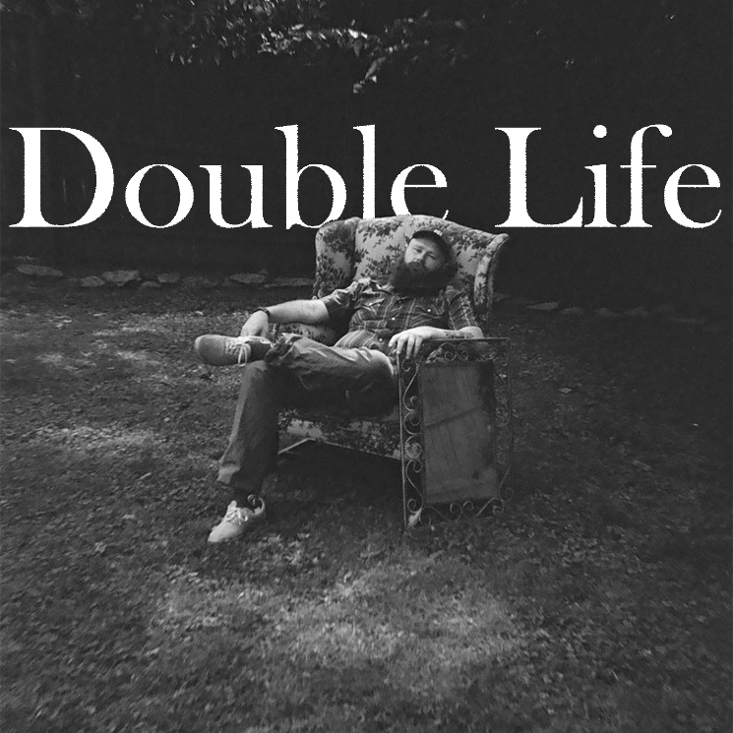
DOWNLOAD HI-RES IMAGE + ARTWORK

# # #
CONNECT WITH NOLAN TAYLOR
OFFICIAL | FACEBOOK | INSTAGRAM | SPOTIFY | TIKTOK

PRESS CONTACT
Corey Brewer | Corey.Brewer@atlanticrecords.com

