OLIVER TREE RELEASES THIRD STUDIO ALBUM
‘ALONE IN A CROWD’ TODAY

REVEALS SELF-DIRECTED OFFICIAL MUSIC VIDEO FOR FOCUS TRACK ‘WITH YOU’

BIGGEST INTERNATIONAL HEADLINING TOUR;
OLIVER TREE PRESENTS: ALONE IN A CROWD
STARTS NEXT MONTH
LIVE NATION-PRODUCED TOUR TRAVELS THROUGH NOVEMBER
WITH STOPS IN AUSTRALIA, FRANCE, LUXEMBOURG, THE UK,
BELGIUM, THE NETHERLANDS, GERMANY, SWITZERLAND AND ITALY

NORTH AMERICAN TOUR DATES SOON TO BE ANNOUNCED

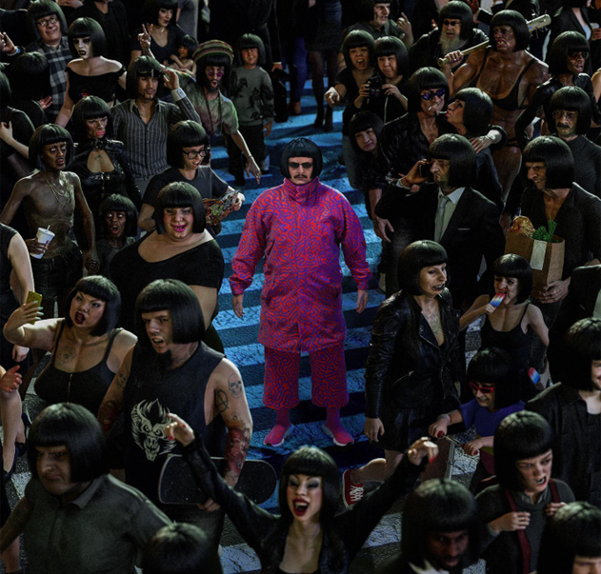

WATCH
“WITH YOU”

LISTEN
“ALONE IN A CROWD” (ALBUM)
TRACK LIST
Bounce
One & Only
Essence (feat. Super Computer)
Star
Fairweather Friends
Smile
Ugly Side
Highlight Of My Life
The First Night
Strangers
Invisible Man
Elevator To The Sky
With You
Miss You (with Robin Schulz) [Bonus Track]

Today, the multi-talented, global phenomenon that is Oliver Tree releases his highly anticipated third studio album ‘ALONE IN A CROWD’, out everywhere now – Listen HERE.

The full-length comes with new focus track ‘With You,’ plus an official music video self-directed by the chart-topping, genre-bending artist himself. The visual is the third and final installment, following the storyline and music videos for ‘Bounce’ and ‘One & Only.’ Filmed in Serbia, each visual follows Oliver Tree’s latest character creation Cornelius Cummings, a fashion designer from London.

Watch the official music video for ‘With You’ HERE.

His most personal album to date, ALONE IN A CROWD follows a string of stellar releases this year, including ‘Bounce,’ ‘One & Only,’ ‘Essence’ Ft Super Computer and ‘Fairweather Friends,’ all taken from the 14-track full-length released today, each produced by Oliver Tree, and accompanied with a signature music videos also written, created, directed and edited by the self-proclaimed workaholic himself.

Undeniably a one-of-a-kind artist who continues to top the charts and sell out amphitheaters worldwide, Tree satisfies his dedicated and growing audience with his Kaufman-esque Dadaist, “meta-humor” while continuing to explore and dissect the absurdity of modern culture, obsession with fame and social media. His latest album ALONE IN A CROWD serves to reflect both the light and the darkness of human nature within popular culture, while holding a mirror up to us all and embracing the absurdity of it all. Exploring themes of loneliness, disconnect, and the human experience.

Never one to slow down, Oliver Tree is gearing up for his biggest international SOLD OUT tour to date, making stops across Europe, United Kingdom and Australia. Produced by Live Nation, OLIVER TREE PRESENTS ALONE IN A CROWD gets underway on October 13 at Brisbane, Australia’s Fortitude Music Hall and then travels through November with stops in France, Luxembourg, the UK, Belgium, the Netherlands, Germany, Switzerland, and Italy. For complete details, please see https://www.olivertreemusic.com/tour/

North American tour dates to be announced very soon.

In celebration of ALONE IN A CROWD, this week Oliver Tree hosted The World’s Worst Radio Show on Amp, Amazon’s live radio app. The show features a mix of music, comedy, and stories behind the album. Fans in the U.S. can catch the replay of The World’s Worst Radio Show by downloading the app here and following @olivertree.

ALONE IN A CROWD is out everywhere now.

OLIVER TREE PRESENTS: ALONE IN A CROWD - TOUR DATES
OCTOBER
13 – Brisbane, AUS – Fortitude Music Hall
14 – Sydney, AUS – Hordern Pavilion
15 – Wollongong, AUS – Yours and Owls Festival *
18 – Melbourne, AUS – Festival Hall
20 – Adelaide, AUS – Hindley Street Music Hall
21 – Perth, AUS – Metro City

NOVEMBER
1 – Paris, France – L’Olympia
2 – Esch-sur-Alzette, Luxembourg – Rockhal
4 – Birmingham, UK – O2 Academy Birmingham
5 – Glasgow, UK – O2 Academy Glasgow
7 – Leeds, UK – O2 Academy Leeds
8 – Manchester, UK – O2 Apollo Manchester
9 – London, UK – Troxy
11 – Brussels, Belgium – Ancienne Belgique
14 – Tilburg, Netherlands – 013 Poppodium
16 – Munich, Germany – TonHalle München
17 – Cologne, Germany – E–Werk
19 – Berlin, Germany – Columbiahalle
20 – Zurich, Switzerland – Halle 622
21 – Milan, Italy – Fabrique
* FESTIVAL PERFORMANCE
10/10-10/21 w/ Sueco
11/1-11/21 w/ Tommy Cash

ABOUT OLIVER TREE
Now boasting more than 4 BILLION global streams, over 1 BILLION YouTube views, over 14.7 MILLION TikTok followers, and an cumulative social reach of over 30 MILLION, Oliver Tree has already had a very productive 2023 with releases such as his first-ever collaboration with fellow superstar David Guetta, “Here We Go Again,” [listen HERE]. An official lyric video, written and directed by Oliver, has earned over 13 MILLION views [view HERE]. “Here We Go Again” in turn followed KSI’s “Voices (Feat. Oliver Tree),” joined by an official music video now boasting close to 7 MILLION views [watch HERE]. Last year also saw Oliver join forces with GRAMMY® Award-nominated producer Robin Schulz for the high-energy viral hit, “Miss You,” which swiftly amassed over 300 MILLION global streams following top 10 debuts on both Billboard’s “Hot Dance/Electronic Songs” chart and the UK’s Official Singles Chart. Recently certified 2x Platinum in Australia as well as Platinum in both the UK and Canada, the track is accompanied by a typically quirky official music video, directed by Oliver and currently boasting more than 190 MILLION views via YouTube HERE.

Oliver wrapped up his very busy 2022 with the long awaited release of Cowboy Tears Drown the World in a Swimming Pool of Sorrow, an expanded deluxe edition of his acclaimed sophomore LP, Cowboy Tears, available now HERE. Highlights include such favorites as “I Hate You,” “Placeholder,” and “Suitcase Full Of Cash,” the latter accompanied by an official visual featuring guest appearances from viral stars Alissa Violet, Tana Mongeau, Viking Barbie, and Melissa Ong, streaming now at Oliver’s YouTube channel HERE.

WEBSITE | FACEBOOK | INSTAGRAM | SPOTIFY | TIK TOK | TWITTER | YOUTUBE

For all media inquiries, please contact:
HIGH RISE PR
Alexandra Baker | Alexandra@highrisepr.com
Jamie Sward | Jamie@highrisepr.com
ATLANTIC RECORDS
JESSICA NALL // JESSICA.NALL@ATLANTICRECORDS.COM

