OLIVER TREE REVEALS “FAIRWEATHER FRIENDS”
FROM FORTHCOMING ALBUM ALONE IN A CROWD, OUT SEPTEMBER 29
– PRE-SAVE/ADD HERE

BIGGEST INTERNATIONAL HEADLINING TOUR;
OLIVER TREE PRESENTS: ALONE IN A CROWD STARTS NEXT MONTH

LIVE NATION-PRODUCED TOUR TRAVELS THROUGH NOVEMBER
WITH STOPS IN AUSTRALIA, FRANCE, LUXEMBOURG, THE UK,
BELGIUM, THE NETHERLANDS, GERMANY, SWITZERLAND AND ITALY

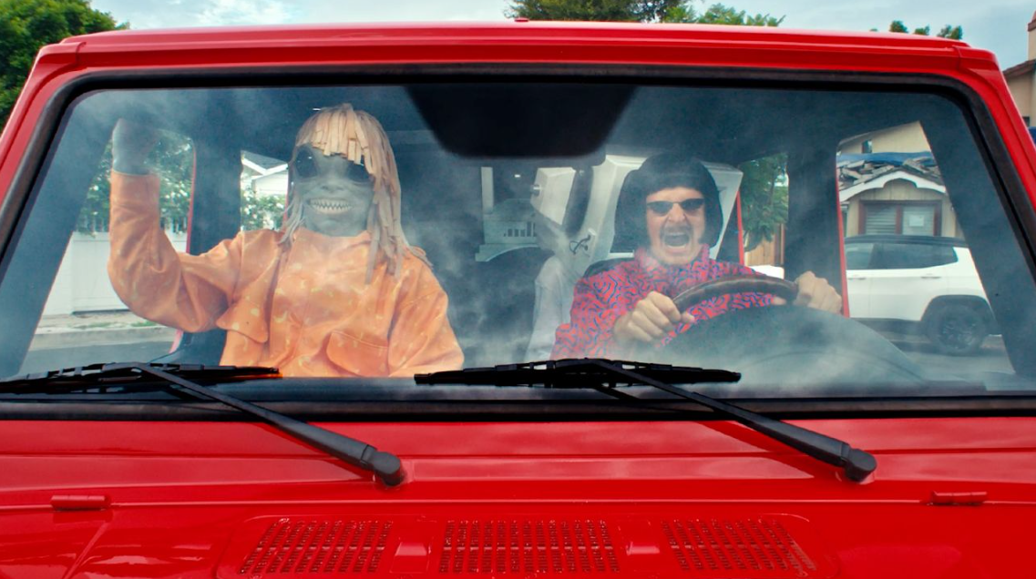
LISTEN | WATCH
“FAIRWEATHER FRIENDS”

PRE-SAVE
ALONE IN A CROWD (ALBUM)

Oliver Tree continues to serve the goods with the release of his latest genre-bending track “Fairweather Friends, ”taken from his highly anticipated forthcoming third studio-album ALONE IN A CROWD, set for release on September 29 via Atlantic Records (Pre-save HERE).

The semi-autobiographical single comes with an official music video, also revealed today, and directed by the multi-talented Oliver Tree himself. Watch the official music video for “Fairweather Friends” HERE

Earlier this summer, Oliver Tree headlined a SOLD-OUT show at Denver’s iconic Red Rocks Amphitheatre and will be embarking on major world tour – his biggest headline run thus far – next month. Produced by Live Nation, OLIVER TREE PRESENTS ALONE IN A CROWD gets underway October 10 at Auckland, NZ’s Shed 10 and then travels through November with stops in Australia, France, Luxembourg, the UK, Belgium, the Netherlands, Germany, Switzerland, and Italy. Support includes Sueco (AUS/NZ) and Tommy Cash (EU/UK). General on-sales started today at 10:00 am (local). For complete details, please see https://www.olivertreemusic.com/tour/

Undeniably a one-of-a-kind artist who continues to top the charts and sell out amphitheaters worldwide, Tree satisfies his dedicated and growing audience with his Kaufman-esque Dadaist, “meta-humor” while continuing to explore and dissect the absurdity of modern culture, obsession with fame and social media. His forthcoming album ALONE IN A CROWD serves to reflect both the light and the darkness of human nature within popular culture, while holding a mirror up to us all and embracing the absurdity of it all. Exploring themes of loneliness, disconnect, and the human experience, ALONE IN A CROWD also introduces a new character named Cornelius Cummings, a fashion designer who sets the runway for his latest body of work.

ALONE IN A CROWD is out September 29 – PRE-ORDER/SAVE HERE

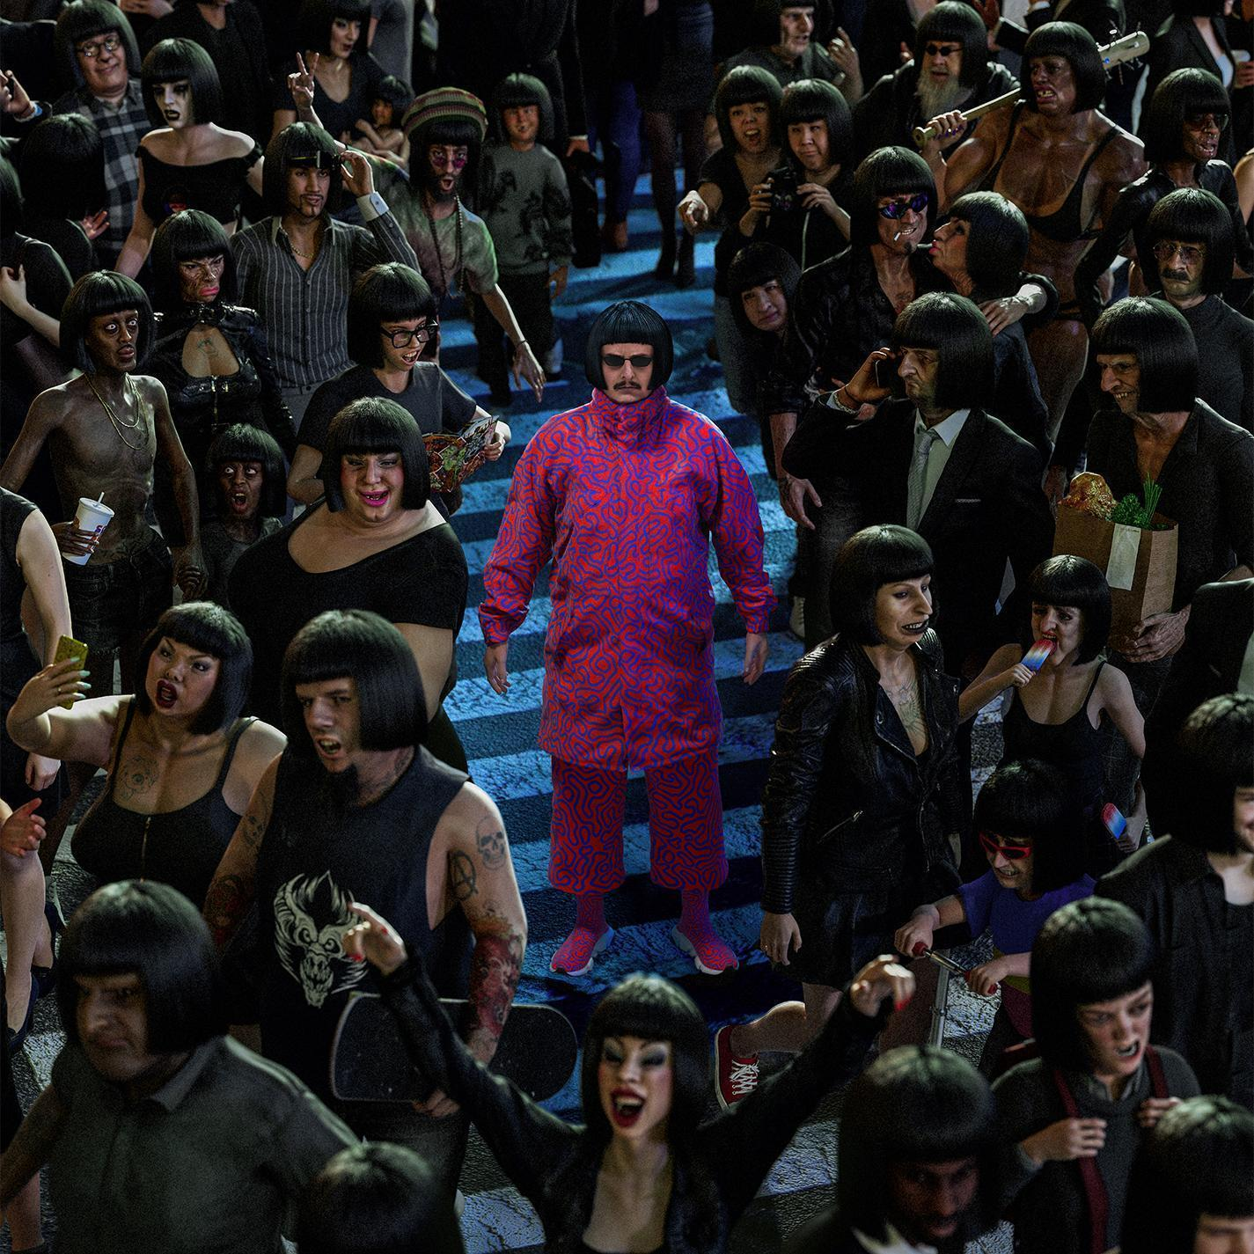

ABOUT OLIVER TREE
Now boasting more than 4 BILLION global streams, over 1 BILLION YouTube views, over 14.7 MILLION TikTok followers, and an cumulative social reach of over 30 MILLION, Oliver Tree has already had a very productive 2023 with releases such as his first-ever collaboration with fellow superstar David Guetta, “Here We Go Again,” [listen HERE]. An official lyric video, written and directed by Oliver, has earned over 13 MILLION views [view HERE]. “Here We Go Again” in turn followed KSI’s “Voices (Feat. Oliver Tree),” joined by an official music video now boasting close to 7 MILLION views [watch HERE]. Last year also saw Oliver join forces with GRAMMY® Award-nominated producer Robin Schulz for the high-energy viral hit, “Miss You,” which swiftly amassed over 300 MILLION global streams following top 10 debuts on both Billboard’s “Hot Dance/Electronic Songs” chart and the UK’s Official Singles Chart. Recently certified 2x Platinum in Australia as well as Platinum in both the UK and Canada, the track is accompanied by a typically quirky official music video, directed by Oliver and currently boasting more than 190 MILLION views via YouTube HERE.

Oliver wrapped up his very busy 2022 with the long awaited release of Cowboy Tears Drown the World in a Swimming Pool of Sorrow, an expanded deluxe edition of his acclaimed sophomore LP, Cowboy Tears, available now HERE. Highlights include such favorites as “I Hate You,” “Placeholder,” and “Suitcase Full Of Cash,” the latter accompanied by an official visual featuring guest appearances from viral stars Alissa Violet, Tana Mongeau, Viking Barbie, and Melissa Ong, streaming now at Oliver’s YouTube channel HERE.

OLIVER TREE PRESENTS: ALONE IN A CROWD - TOUR DATES
OCTOBER
10 – Auckland, NZ – Shed 10
11 – Wellington, NZ – Michael Fowler Centre
13 – Brisbane, AUS – Fortitude Music Hall
14 – Sydney, AUS – Hordern Pavilion
15 – Wollongong, AUS – Yours and Owls Festival *
18 – Melbourne, AUS – Festival Hall
20 – Adelaide, AUS – Hindley Street Music Hall
21 – Perth, AUS – Metro City

NOVEMBER
1 – Paris, France – L’Olympia
2 – Esch-sur-Alzette, Luxembourg – Rockhal
4 – Birmingham, UK – O2 Academy Birmingham
5 – Glasgow, UK – O2 Academy Glasgow
7 – Leeds, UK – O2 Academy Leeds
8 – Manchester, UK – O2 Apollo Manchester
9 – London, UK – Troxy
11 – Brussels, Belgium – Ancienne Belgique
14 – Tilburg, Netherlands – 013 Poppodium
16 – Munich, Germany – TonHalle München
17 – Cologne, Germany – E–Werk
19 – Berlin, Germany – Columbiahalle
20 – Zurich, Switzerland – Halle 622
21 – Milan, Italy – Fabrique
* FESTIVAL PERFORMANCE
10/10-10/21 w/ Sueco
11/1-11/21 w/ Tommy Cash

WEBSITE | FACEBOOK | INSTAGRAM | SPOTIFY | TIK TOK | TWITTER | YOUTUBE

For all media inquiries, please contact:
HIGH RISE PR
Alexandra Baker | Alexandra@highrisepr.com
Jamie Sward | Jamie@highrisepr.com
ATLANTIC RECORDS
JESSICA NALL // JESSICA.NALL@ATLANTICRECORDS.COM

