FOR IMMEDIATE RELEASE

MARCH 21, 2023

**APRIL 4: FANS AROUND THE GLOBE CAN LIVESTREAM “BRELAND & FRIENDS” VIA MANDOLIN WITH TICKETS ON SALE TODAY**

**SPECIAL GUESTS LECRAE AND TYLER HUBBARD JOIN THE LINEUP FOR THE ONE NIGHT ONLY CONCERT AT RYMAN AUDITORIUM BENEFITTING NASHVILLE’S OASIS CENTER**

**SINGLE “FOR WHAT IT’S WORTH” CLIMBING THE COUNTRY RADIO CHARTS**

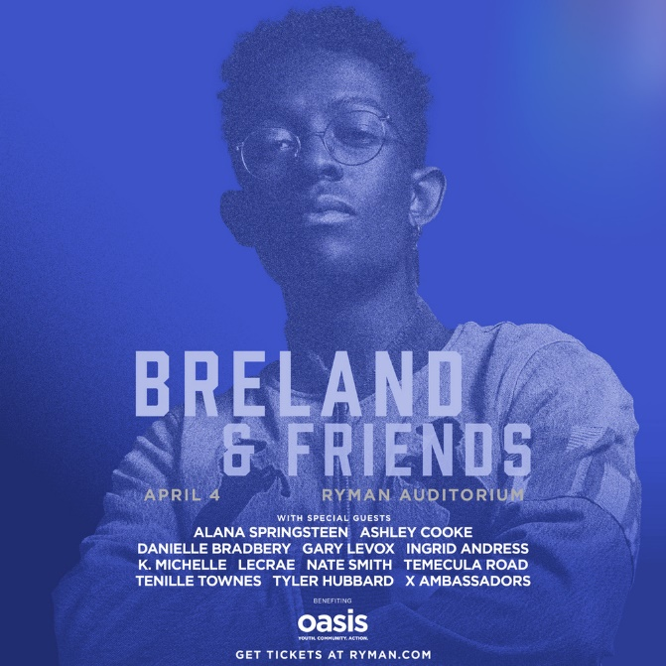

[DOWNLOAD GRAPHIC HERE](https://warnermusicgroup.box.com/s/v9uc78p3zjodxxikeuvelewmpefi7inn)

|  |  |
| --- | --- |
| |  | | --- | | Presented by **Amazon**, the Bad Realm Records/Atlantic Records/Warner Music Nashville PLATINUM artist **BRELAND** is bringing his second annual **“BRELAND & Friends”** concert to fans worldwide via **Mandolin** livestream. Set for **April 4 at Ryman Auditorium**, the one night only event benefits Nashville’s Oasis Center and their mission to aid local at-risk youth.   Teaming up with **Mandolin, Pay What You Want** tickets for the livestream are on sale today (3/21). **Purchase** [**here**](https://t.e2ma.net/click/4k7i9ec/cznzm11/8j1oidm)**.** Tickets for **Ryman Auditorium can be purchased** [**here**](https://t.e2ma.net/click/4k7i9ec/cznzm11/oc2oidm)**.**  **Special guests Lecrae** and **Tyler Hubbard** will join the stacked lineup previously announced: **Alana Springsteen, Ashley Cooke, Danielle Bradbery, Gary Levox, Ingrid Andress, K. Michelle, Nate Smith, Temecula Road, Tenille Townes**, and **X Ambassadors**.   Touring in support of his debut album [***CROSS COUNTRY***](https://t.e2ma.net/click/4k7i9ec/cznzm11/442oidm) featuring chart-rising single “**For What It’s Worth**,” BRELAND recently returned from **C2C Country to Country** festival in London, UK, where [***Holler***](https://t.e2ma.net/click/4k7i9ec/cznzm11/kx3oidm) stated “BRELAND delivered a fun, lively set that renewed the special relationship he enjoys with the UK,” at The 02 Arena. He’ll now join **Walker Hayes’ DUCK BUCK TOUR** and **Shania Twain’s QUEEN OF ME TOUR** this summer, with high-profile festival stops including **Stagecoach Country Music Festival, Gulf Coast Jam, Country Fest**, and **Boots and Hearts Music Festival**. Check out full list of tour dates [here](https://t.e2ma.net/click/4k7i9ec/cznzm11/0p4oidm). | |

|  |  |
| --- | --- |
| |  | | --- | | **CONNECT WITH BRELAND**  [WEBSITE](https://nam04.safelinks.protection.outlook.com/?url=https%3A%2F%2Ft.e2ma.net%2Fclick%2Fo0sh9ec%2Fcznzm11%2Fsrojidm&data=05%7C01%7COlivia.Lee%40atlanticrecords.com%7C11c93b6c5f19492f009b08db299fa3e4%7C8367939002ec4ba1ad3d69da3fdd637e%7C0%7C0%7C638149537869469918%7CUnknown%7CTWFpbGZsb3d8eyJWIjoiMC4wLjAwMDAiLCJQIjoiV2luMzIiLCJBTiI6Ik1haWwiLCJXVCI6Mn0%3D%7C3000%7C%7C%7C&sdata=br48PVb%2F2kBipaXoigOCbR7PNuaDWam4BeW4im8STwg%3D&reserved=0) | [INSTAGRAM](https://nam04.safelinks.protection.outlook.com/?url=https%3A%2F%2Ft.e2ma.net%2Fclick%2Fo0sh9ec%2Fcznzm11%2F8jpjidm&data=05%7C01%7COlivia.Lee%40atlanticrecords.com%7C11c93b6c5f19492f009b08db299fa3e4%7C8367939002ec4ba1ad3d69da3fdd637e%7C0%7C0%7C638149537869469918%7CUnknown%7CTWFpbGZsb3d8eyJWIjoiMC4wLjAwMDAiLCJQIjoiV2luMzIiLCJBTiI6Ik1haWwiLCJXVCI6Mn0%3D%7C3000%7C%7C%7C&sdata=soMTbkij%2FHihEOnCtnlNM7q%2F70Avz%2FexkEzcxETjIdM%3D&reserved=0) | [FACEBOOK](https://nam04.safelinks.protection.outlook.com/?url=https%3A%2F%2Ft.e2ma.net%2Fclick%2Fo0sh9ec%2Fcznzm11%2Focqjidm&data=05%7C01%7COlivia.Lee%40atlanticrecords.com%7C11c93b6c5f19492f009b08db299fa3e4%7C8367939002ec4ba1ad3d69da3fdd637e%7C0%7C0%7C638149537869469918%7CUnknown%7CTWFpbGZsb3d8eyJWIjoiMC4wLjAwMDAiLCJQIjoiV2luMzIiLCJBTiI6Ik1haWwiLCJXVCI6Mn0%3D%7C3000%7C%7C%7C&sdata=KsaAjoFRtdcGP47Gk0IkdoVXfhqWo5901PYFFtEw%2B8o%3D&reserved=0) | [TWITTER](https://nam04.safelinks.protection.outlook.com/?url=https%3A%2F%2Ft.e2ma.net%2Fclick%2Fo0sh9ec%2Fcznzm11%2F44qjidm&data=05%7C01%7COlivia.Lee%40atlanticrecords.com%7C11c93b6c5f19492f009b08db299fa3e4%7C8367939002ec4ba1ad3d69da3fdd637e%7C0%7C0%7C638149537869469918%7CUnknown%7CTWFpbGZsb3d8eyJWIjoiMC4wLjAwMDAiLCJQIjoiV2luMzIiLCJBTiI6Ik1haWwiLCJXVCI6Mn0%3D%7C3000%7C%7C%7C&sdata=arTcn5G3gUaW%2FpsEGp%2FXlVpNwJpoLSbH9nRcXK5zt%2FI%3D&reserved=0)  [AMAZON MUSIC](https://nam04.safelinks.protection.outlook.com/?url=https%3A%2F%2Ft.e2ma.net%2Fclick%2Fo0sh9ec%2Fcznzm11%2Fkxrjidm&data=05%7C01%7COlivia.Lee%40atlanticrecords.com%7C11c93b6c5f19492f009b08db299fa3e4%7C8367939002ec4ba1ad3d69da3fdd637e%7C0%7C0%7C638149537869469918%7CUnknown%7CTWFpbGZsb3d8eyJWIjoiMC4wLjAwMDAiLCJQIjoiV2luMzIiLCJBTiI6Ik1haWwiLCJXVCI6Mn0%3D%7C3000%7C%7C%7C&sdata=WV3JVlIZU24dkbC%2FE3Uxp2sEl5BZS6cviX5vsbZUUsM%3D&reserved=0) | [YOUTUBE](https://nam04.safelinks.protection.outlook.com/?url=https%3A%2F%2Ft.e2ma.net%2Fclick%2Fo0sh9ec%2Fcznzm11%2F0psjidm&data=05%7C01%7COlivia.Lee%40atlanticrecords.com%7C11c93b6c5f19492f009b08db299fa3e4%7C8367939002ec4ba1ad3d69da3fdd637e%7C0%7C0%7C638149537869469918%7CUnknown%7CTWFpbGZsb3d8eyJWIjoiMC4wLjAwMDAiLCJQIjoiV2luMzIiLCJBTiI6Ik1haWwiLCJXVCI6Mn0%3D%7C3000%7C%7C%7C&sdata=1NdfmlsnI9cqcXUCm3afDEE8scZKE1UPC7313z8lFTE%3D&reserved=0) | [SOUNDCLOUD](https://nam04.safelinks.protection.outlook.com/?url=https%3A%2F%2Ft.e2ma.net%2Fclick%2Fo0sh9ec%2Fcznzm11%2Fgitjidm&data=05%7C01%7COlivia.Lee%40atlanticrecords.com%7C11c93b6c5f19492f009b08db299fa3e4%7C8367939002ec4ba1ad3d69da3fdd637e%7C0%7C0%7C638149537869469918%7CUnknown%7CTWFpbGZsb3d8eyJWIjoiMC4wLjAwMDAiLCJQIjoiV2luMzIiLCJBTiI6Ik1haWwiLCJXVCI6Mn0%3D%7C3000%7C%7C%7C&sdata=%2FfQ8%2FntbGhqwJnrvpFWLwU0gaemWFwkdt0lEx8kCXb4%3D&reserved=0) | |

|  |  |  |  |  |
| --- | --- | --- | --- | --- |
| |  |  |  |  | | --- | --- | --- | --- | | **ABOUT BRELAND:** With PLATINUM breakout “My Truck,” singer/songwriter/producer BRELAND has emerged as a bold new force on today’s music landscape. The Amazon Music Breakthrough Spotlight Artist first popped off when the Hip-Hop and Country hybrid hit #1 on Spotify’s Global Viral 50 in 2019, and a remix featuring Sam Hunt landed on best-of-the-year lists from *NPR* to *The New York Times*. Adding to his 1 BILLION+ career streams, BRELAND’s debut album *CROSS COUNTRY* is out now and features current chart-climbing single “For What It’s Worth,” plus “Told You I Could Drink (feat. Lady A),” “Natural,” GOLD-certified “Praise The Lord (feat. Thomas Rhett),” GOLD-certified “Throw It Back (feat. Keith Urban)” and title track (feat. Mickey Guyton). Hailed as the “symbol of Country music’s ongoing evolution” (*Rolling Stone*), the Bad Realm Records/Atlantic Records/Warner Music Nashville artist has scored high-profile looks on ABC’s *Good Morning America*, ABC’s *Jimmy Kimmel Live!,* *CBS Mornings*, CBS’ *New Year’s Eve Live: Nashville’s Big Bash*, *CMT Crossroads*, NBC’s *The Voice*, NBC’s *TODAY*, *The Kelly Clarkson Show,* plus performances on the ACM, CMT, and CMA Awards. BRELAND has a stacked tour schedule with coveted slots on Walker Hayes' DUCK BUCK TOUR, Stagecoach Festival, and Shania Twain’s QUEEN OF ME TOUR.    **ABOUT OASIS CENTER:**  Oasis Center, one of Nashville’s leading youth-serving organizations, provides a wide range of services that reflect the diverse needs of youth and their families. Oasis’ spectrum of support includes: 1) Crisis to Housing services that help youth who are homeless, have run away, or are experiencing familial crises to gain long-term safety, stability and self-sufficiency; and 2) Action, Advocacy, and Education programs comprised of over 10 school-based and out-of-school time programs dedicated to empowering young people to be catalysts for social change and achieve personal and academic success. Oasis Center began in 1969 as a drop-in center for young people in crisis, offering safety and intervention to Nashville’s most vulnerable youth. It now provides hope, healing and support to over 4,000 youth and their families per year. For more information about Oasis Center, please visit [https://oasiscenter.org/.](https://oasiscenter.org/)      [DOWNLOAD HERE](https://www.sweettalkpublicity.com/emmafiles/BRELAND_JIMMY%20FONTAINE.jpg) // CREDIT: JIMMY FONTAINE   |  | | --- | |  | | |  | | --- | | **MEDIA CONTACTS:**  Fairley McCaskill / [**Fairley.McCaskill@atlanticrecords.com**](mailto:Fairley.McCaskill@atlanticrecords.com?subject=%28going%20fast%29%20SECOND%20ANNUAL%20%u201CBRELAND%20%26%20FRIENDS%u201D%20TO%20BENEFIT%20THE%20OASIS%20CENTER%20ON%20SALE%20TODAY%20%282/10%29)  Jensen Sussman / [**jensen@sweettalkpr.com**](mailto:jensen@sweettalkpr.com?subject=%28going%20fast%29%20SECOND%20ANNUAL%20%u201CBRELAND%20%26%20FRIENDS%u201D%20TO%20BENEFIT%20THE%20OASIS%20CENTER%20ON%20SALE%20TODAY%20%282/10%29)  Mary Catherine Rebrovick / [**marycatherine@wmg.com**](mailto:MARYCATHERINE@WMG.COM?subject=%28going%20fast%29%20SECOND%20ANNUAL%20%u201CBRELAND%20%26%20FRIENDS%u201D%20TO%20BENEFIT%20THE%20OASIS%20CENTER%20ON%20SALE%20TODAY%20%282/10%29) | | | |