DUTCH PRODUCER/DJ BAKERMAT FLIPS
PORTUGAL. THE MAN’S
“SUMMER OF LUV (FEAT. UNKNOWN MORTAL ORCHESTRA)”

DOWNLOAD/STREAM HERE

ORIGINAL VERSION CURRENTLY TOP 20 + RISING AT ALT RADIO
LISTEN TO “SUMMER OF LUV”

LISTEN TO PORTUGAL. THE MAN’S NEW ALBUM CHRIS BLACK CHANGED MY LIFE HERE

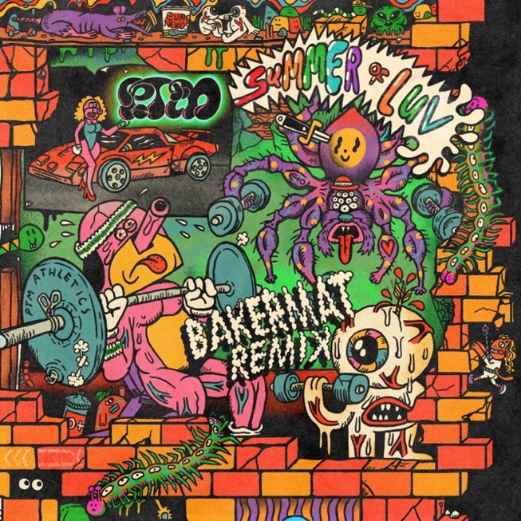
DOWNLOAD REMIX ARTWORK HERE

“I was thrilled to remix this already great tune into something more dancy and to put my signature sound on it. The style was already right up my alley, so it felt really natural creating my own version of it. The result is now here and I’m really proud! It’s a feel-good, fun, and positive tune to lift your mood.”
– Bakermat

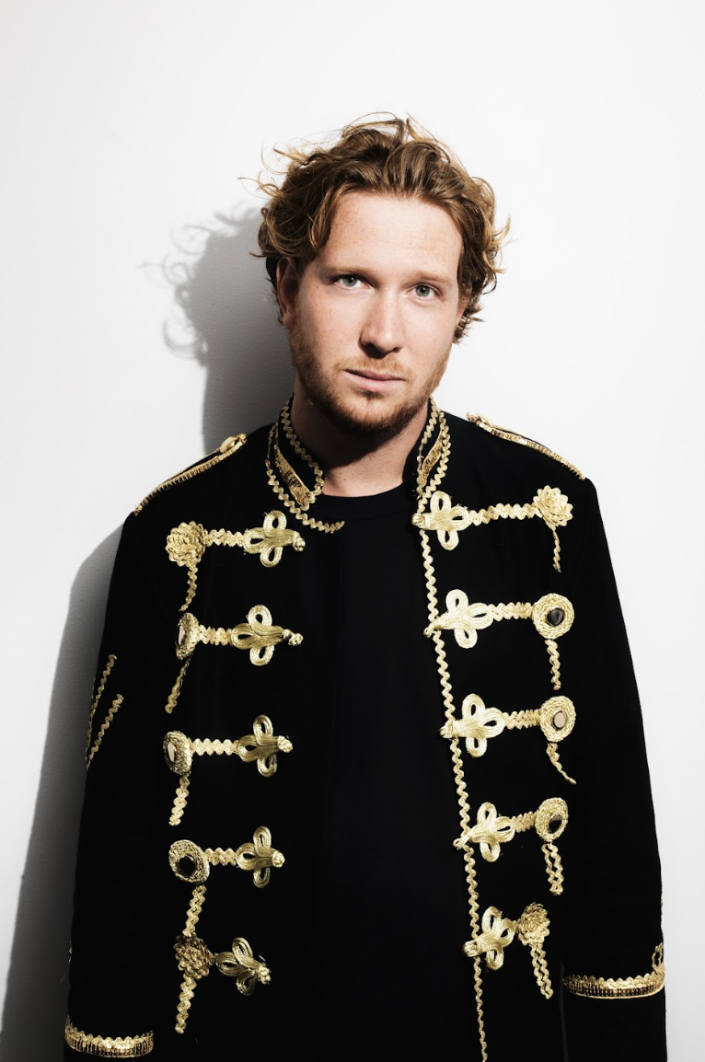
Download Bakermat Press Photo HERE

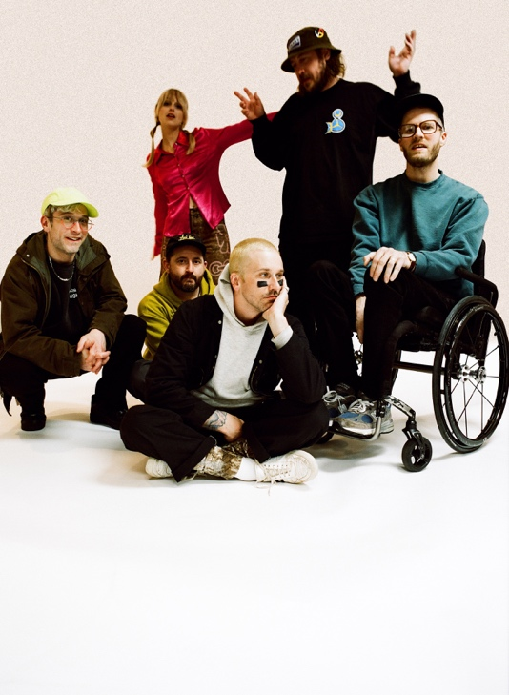
Download PTM Press Photo HERE | Credit: Maclay Heriot

CHRIS BLACK CHANGED MY LIFE TRACKLIST:
Heavy Games II (feat. Jeff Bhasker)
Grim Generation
Thunderdome [W.T.A] (feat. Black Thought & Natalia Lafourcade)
Dummy
Summer of Luv (feat. Unknown Mortal Orchestra)
Ghost Town
Time’s a Fantasy (feat. Jeff Bhasker)
Doubt
Plastic Island
Champ (feat. Edgar Winter)
Anxiety:Clarity (feat. Paul Williams)

UPCOMING PORTUGAL. THE MAN LIVE SHOWS
10/6 – Austin, TX @ Austin City Limits
10/7 – Dallas, TX @ Granada Theater
10/8 – Dallas, TX @ Granada Theater
10/13 – Austin, TX @ Austin City Limits
11/6 – Vancouver, BC – Orpheum
11/8 – Calgary, AB – Grey Eagle
11/9 – Edmonton, AB – Edmonton Convention Centre
11/11 – Winnipeg, MB – Burton Cummings Theatre
11/14 – London, ON – London Music Hall
11/15 – Toronto, ON – HISTORY
11/16 – Toronto, ON – HISTORY
11/18 – Ottawa, ON – Ey Centre
11/19 – Montreal, QC – MTELUS

DOWNLOAD ALL PRESS ASSETS

PRESS CONTACTS:
Jason Davis | Jason.Davis@atlanticrecords.com
Libby Kober | Libby.Kober@atlanticrecords.com

ABOUT PORTUGAL. THE MAN:
Over the past decade, Portugal. The Man has established themselves as one of rock’s most prized possessions and a live phenomenon, with over 1,600 shows under their belts and a storied reputation as festival favorites.

Originally heralding from Alaska, the Portland-based band soared to new heights in 2017 with the release of their now RIAA certified-Platinum album, Woodstock. The album was marked by the astounding success of their infectious single, “Feel It Still,” which earned the group a plethora of new accolades – including a GRAMMY for “Best Pop Duo/Group Performance,” a 7x RIAA Platinum certification, a record setting 20-week residency at #1 on alternative radio, and an inescapable presence on the Top 40 airwaves.

Alongside the shine of their myriad of musical accomplishments lies the group’s long-standing passion for social justice. In fact, this is precisely the intersection in which Portugal. The Man thrives; throughout their career, the band has consistently exemplified how to deeply commit to both artistry and activism. This ultimately inspired them to officially launch PTM Foundation in 2020, focused on universal issues related to human rights, community health, and the environment, with an emphasis on causes directly impacting Indigenous Peoples, including Alaska Native Health (providing the highest quality of health services for Alaska Native people) and Seeding Sovereignty (radicalizing and disrupting colonized spaces through land, body, food sovereignty work and more).

Portugal. The Man have also partnered with an array of organizations such as National Coalition Against Censorship, The Skatepark Project (helping communities build public skate parks for youth in underserved communities), March for Our Lives (Gun Reform), Keep Oregon Well (Mental Health), and Protect Our Winters (Climate Change), to name just a few. In 2022, the band furthered their passion for activism when they launched PTM’s NIGHT OUT initiative – supporting disabled fans requiring ADA access.

ABOUT CHRIS BLACK CHANGED MY LIFE:
We lost a very dear friend of ours on May 19, 2019. It shook us to our core. Chris was one of those people who was like glue; he brought everyone together. His passing really messed with us. The band was in shambles and this record is the first time I feel I made a complete record; a complete thought about our world crumbling around us and the journey back. While it is a very personal journey, I feel like everyone has a Chris Black in their life; at least I hope that everyone has a Chris Black in their life. That one friend who has a way of making everything right and making everything fun. The one who keeps you in check when you go off course and is always there to celebrate the good times and to support you in the bad times. Chris Black Changed My Life.

ABOUT BAKERMAT:
ORIGINAL – that is the word that would best describe Bakermat’s music. The Dutch producer and DJ has been selling out shows and releasing platinum hits for audiences globally for over a decade. By combining influences and genres that normally wouldn’t be combined, the Dutchman never fails to surprise his fans and colleagues. Although his productions are diverse, there is always an element that binds them together: Bakermat’s signature FeelGood sound.

# # #

