FOR IMMEDIATE RELEASE
SEPTEMBER 1, 2023

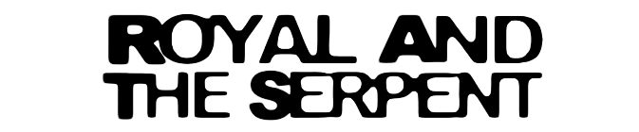

ROYAL & THE SERPENT CONTINUES RAT TRAP SAGA WITH
RAT TRAP 4: the burden

LATEST INSTALLMENT IN MONTHLY SERIES OF NEW EPS

“SEPARATION ANXIETY” JOINED BY OFFICIAL MUSIC VIDEO – WATCH HERE

FIRST-EVER NORTH AMERICAN HEADLINE TOUR KICKS OFF OCTOBER 14 IN PHOENIX, AZ

LISTEN TO RAT TRAP 4: the burden HERE

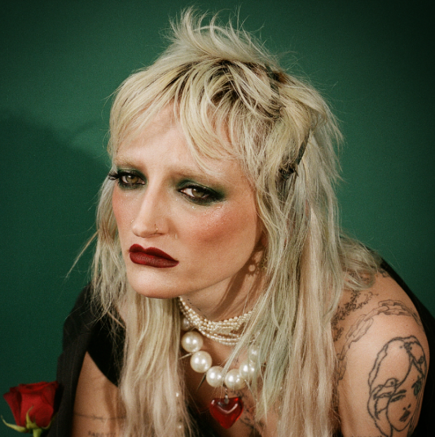
DOWNLOAD HI-RES ARTWORK

RIAA Gold-certified singer-songwriter Royal & the Serpent continues her RAT TRAP saga with her latest project, RAT TRAP 4: the burden – Listen HERE. The 4th installment in her monthly series of new songs, today’s release includes “u ruined frank ocean for me,” “separation anxiety,” and “oops.” “separation anxiety” is accompanied by an official music video (Watch HERE) while “u ruined frank ocean for me” and “oops” are joined by official visualizers – Watch HERE.

RAT TRAP 4 exists in a soft sonic palette with themes scoping many different facets of love. Unrequited, anxious, and avoidant - each song tells a tale from Royal’s personal experience with romance. On “separation anxiety,” we get a taste of self-sabotage, along with a graceful air of acceptance and apology. "u ruined frank ocean 4 me" is a relatable track about an ex spoiling your favorite artist, while "oops" tells a story of regrettable intimacy in a light-hearted and quirky form.
Having recently earned applause supporting artists such as Demi Lovato and Fall Out Boy, Royal & the Serpent will celebrate the RAT TRAP saga and much more on her first-ever North American headline tour. The dates begin October 14 at Phoenix, AZ’s Crescent Ballroom and then continue through a November 18 tour finale at Los Angeles, CA’s The Roxy. Highlights include stops at Nashville, TN’s Exit/In (October 21), Brooklyn, NY’s Music Hall of Williamsburg (October 30), and Denver, CO’s Bluebird Theater (November 10). For full details and ticket information, please see www.royalandtheserpent.com/tour.

ROYAL & THE SERPENT
TOUR 2023

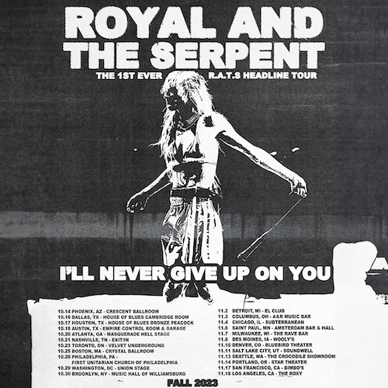

OCTOBER
14 – Phoenix, AZ – Crescent Ballroom
16 – Dallas, TX – House of Blues Dallas Cambridge Room
17 – Houston, TX – House of Blues Bronze Peacock
18 – Austin, TX – Empire Control Room & Garage
20 – Atlanta, GA – Masquerade Hell Stage
21 – Nashville, TN – Exit/In
23 – Toronto, ON – Velvet Underground
25 – Boston, MA – Crystal Ballroom
26 – Philadelphia, PA – First Unitarian Church of Philadelphia
29 – Washington, DC – Union Stage
30 – Brooklyn, NY – Music Hall of Williamsburg

NOVEMBER
2 – Detroit, MI – EL Club
3 – Columbus, OH – A&R Music Bar
4 – Chicago, IL – Subterranean
6 – Saint Paul, MN – Amsterdam Bar & Hall
7 – Milwaukee, WI – The Rave Bar
8 – Des Moines, IA – Wooly’s
10 – Denver, CO – Bluebird Theater
11 – Salt Lake City, UT – Soundwell
13 – Seattle, WA – The Crocodile – Showroom
14 – Portland, OR – Star Theatre
17 – San Francisco, CA – Bimbo’s
18 – Los Angeles, CA – The Roxy

# # #

Royal introduced the “royalverse” this spring with the premiere of the saga’s first chapter, RAT TRAP I: the blueprint, featuring “Astroturf“ and the powerfully inspiring LGBTQ+ anthem, “One Nation Underdogs.” RAT TRAP 2: the burn followed in June, and RAT TRAP 3: the band-aid arrived next. “The third installment is as catchy as ever,” declared Alternative Press, “with both new cuts proving that Royal has a knack for transitioning from delicate verses to booming choruses.”

ABOUT ROYAL & THE SERPENT
Royal & the Serpent is an artist entirely unafraid to bare the deepest and darkest parts of her psyche. After making her Atlantic Records debut with the 2020 EP, get a grip – highlighted by the RIAA Gold-certified single “Overwhelmed,” which captured the chaos of sensory overload and spent 22 weeks on Billboard’s “Alternative Airplay” chart – the L.A.-based singer-songwriter revealed even more of her frenetic inner world in 2022 with IF I DIED WOULD ANYONE CARE and Happiness Is An Inside Job. This Spring she released RAT TRAP I: the blueprint, kicking off a series of double-sided singles released every month. RAT TRAP 2: the burn followed in June and RAT TRAP 3: the band-aid in July, with more to come. Her unfiltered songwriting has proved wildly resonant to her ever-growing fanbase – and led to such triumphs as touring with Demi Lovato, grandson, PVRIS, and Fall Out Boy.

Originally from New Jersey, Royal started in dance and theatre, and first took up guitar at age 14, then relocated to L.A. at age 18. While working as a bartender, Royal soon started self-releasing her music, beginning with her spellbinding 2017 single “Temperance.” Thanks to the buzz behind songs like 2019’s “Weddings & Funerals” and “Salvador Dali” – as well as her electrifying live show – she eventually inked a deal with Atlantic and released “Overwhelmed” in the early days of Covid lockdown.

Over the past few years, Royal has built a close-knit community of fans undeniably drawn to her one-of-a-kind balance of intense sensitivity and unruly self-possession. “The main reason I make music is that it’s the best therapy I could ever ask for: the process of taking everything in my brain and putting it on paper and then singing it out loud for people is so helpful and healing for me. The idea that my own expression can affect people in positive ways is such a blessing and a gift; I don’t ever take it lightly. I just want to keep telling my truth and reach as many people as I possibly can, and see where this little journey takes us.”

# # #

CONNECT WITH ROYAL & THE SERPENT:
OFFICIAL | FACEBOOK | INSTAGRAM | TWITTER | YOUTUBE

PRESS CONTACTS:
Corey Brewer / Corey.Brewer@atlanticrecords.com
Jessica Nall / Jessica.Nall@atlanticrecords.com
Gabby Reese / Gabrielle.Reese@atlanticrecords.com

