FOR IMMEDIATE RELEASE
SEPTEMBER 22, 2023

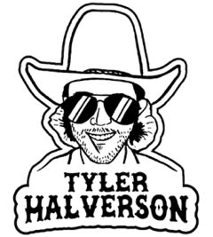

TYLER HALVERSON SHARES “YELLA ROSE”

ACCLAIMED SOUTH DAKOTA TROUBADOUR DROPS LATEST SINGLE

NON-STOP LIVE SCHEDULE INCLUDES HEADLINE TOUR,
CO-HEADLINE RUN WITH KYLIE FREY, FESTIVAL APPEARANCES,
AND SHOWS SUPPORTING THE PANHANDLERS

LISTEN TO “YELLA ROSE” | WATCH OFFICIAL MUSIC VIDEO

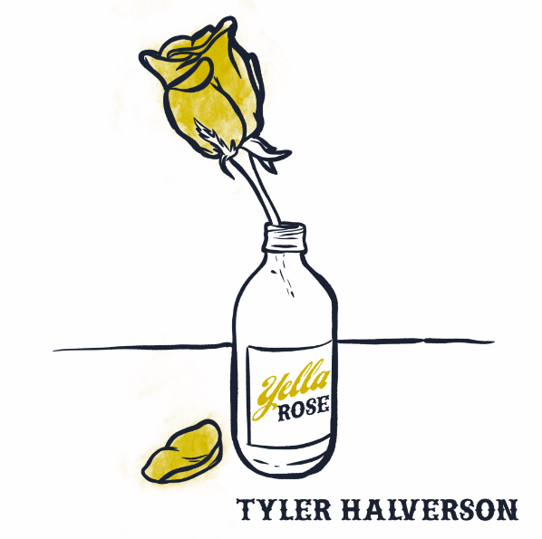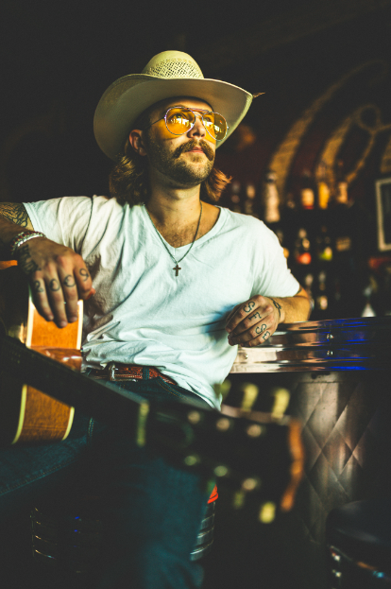
DOWNLOAD HI-RES IMAGES // PRESS PHOTO CREDIT: WILL SMITH

“Tyler Halverson is a new kid on the block but is not coming to mess around.” – WHISKEY RIFF

“Tyler Halverson is the real deal.” – COUNTRY SWAG

South Dakota troubadour Tyler Halverson has shared his latest single, “Yella Rose,” available everywhere now via Atlantic Records. An official music video, directed by filmmaker Wales Toney, premieres today at YouTube – Watch HERE.

"A couple years ago, my friend Nate Fredrick and I sat down to write us a stubborn love song: one about a Dallas darlin who likes new love, and not the kind that ages,” said Halverson. “It’s about someone who can’t make up their mind about you, when yours has been done made up.”

“Yella Rose” continues what is proving a milestone year for Halverson, highlighted by a seemingly unstoppable run of new music that includes such recent singles as “As They Did,” “Her,’ “Cut You Loose,” and the boisterous “Run Wild,” all joined by official music videos streaming HERE.

Halverson recently hit the road on his biggest headline run to date. The Run Wild Tour travels the US through mid-November. Tickets for all dates are on sale now. In addition, Halverson will make a series of select festival appearances and join forces with fellow singer-songwriter – and duet partner on last year’s acclaimed single, “Your Bar Now” – Kylie Frey for the co-headline Your Bar Now Tour, beginning October 6 at Rowdy’s in Spring, TX. Halverson is represented by legendary Nashville manager Erv Woolsey (George Strait, LeeAnn Womack) and Allen Mitchell of The Erv Woolsey Company.

Born and raised in the tiny town of Canton, SD (pop. 3054), Tyler Halverson isn’t just any cowboy. He’s got the hat and the boots, but he also plays a mean guitar and writes an even meaner tune. He has no problem bouncing around the country chasing adventure (or a girl), and is telling his different kind of cowboy tale with his self-described “Western Amerijuana Music,” bridging honest storytelling with songcraft inspired by country powerhouses Garth Brooks, George Strait, and Hayes Carll as much as Boyz II Men, Taking Back Sunday, and The Used.

Halverson fell in thrall to music at an early age, receiving his first guitar while in middle school. A local bluegrass festival convinced him to focus on music, throwing down at 4H and FFA festivals before heading to Nashville to attend the prestigious Belmont University. Upon graduation, he decided to hit the road and spent an extended run traveling around South Dakota, Montana, and Wyoming, all the while writing and playing his songs on social media. Halverson’s original approach caught fire with a string of independent releases including “Beer Garden Baby,” “Mac Miller,” and “Your Bar Now” (with Kylie Frey), amassing tens of millions of streams. Now, with The Run Wild Tour and more new music still to come, Tyler Halverson is eager to take the next step on what has already proven an amazing journey.

“I’m finding myself,” says Tyler Halverson. “I feel like I’m an artist and I’m finally about to do something.”

# # #

TYLER HALVERSON
ON TOUR 2023

SEPTEMBER
22 – Oklahoma City, OK – Diamond Ballroom †
23 – El Dorado, KS – City of Gold Fest 2023
28 – Omaha, NE – Slowdown †
29 – Manhattan, KS – The Hat †
30 – Canadian, TX – Calf Fry Festival

OCTOBER
6 – Spring, TX – Rowdy’s ^
7 – New Braunfels, TX – Gruene Hall ^
8 – Ennis, TX – Stars Over Texas Music Festival 2023
12 – Denver, CO – Mercury Café ^
13 – Colorado Springs, CO – Boot Barn Hall ^
14 – Cheyenne, WY – Outlaw Saloon ^
15 – Greeley, CO – Moxi Theater ^
18 – Des Moines, IA – xBk Live †
19 – Chicago, IL – Carol’s Pub †
20 – Columbus, OH – A&R Music Bar †
26 – Lawrence, KS – The Bottleneck †
27 – Broken Bow, OK – Hochatown Saloon †
28 – Wichita, KS – The Wave †

NOVEMBER
2 – Athens, GA – 40 Watt Club †
4 – Charlotte, NC – The Evening Muse †
10 – Queens, NY – Gottscheer Hall †
15 – Decatur, GA – Eddie’s Attic †
16 – Oxford, MS – Proud Larry’s †
18 – Birmingham, AL – Zydeco †

JANUARY 2024
10 – Steamboat Springs, CO – Strings Music Festival #
11 – Denver, CO – Grizzly Rose #
12 – Wichita, KS – The Cotillion #
14 – Midland, TX - Wagner Noël Performing Arts Center #
17 – College Station, TX – Hurricane Harrys #
18 – Houston, TX – House of Blues Houston #
19 – Dallas, TX – House of Blues Dallas #

† The Run Wild Tour
^ Your Bar Now Tour w/ Kylie Frey
# w/ The Panhandlers

# # #

CONNECT WITH TYLER HALVERSON
OFFICIAL | FACEBOOK| INSTAGRAM | TIKTOK | TWITTER | YOUTUBE

PRESS CONTACT
Jessica Nall // Jessica.Nall@atlanticrecords.com

