FOR IMMEDIATE RELEASE
SEPTEMBER 15, 2023

BRELAND GOES THE DISTANCE WITH RELEASING
CROSS COUNTRY: THE EXTRA MILE

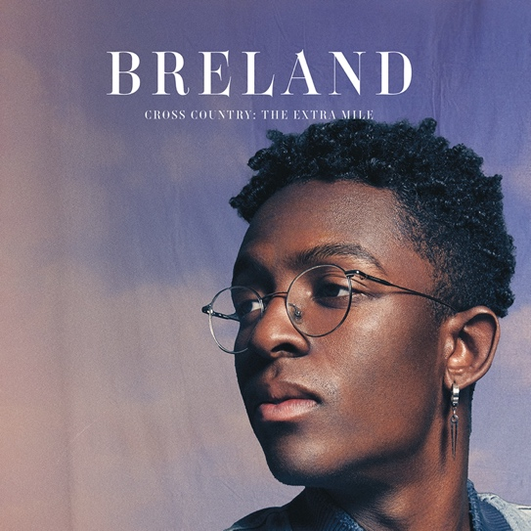
DOWNLOAD HI-RES ARTWORK HERE
Photo Credit: Jimmy Fontaine
Artwork: Nada Taha

EXPANDED VERSION OF HIS WIDELY PRAISED DEBUT FEATURES SIX NEW TRACKS

RAVE REVIEWS OF INTERNATIONAL THE EXTRA MILE TOUR STACKING UP, RE-JOINS SHANIA TWAIN FOR THE UK LEG OF QUEEN OF ME TOUR

STREAM OR DOWNLOAD BRELAND’S CROSS COUNTRY: THE EXTRA MILE HERE

LOS ANGELES, CA. (September 15, 2023) – Celebrating a year of success since his widely praised debut album, BRELAND is taking his “…calling card as a keen, visionary solo artist” (Billboard) to new heights with an expanded version - CROSS COUNTRY: THE EXTRA MILE (Bad Realm Records/Atlantic Records/Warner Music Nashville) available across all streaming platforms and digital providers today (9/15).

The complete set brings six fresh tracks to the original project that proves why BRELAND has been dubbed the “king of collabs” by Associated Press, unveiling a brand-new feature with Brittney Spencer “Guilty Pleasure,” plus Ingrid Andress, Mickey Guyton, Thomas Rhett and Keith Urban. The bonus version also includes fan-favorite “Cowboy Don’t.” Living up to his moniker as the “Pen Point Guard,” BRELAND’s pen name is on every song alongside an impressive list of some of the most in-demand songwriters including Ashley Gorley, HARDY, Sam Hunt, Caitlyn Smith, ERNEST, Sasha Sloan, Ryan Hurd and more.

CROSS COUNTRY: THE EXTRA MILE
DISC 1
1. “Cowboy Don’t”
2. “Thirsty”
3. “Anniversary”
4. “Cracks”
5. “Guilty Pleasure (feat. Brittney Spencer)”
6. “The Extra Mile”
DISC 2
1. “Here For It (feat. Ingrid Andress)”
2. “County Line”
3. “Praise The Lord (feat. Thomas Rhett)”
4. “Natural”
5. “Told You I Could Drink (feat. Lady A)”
6. “For What It’s Worth”
7. “Happy Song”
8. “Growing Pains”
9. “Throw It Back (feat. Keith Urban)”
10. “Thick”
11. “Cross Country (feat. Mickey Guyton)”
12. “Good For You”
13. “Don’t Look At Me”
14. “Alone At The Ranch”
15. “My Truck”
16. “Cross Country”
17. “For What It’s Worth (feat. Alana Springsteen)”
18. “My Truck (feat. Sam Hunt)”

Hot on the heels of his international headlining debut THE EXTRA MILE TOUR across U.K., Germany, Netherlands, Denmark, Sweden, and Norway, BRELAND has joined back up with Shania Twain for the U.K. leg of her QUEEN OF ME TOUR. With dates continuing through the end of the month, BRELAND will bring his “as close to perfection as you can get” (Building Our Own Nashville) set to three nights in Glasgow, plus back-to-back nights in Dublin and London. For BRELAND’s tour
details and ticket information visit here.
Recently, BRELAND was honored with the ACM Lift Every Voice Award, recognizing his role in “elevating underrepresented voices throughout the Country music genre, transcending demographics and geography,” and fans can catch him and Keith Urban performing their GOLD-certified hit “Throw It Back” on the 16th annual Academy of Country Music Honors, airing this Monday (9/18) from 8 p.m. to 10 p.m. ET/PT on FOX.

ABOUT BRELAND:
With PLATINUM breakout “My Truck,” singer/songwriter/producer BRELAND has emerged as a bold new force on today’s music landscape. The ACM Lift Every Voice Award recipient first popped off when the Hip-Hop and Country hybrid hit #1 on Spotify’s Global Viral 50 (2019), and a remix featuring Sam Hunt landed on best-of-the-year lists from NPR to The New York Times. Praised by HITS for “building bridges” across genres while racking up 1.1 BILLION+ career streams, BRELAND is cementing his impact with the release of the expanded version of his widely praised debut CROSS COUNTRY: THE EXTRA MILE (Bad Realm Records/Atlantic Records/Warner Music Nashville). This new edition features six fresh tracks including “Cowboy Don’t” and “Guilty Pleasure (feat. Brittney Spencer),” alongside GOLD-certified hits “Praise The Lord (feat. Thomas Rhett)” and “Throw It Back (feat. Keith Urban).” Hailed as the “symbol of Country music’s ongoing evolution” (Rolling Stone), BRELAND has scored high-profile looks on ABC’s Good Morning America, ABC’s Jimmy Kimmel Live!, CBS Mornings, CBS’ New Year’s Eve Live: Nashville’s Big Bash, CMT Crossroads, NBC’s The Voice, NBC’s TODAY, The Kelly Clarkson Show, plus performances on the ACM, CMT, and CMA Awards. Hot on the heels of his international headlining debut THE EXTRA MILE TOUR across U.K., Germany, Netherlands, Denmark, Sweden, and Norway, BRELAND has joined back up with Shania Twain for the U.K. leg of her QUEEN OF ME TOUR through the end of the month.

# # #
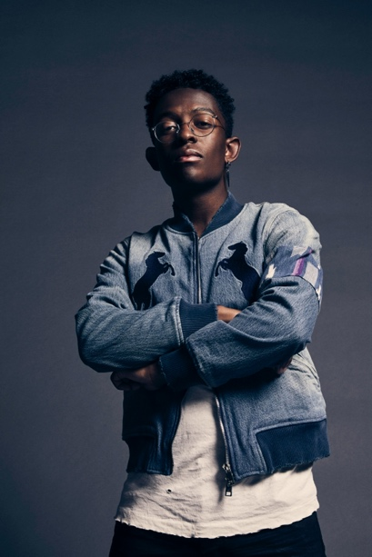
DOWNLOAD HI-RES PRESS IMAGE HERE
Credit: Jimmy Fontaine

CONNECT WITH BRELAND
WEBSITE | INSTAGRAM | FACEBOOK | TWITTER
AMAZON MUSIC | YOUTUBE | SOUNDCLOUD

MEDIA CONTACTS

Fairley McCaskill / Fairley.McCaskill@atlanticrecords.com
Jensen Sussman / Jensen@sweettalkpr.com
Kristi Bradshaw / Kristi.Bradshaw@wmg.com

