FOR IMMEDIATE RELEASE
SEPTEMBER 22, 2023

RISING R&B STAR RAICHE PUTS A STRIPPED-DOWN SPIN ON SEDUCTIVE TRACK
“BIG DADDY” WITH NEW ACOUSTIC VERSION

“BIG DADDY – ACOUSTIC VERSION” AVAILABLE NOW VIA
GDE/ISLAND PROLIFIC/ATLANTIC RECORDS

LISTEN TO “BIG DADDY – ACOUSTIC VERSION” HERE | WATCH ACOUSTIC VISUALIZER HERE

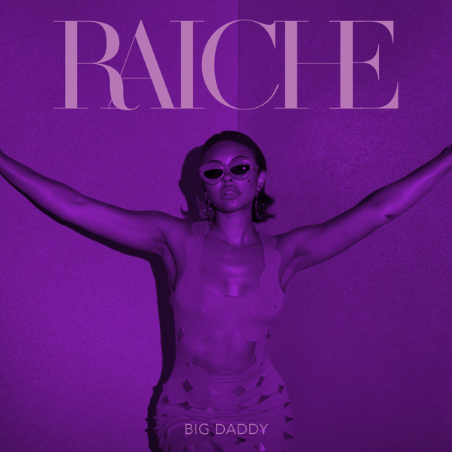
CREDIT: Brittany "BJ" Houston-Johnson
DOWNLOAD HI-RES ARTWORK

Rising R&B vocalist Raiche has released an acoustic version of her popular new single “Big Daddy,” filled with rich vocals and seduction. “Big Daddy – Acoustic Version,” available now via GDE/Island Prolific/Atlantic Records HERE and watch the visualizer HERE. Listen to the original “Big Daddy” HERE and watch original visualizer HERE.

This acoustic rendition drops the instrumentals to highlight Raiche’s incredible lyricism, in addition to her sultry vocals. Raiche describes “Big Daddy” as “intentionally sexy and sensual…yet still very classy."

“I’m looking for a ‘BIG DADDY’ who has what it takes. ‘Big Daddy’ is one of one—it feels good and it's authentically me,” Raiche explains. “I had apprehensions about the term ‘Big Daddy’, but I redefined it, and it describes what I am looking for in a future partner. A real man who treats me well. Just that simple.”

Following her recent live performance at Atlanta’s Funk Fest, “Big Daddy” marked the first new music of 2023 from Raiche following a spectacular series of 2022 releases including “Fool,” “Feelings,” “New York New York,” and “I Hate Christmas,” all of which are accompanied by official music videos streaming now at YouTube HERE.

Named one of Billboard’s “15 Hip-Hop & R&B Artists to Watch in 2021” as well as an ESSENCE “Rising Star,” YouTube “Artist on the Rise,” and iHeartRadio “On The Verge Artist,” Raiche has quickly proven to be a creative sensation and breath of fresh air in contemporary R&B. The gifted young artist fuses soulful roots with modern pop to concoct a genuinely distinctive new sound all her own, lit up with confidence, consistency and positivity. Born and raised in Pittsfield, MA, just two hours outside of Boston, Raiche devoted her energies towards music from an early age, uploading cover videos to YouTube that almost immediately earned her online applause. Her musical dreams almost came to a halt following high school graduation but some encouraging words from her beloved Nana eventually led her to Boston, where she met and began being mentored by DJ Knock Out. The local legend soon introduced Raiche to her GDE production team as well as to superstar songwriter Prince Charlez (Rihanna, Beyoncé, Usher), who promptly signed the talented vocalist to his recently launched Island Prolific imprint at Atlantic Records.

Now boasting over 20M worldwide streams across her growing body of work, Raiche made her national debut with 2018’s “Money Pies,” streaming HERE; a colorful official video – directed by the all-female Verluxe collective – can be viewed HERE. Raiche’s acclaimed debut EP, DRIVE, followed the next year, highlighted by the powerful title track, “Drive,” featured in Netflix’s Self Made: Inspired by the Life of Madam C.J. Walker. The EP’s “Complicated” also proved a true fan favorite, now with more than 3.2 worldwide streams and over 900K views via the MA-based singer’s official YouTube channel HERE.

2020 saw Raiche’s star ascend with “Pick A Side,” which reached #2 at R&B radio outlets nationwide while earning more than 5M worldwide streams. The track is joined by an official music video (streaming HERE) as well as a melodic remix featuring 2x GRAMMY® Award-nominated R&B icon Ty Dolla $ign, available HERE. Raiche further celebrated “Pick A Side” with a spectacular live performance on NBCUniveral’s nationally syndicated Kelly Clarkson Show, streaming HERE.

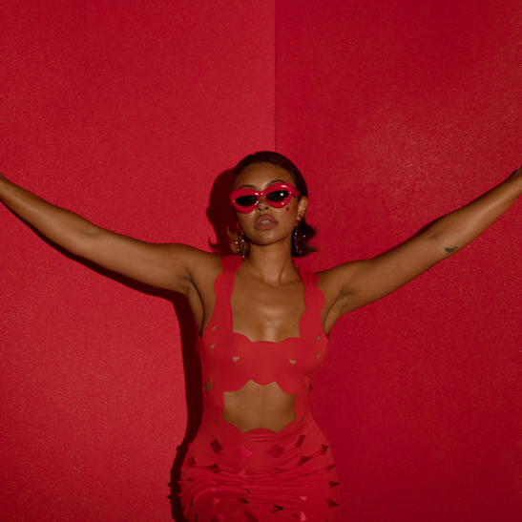
CREDIT: Brittany "BJ" Houston-Johnson
DOWNLOAD HI-RES PRESS PHOTO HERE

CONNECT WITH RAICHE
MYNAMEISRAICHE.COM | FACEBOOK | INSTAGRAM | TWITTER | YOUTUBE
FOR PRESS INQUIRIES CONTACT:
FAIRLEY.MCCASKILL@ATLANTICRECORDS.COM

