FOR IMMEDIATE RELEASE
SEPTEMBER 29, 2023

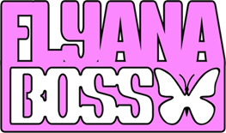

RISING CUTE-GIRL RAP DUO FLYANA BOSS DROPS “BIG ONE”

NEW SINGLE MARKS SECOND RELEASE THIS WEEK
FOLLOWING THEIR SEPTEMBER 26 RELEASE “BITCH IMMA STAR”

SPECIAL GUEST RUN ON JANELLE MONÁE’S THE AGE OF PLEASURE TOUR
CONTINUES INTO OCTOBER

“BIG ONE” AVAILABLE EVERYWHERE NOW VIA VNCLM_ X ATLANTIC RECORDS

LISTEN TO “BIG ONE” HERE | WATCH OFFICIAL LYRIC VIDEO HERE

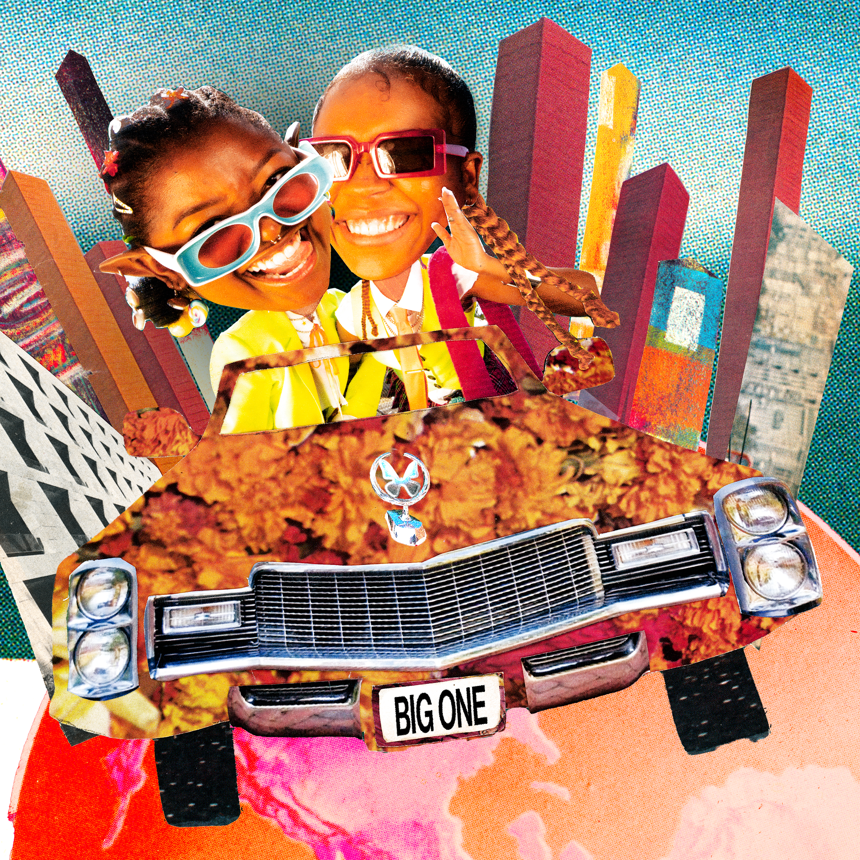
DOWNLOAD HI-RES IMAGE HERE

Breakout cute-girl rap duo Flyana Boss are back for the second time this week with their hugely anticipated new single, “Big One,” available everywhere now via vnclm_ x Atlantic Records HERE. An official lyric video premieres today at YouTube HERE.

“We’re two best friends who make music together and we like to do it BIG!,” say Flyana Boss. “This one just might be our BIG ONE!”

Heralded with two TikTok teasers (watch HERE and HERE) now boasting over 3.7m views total, “Big One” marks the long awaited follow-up to this summer’s chart-topping viral smash, “You Wish,” as well as Tuesday’s new track, “Bitch Imma Star,” (watch TikTok teaser HERE) both available everywhere now.

The duo most recently made their national television debut on MSNBC’s “SYMONE” and FOX5’s “Lion Lunch Hour”, while on the Washington, D.C. leg of Janelle Monáe’s “Age of Pleasure” Tour. The duo additionally recently lit up the popular UPROXX Sessions with spectacular new performances of “You Wish” and “Nu Nu,” both streaming now at YouTube.

Flyana Boss – a.k.a. multi-instrumentalist/MCs Bobbi LaNea and Folayan – are currently celebrating the explosive success of “You Wish” as special guests on Janelle Monáe’s The Age of Pleasure Tour, making stops across North America through mid-October. Highlights include visits to such historic venues as Atlanta, GA’s Fox Theatre (October 6). From there, Flyana Boss will head Down Under for Australia’s SXSW Sydney, the first-ever international edition of the famed Austin, TX music festival, taking place October 18-21.

Flyana Boss burst onto the scene with their breakout single, “You Wish,” which debuted at # 1 on Spotify’s “Viral 100” amidst worldwide attention from hip-hop legends Missy Elliott and Timbaland as well as such high-profile media outlets as Variety, Complex, NYLON, Vulture, UPROXX, Ones To Watch, and Rolling Stone, among many others. Produced by rising hitmaker Marky Style, the track – featured on the two-track single “You Wish + Trashboi” – quickly proved a sensation, earning over 25M global streams to date while rocketing the duo into the spotlight (and kickstarting a spirited viral discussion regarding the word “Kanekalon”).

“You Wish” was recently joined by an official music video, directed by Brad Wong (IV Jay Feat. Pink Sweat$) and streaming now at YouTube HERE. The colorful new visual came to life earlier this summer after Flyana Boss posted a “You Wish” TikTok while riding DoorDash-branded bikes, earning more than 10M views and the attention of fans everywhere. DoorDash delivered (pun intended) on the public response, officially joining forces with Flyana Boss for the irresistible “You Wish” visual. Entertainment Tonight recently took an exclusive “Behind The Scenes” look at the making of “You Wish,” streaming HERE.

Flyana Boss’s Black Girl Magic is further captured on a pair of spectacular “You Wish” remixes, including the star-studded “You Wish (with Missy Elliott & Kaliii) – Remix,” featuring brand new verses from Flyana Boss and their guest stars, streaming HERE. “You Wish – DJ Smallz 732 – Jersey Club Remix,” another spin on the hit track, is available HERE.

Hailing from Detroit, MI and Dallas, TX respectively, Bobbi and Folayan met at a music college in Los Angeles where they immediately hit it off and began collaborating. The fierce duo adopted the name Flyana Boss (rhymes with Diana Ross), repping the Vagina Dynasty while simultaneously embodying the spirit of flyness and bossness. Together, Bobbi and Folayan form a formidable union that pushes the boundaries of contemporary hip-hop, seamlessly blending their individual strengths to create a sound that is distinctively Flyana Boss. Bobbi brings a knack for storytelling and infuses her music with authenticity and vulnerability as Folayan effortlessly switches between different styles and genres, adding depth and dimension to Flyana Boss’ one-of-a-kind music.

Increasingly known for their unforgettable live performances – including a spectacular set at New Orleans’s Essence Festival of Culture highlighted by a twerkable onstage moment with Megan Thee Stallion – Flyana Boss are focused on creating music that reflects their experiences and resonates with their listeners, embracing their uniqueness and uplifting others through their art.
With talent, ambition, and more impossible-to-resist tracks to come, Flyana Boss is poised to leave an indelible mark on the hearts and minds of music lovers worldwide.

FLYANA BOSS
ON TOUR 2023

DOWNLOAD ADMAT HERE

ALL DATES w/ JANELLE MONÁE’S THE AGE OF PLEASURE TOUR

OCTOBER
2 – Charlotte, NC – Skyla Credit Union Amphitheatre
3 – Nashville, TN – Ryman Auditorium
4 – Birmingham, AL – Avondale Brewing Company
6 – Atlanta, GA – Fox Theatre Atlanta
7 – New Orleans, LA – Orpheum Theatre

# # #

SXSW SYDNEY
OCTOBER 18-21

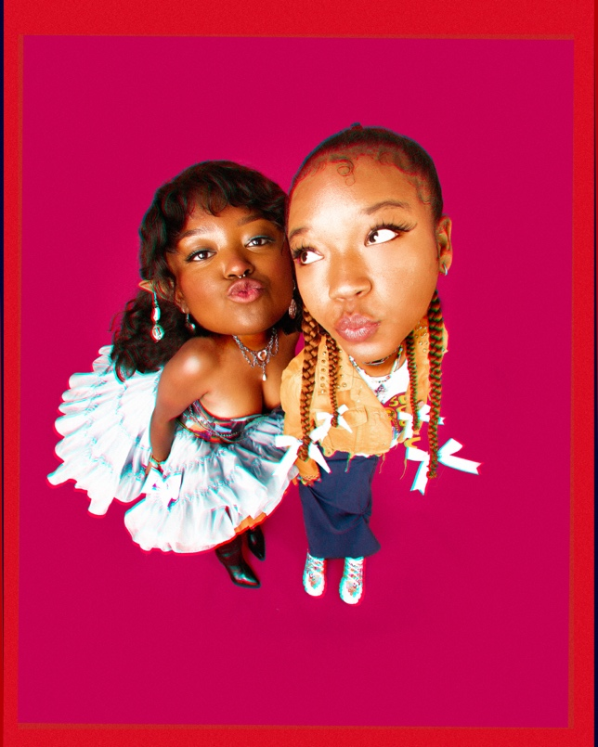
DOWNLOAD PRESS PHOTO HERE // PHOTO CREDIT: SJ SPRENG

CONNECT WITH FLYANA BOSS
FLYANABOSS.COM | INSTAGRAM | TIKTOK | TWITTER | YOUTUBE

PRESS CONTACT
FAIRLEY MCCASKILL | FAIRLEY.MCCASKILL@ATLANTICRECORDS.COM

