FOR IMMEDIATE RELEASE
OCTOBER 6, 2023

RISING R&B STAR RAICHE SHARES NEWEST SINGLE “LATE SHOW”

“LATE SHOW” AVAILABLE NOW VIA GDE/ISLAND PROLIFIC/ATLANTIC RECORDS HERE

NEW SHOW-STOPPING SINGLE FOLLOWS “BIG DADDY” AND “BIG DADDY (ACOUSTIC)”
STELLAR IN-STUDIO ACOUSTIC PERFORMANCE RECENTLY RELEASED HERE

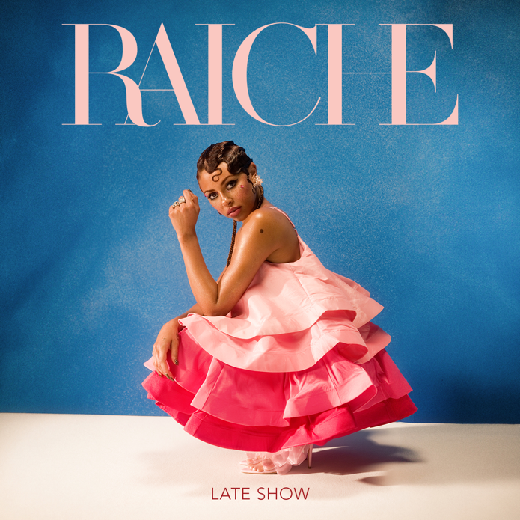
CREDIT: Brittany "BJ" Houston-Johnson
DOWNLOAD HI-RES PRESS PHOTO HERE

Rising R&B vocalist Raiche has dropped her newest single, “Late Show”, following the release of seductive “Big Daddy”. “Late Show” now via GDE/Island Prolific/Atlantic Records HERE.

“Big Daddy” marked the first new music of 2023 from Raiche, following a spectacular series of 2022 releases including “Fool,” “Feelings,” “New York New York,” and “I Hate Christmas,” all of which are accompanied by official music videos streaming now at YouTube HERE. After receiving much love from fans surrounding “Big Daddy”, the sultry singer dropped an acoustic version of the single HERE followed by an in-studio performance HERE.

Named one of Billboard’s “15 Hip-Hop & R&B Artists to Watch in 2021” as well as an ESSENCE “Rising Star,” YouTube “Artist on the Rise,” and iHeartRadio “On The Verge Artist,” Raiche has quickly proven to be a creative sensation and breath of fresh air in contemporary R&B. The gifted young artist fuses soulful roots with modern pop to concoct a genuinely distinctive new sound all her own, lit up with confidence, consistency and positivity. Born and raised in Pittsfield, MA, just two hours outside of Boston, Raiche devoted her energies towards music from an early age, uploading cover videos to YouTube that almost immediately earned her online applause. Her musical dreams almost came to a halt following high school graduation but some encouraging words from her beloved Nana eventually led her to Boston, where she met and began being mentored by DJ Knock Out. The local legend soon introduced Raiche to her GDE production team as well as to superstar songwriter Prince Charlez (Rihanna, Beyoncé, Usher), who promptly signed the talented vocalist to his recently launched Island Prolific imprint at Atlantic Records.

Now boasting over 20M worldwide streams across her growing body of work, Raiche made her national debut with 2018’s “Money Pies,” streaming HERE; a colorful official video – directed by the all-female Verluxe collective – can be viewed HERE. Raiche’s acclaimed debut EP, DRIVE, followed the next year, highlighted by the powerful title track, “Drive,” featured in Netflix’s Self Made: Inspired by the Life of Madam C.J. Walker. The EP’s “Complicated” also proved a true fan favorite, now with more than 3.2m worldwide streams and over 900K views via the MA-based singer’s official YouTube channel HERE.

2020 saw Raiche’s star ascend with “Pick A Side,” which reached #2 at R&B radio outlets nationwide while earning more than 5M worldwide streams. The track is joined by an official music video (streaming HERE) as well as a melodic remix featuring 2x GRAMMY® Award-nominated R&B icon Ty Dolla $ign, available HERE. Raiche further celebrated “Pick A Side” with a spectacular live performance on NBCUniversal’s nationally syndicated Kelly Clarkson Show, streaming HERE.

CREDIT: Brittany "BJ" Houston-Johnson
DOWNLOAD HI-RES PRESS PHOTO HERE

CONNECT WITH RAICHE
MYNAMEISRAICHE.COM | FACEBOOK | INSTAGRAM | TWITTER | YOUTUBE
FOR PRESS INQUIRIES CONTACT:
FAIRLEY.MCCASKILL@ATLANTICRECORDS.COM

