FOR IMMEDIATE RELEASE
OCTOBER 13, 2023

JASON DERULO AND MEGHAN TRAINOR
UNITE FOR “HANDS ON ME”

MULTIPLATINUM GLOBAL SUPERSTARS TEAM UP
FOR UPBEAT NEW SINGLE

LISTEN TO “HANDS ON ME (FEAT. MEGHAN TRAINOR)” HERE
WATCH THE OFFICIAL LYRIC VIDEO HERE

EPIC “NU KING WORLD TOUR” SET TO TRAVEL THROUGH MARCH 2024

IMMERSIVE NEW PODCAST SERIES, UNDERWATER, PREMIERES OCTOBER 31
CO-STARRING AND FEATURING NEW ORIGINAL MUSIC FROM DERULO

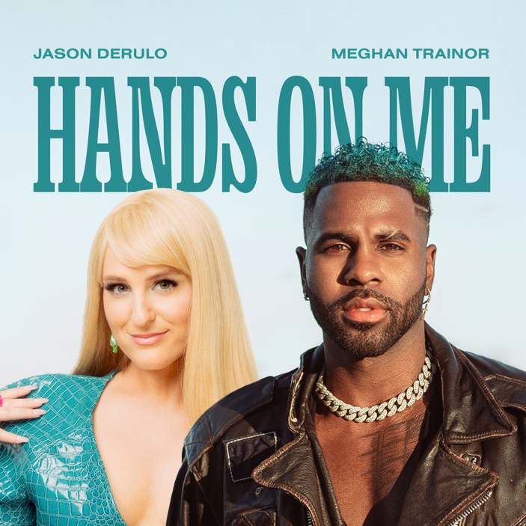
DOWNLOAD HI-RES IMAGE HERE

Jason Derulo has joined forces with his fellow multiplatinum global superstar, GRAMMY® Award-winner Meghan Trainor, for the upbeat new single, “Hands On Me (Feat. Meghan Trainor),” available now via Atlantic Records HERE. Watch the official lyric video HERE.

“Hands On Me (Feat. Meghan Trainor)” – which was teased across social media by both artists, and recently showcased by Derulo with a spectacular live performance on NBC’s America’s Got Talent, streaming HERE – marks the latest in the indefatigable superstar’s non-stop series of releases, including the tempo-changing smash, ”Slow Low” (and the Latin-flavored “Slow Low (Remix) [Feat. Yng Lvcas]”), “Running (All The Things You Said),” the seductive “Body Count,” and the smoothly dynamic “Glad U Came,” the latter joined by an official music video, directed by Derulo on location in beautiful Bali and streaming now at YouTube HERE. In addition, Derulo stripped back “Glad U Came” to create the ideal romantic theme for summer wedding season, “Glad U Came (Acoustic Wedding Version),” available now HERE. Other recent favorites include the sultry club-pop hit, “When Love Sucks (Feat. Dido),” interpolating Dido’s 1999 top 3 hit single, “Thank You,” famously sampled in Eminem’s classic “Stan.” Early 2023 saw the release of Derulo and David Guetta’s feel-good collaboration, “Saturday/Sunday.” The ultimate showcase for both artists’ signature approach towards club-ready pop anthems, the irresistibly energetic track is joined by an official dance video streaming at Derulo’s hugely popular YouTube channel HERE.

November will see Derulo embark on the typically globe-straddling “Nu King World Tour,” including shows in Australia, New Zealand, Spain, Portugal, Kazakhstan, Sweden, Norway, Denmark, France, Netherlands, Luxembourg, Belgium, the United Kingdom, Ireland, Germany, Austria, Czech Republic, Italy, and Switzerland slated through March 2024. For complete details, please visit www.jasonderulo.com/tour.

The ever-active Derulo will also co-star alongside Alexandra Shipp (Barbie, X-Men: Apocalypse) in Underwater, a neo-noir romantic thriller presented by Interval Presents, Warner Music Group’s in-house podcast network. A rollercoaster love story told in the form of a narrative album, the series features brand new, original music from Derulo woven into the story and score, creating an innovative and immersive listening experience and making for a groundbreaking event at the cutting edge of audio entertainment. The first two episodes of Underwater premiere October 31 on all major podcast platforms. New episodes will be released weekly on Tuesdays following the launch.

Derulo served in his first season as judge on The Voice Australia, which aired its finale episode on October 8 and announced Tarryn Stokes as the season winner. Derulo also found time for a visit to The Really Good Podcast, hosted by social media star Bobbi Althoff and streaming now via YouTube HERE.

# # #

ABOUT JASON DERULO
Forward-thinking, genre-defying, and massively creative, Jason Derulo has staked his claim as one of the most dynamic forces on the global pop landscape. Since breaking through with his 5x RIAA Platinum-certified single, “Whatcha Say,” the award-winning singer-songwriter who has a net worth in excess of $100 million, has sold more than 250M singles worldwide and achieved 15 Platinum singles including “Wiggle“, “Talk Dirty“, “Want to Want Me,” “Trumpets,” “It Girl“, “In My Head,” “Ridin’ Solo,” “Don’t Wanna Go Home,” “Marry Me,” “ The Other Side,” “Get Ugly,” “Swalla,” “Savage Love” and “Take You Dancing.” Since the start of his solo recording career in 2009, he has earned over 18.2B worldwide streams, and built an unstoppable social media following of over 117M followers across all platforms. Now at work on his highly anticipated fifth album – and full-length debut for Atlantic Records – Derulo has delivered an ongoing series of smash singles that have drawn a stunning 500M+ views, including the irresistibly buoyant “Acapulco,” the RIAA platinum-certified “Take You Dancing,” and Jawsh 685 x Jason Derulo’s 3x platinum-certified chart-topper, “Savage Love (Laxed – Siren Beat).” The latter track – and its official BTS remix – proved an unstoppable international sensation upon its 2020 arrival, peaking at #1 on Billboard’s “Hot 100” as well as atop charts in 16 additional countries around the world.

A truly multi-dimensional creator, Derulo has also established himself as an actor and businessman, investing in enterprises like Catch L.A. and Rumble Boxing, becoming part-owner of Bedlam Vodka, launching an innovation-minded podcast, and developing a line of supplements and fitness products with the Najafi Group and BodyBuilding.com. What’s more, Derulo unveiled Jason Derulo’s UZO, an immersive new graphic novel from Z2 Comics based on a TikTok character created by the artist himself.

With his TikTok regularly amassing over 10M views per post, Derulo notes that the platform has drastically reshaped his relationship with his fans. Derulo is now amongst TikTok’s biggest superstars, currently the 4th most followed male on the video-sharing platform with the 11th biggest account overall. He continues to see his already astronomical TikTok presence growing daily, now boasting more than 58M followers worldwide and over 1.2B likes. Reclaiming his title as the TikTok king, last year saw the summer smash single “Slidin’” released alongside a fan-challenged TikTok video to his own rendition of the electric slide (streaming HERE). His knack for laying undeniably catchy melodies on top of fun, upbeat productions, was the formula for his Summer takeover. To celebrate the single, Derulo hosted a wildly extravagant ”Slidin’” Weekend in Miami with some of his closest creator friends. The weekend included a private “Slidin’” jet set from LA to Miami; an insanely large “Slidin’” mansion; a sexy “Slidin’” yacht party; hibachi, dinners, clubbing and more (watch HERE).

ABOUT MEGHAN TRAINOR
Meghan Trainor first made history in 2014 with her Diamond-certified smash single, “All About That Bass.” Since then, the award-winning singer, songwriter, and multi-instrumentalist has garnered a GRAMMY® for “Best New Artist,” achieved eight multiplatinum singles and two multiplatinum albums, sold out three world tours, penned multiplatinum hits for peers across pop and country, and received countless industry awards and nominations. Expanding her influence on pop culture, she starred on FOX’s hit series, THE FOUR: Battle for Stardom, and on the superstar coaching panel of The Voice UK. She kicked off 2020 with the release of her third full-length album, Treat Myself (Epic Records), which includes the platinum smash “No Excuses” as well as blockbuster anthems and collaborations such as “Nice To Meet Ya” [Feat. Nicki Minaj], “Genetics” [Feat. Pussycat Dolls], and “Wave” [Feat. Mike Sabath]. At the end of 2020 she released her first ever Christmas album, A Very Trainor Christmas, featuring the #1 holiday radio single, “White Christmas,” featuring Seth MacFarlane. In 2021, we got to watch her as the host of Top Chef Family Style on Peacock and as a judge on Clash of the Cover Bands on E!. In September of 2021 she launched her podcast, Workin’ On It, which she hosts alongside her brother, Ryan Trainor. In 2022 Meghan released her fourth full-length album, Takin’ It Back, which takes you through her journey into marriage, motherhood, and achieving a new level of confidence. The album features the colossal platinum-certified hit, “Made You Look,” which has garnered over 300M streams and become a global sensation, being used in over 6M videos on social media to date. The track also took the #1 spot on Billboard’s “Adult Pop Airplay” and “Hot AC” charts and won the first ever Rolling Stone “Sound of the Year” Award at the Streamys. She kicked off 2023 by joining the judging panel of the iconic star-maker series, Australian Idol, in its highly anticipated return to air. In March, Meghan released Made You Look (Deluxe), which features three new songs including the single, “Mother.” This year, Meghan made her literary debut with Dear Future Mama, a humorous, unflinching guide to pregnancy and motherhood. Recently, Meghan also gave birth to her second child with husband Daryl Sabara, Barry Bruce Trainor. For more, please visit www.meghan-trainor.com.

# # #

CONNECT WITH JASON DERULO
OFFICIAL | FACEBOOK | INSTAGRAM | TIKTOK | TWITTER | YOUTUBE

CONNECT WITH MEGHAN TRAINOR
OFFICIAL | FACEBOOK | INSTAGRAM | TIKTOK | TWITTER | YOUTUBE

PRESS CONTACT FOR JASON DERULO
FAIRLEY MCCASKILL | FAIRLEY.MCCASKILL@ATLANTICRECORDS.COM

PRESS CONTACT FOR MEGHAN TRAINOR
LUKE BERLAND | LUKE@2BENTERTAINMENT.NET
BAILEY KATLER | BAILET@2BENTERTAINMENT.NET

