BRELAND EMBRACES THROWBACK FUN WITH “COWBOY DON’T” MUSIC VIDEO

UP-TEMPO LIVE-SHOW FAVORITE FLIPS THE SCRIPT ON THE
“COWBOY” STEREOTYPE

TRACK FEATURED ON EXPANDED CROSS COUNTRY: THE EXTRA MILE, OUT NOW

LISTEN TO “COWBOY DON’T” HERE | WATCH THE MUSIC VIDEO HERE

BRELAND SURPRISED WITH RIAA GOLD-CERTIFIED PLAQUE YESTERDAY (10/19) FOR DEBUT ALBUM

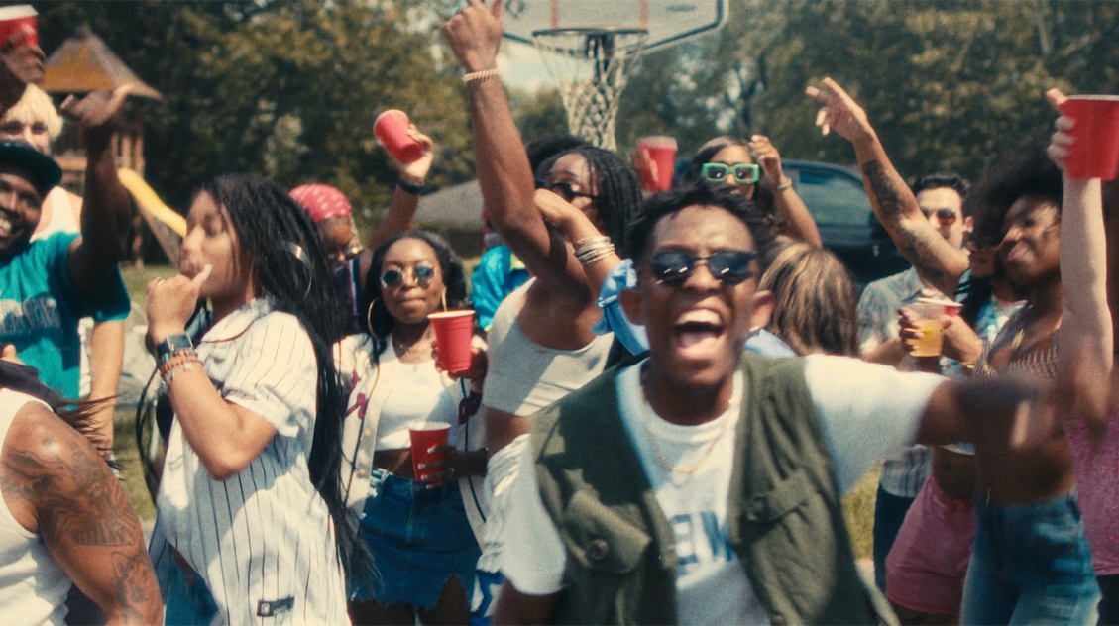

NASHVILLE, TENN. (October 20, 2023) – Flipping the script of Country music once again, Bad Realm Records/Atlantic Records/Warner Music Nashville artist BRELAND dials up some throwback fun in the official music video for “Cowboy Don’t” HERE, matching his 1000-watt smile to a promise he’s not like other guys.

Directed by Nada Taha and filmed at a backyard barbecue, the wholesome clip features a throwback ‘90s vibe to match the high-energy honky tonker, and finds BRELAND embracing a down-to-earth form of good times.

Rejecting flashy facades for a classic day of community instead, BRELAND lets his irresistible charm shine, helping showcase the carefreeness at the core of the up-tempo track: BRELAND promises to treat a girl with the rowdy fun-love no “cowboy” can.

The clip was produced by GoodCopBadCop and executive produced by Andrew Tuttle, featuring dancers Kyrstin Young, Detavius Boyd, Gian Marco Dela Cruz and Natalie Aaron. It follows the official release of “Cowboy Don’t” in August, which itself came after the track became a live-show staple and favorite of crowds around the globe.

An undeniable anthem full of playful flirtation, “Cowboy Don’t” was also featured on the expanded version of BRELAND’s debut album, CROSS COUNTRY: THE EXTRA MILE, which was released in September. Adding six fresh tracks and proving why BRELAND has been dubbed the “king of collabs” by The Associated Press, this bonus edition includes new collaboration with Brittney Spencer (“Guilty Pleasure”) alongside previous duets with Ingrid Andress, Mickey Guyton, Thomas Rhett and Keith Urban.

Adding to the excitement, BRELAND was surprised yesterday at his label home (Atlantic Records) with a plaque and news of his debut album, CROSS COUNTRY, earning RIAA GOLD-certification.

Meanwhile, BRELAND’s reputation as a standout performer continues to grow. The rising talent spent 2023 on the road as part of Shania Twain's QUEEN OF ME TOUR in the U.S. and U.K., and also made his international headlining debut with THE EXTRA MILE TOUR. The run made stops in the U.K., Germany, Netherlands, Denmark, Sweden, and Norway, and found a dedicated fanbase wherever it went.

Find complete tour and ticket information at BRELAND’s website.

ABOUT BRELAND:
A boundary-shattering breakout star, BRELAND is pushing the possibilities of Country music on a global scale. Since the arrival of his PLATINUM-certified debut single “My Truck,” the New Jersey-bred singer/songwriter/producer has amassed over 1.1 BILLION career streams, brought his crowd-thrilling live show to an international headline tour, and gained acclaim from many of the world’s leading music publications (with Rolling Stone hailing him as “a symbol of Country music’s ongoing evolution” and Billboardcalling him a “keen, visionary solo artist”). On his critically acclaimed 2022 debut album CROSS COUNTRY, the Bad Realm Records/Atlantic Records/Warner Music Nashville artist introduced a high-energy sound that blurs the barriers between Country, Pop, Hip-Hop, Soul, and Southern Gospel, offering up smash hits like the GOLD-certified “Praise The Lord (feat. Thomas Rhett).” A blockbuster year for BRELAND, 2023 has included such triumphs as teaming up with superstar Keith Urban to open the 16th annual Academy of Country Music Honors by performing their GOLD-certified collaboration “Throw It Back” and — immediately following the performance — receiving the ACM Lift Every Voice Award, recognizing his role in “elevating underrepresented voices throughout the Country music genre, transcending demographics and geography.” Released in September, CROSS COUNTRY: THE EXTRA MILE delivered a star-packed bonus version of his full-length debut, with the expanded album’s six fresh tracks including a brand-new feature with Brittney Spencer as well as longtime live favorite “Cowboy Don’t.” With his high-profile TV appearances to date including Good Morning America, Jimmy Kimmel Live!, The Voice, and TODAY, he also spent much of 2023 on the road as support for the legendary Shania Twain’s QUEEN OF ME TOUR in the U.S. and U.K. (with stops at iconic venues like Madison Square Garden), in addition to taking his THE EXTRA MILE TOUR across the U.K., Germany, Netherlands, Denmark, Sweden, and Norway. A truly magnetic live performer, BRELAND has also graced the stage at major festivals like Stagecoach and C2C: Country to Country Festival, fulfilling his mission of uniting audience members from all walks of life with his wildly joyful music.

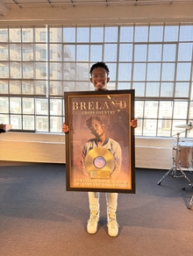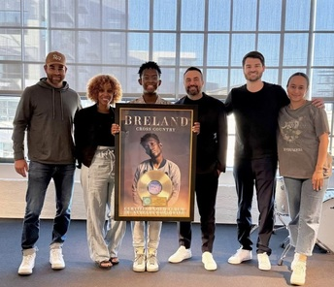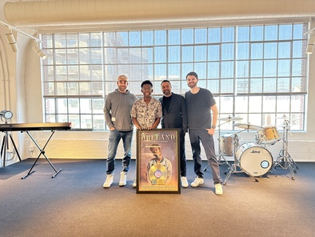
DOWNLOAD DOWNLOAD DOWNLOAD
PICTURED L-R: BRUCE KALMICK, WHY&HOW; PICTURED L-R: BRUCE KALMICK,
FAIRLEY MCCASKILL, VP, PUBLICITY, ATLANTIC WHY&HOW; BRELAND; KEVIN
RECORDS; BRELAND; KEVIN WEAVER, WEAVER, PRESIDENT, ATLANTIC RECORDS,
PRESIDENT, ATLANTIC RECORDS, WEST COAST; WEST COAST; MATT STUBBS, WHY&HOW
MATT STUBBS, WHY&HOW; BIANCA ORTEGA,
VP, MARKETING & DIGITAL, ATLANTIC RECORDS

BRELAND IS SURPRISED WITH THE NEWS OF THE RIAA GOLD-CERTIFICATION OF HIS DEBUT ALBUM CROSS COUNTRY YESTERDAY AT HIS LABEL HOME OF ATLANTIC RECORDS IN L.A.

CREDIT FOR ALL PHOTOS: ATLANTIC RECORDS

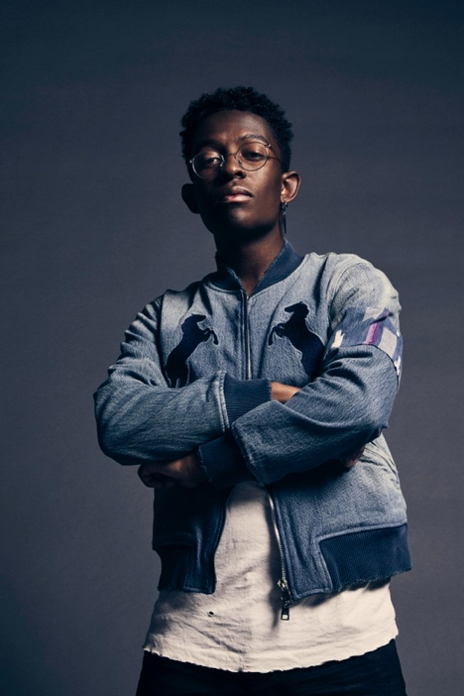
DOWNLOAD HI-RES PRESS PHOTO HERE

CONNECT WITH BRELAND
WEBSITE | INSTAGRAM | FACEBOOK | TWITTER | AMAZON MUSIC | YOUTUBE | SOUNDCLOUD
# # #

MEDIA CONTACTS

Fairley McCaskill / Fairley.McCaskill@atlanticrecords.com
Jensen Sussman / Jensen@sweettalkpr.com
Kristi Bradshaw / Kristi.Bradshaw@wmg.com

