BABY FISHER IS BACK WITH “MADONNA”

“MADONNA” AVAILABLE NOW VIA ARTHOUSE RECORDS/ATLANTIC RECORDS

EPIC NORTH AMERICAN TOUR SUPPORTING ROYAL AND THE SERPENT
BEGINS OCTOBER 14 IN PHOENIX, AZ

LISTEN TO “MADONNA” | WATCH OFFICIAL MUSIC VIDEO

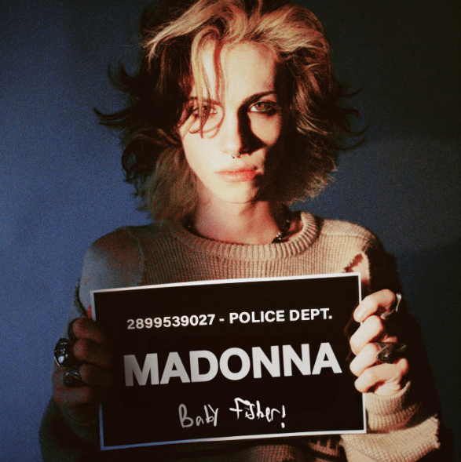
DOWNLOAD HI-RES ARTWORK

Los Angeles-based Baby Fisher returns with his most intensely romantic single thus far, “Madonna,” available today via Arthouse Records/Atlantic Records HERE. An official music video/visualizer is streaming now at YouTube HERE.

“Have you ever met someone that makes you feel like time is moving a touch slower?,” says Baby Fisher. “Have you ever been so in love that it burns? Love is incapacitating when it’s fierce and sporadic but inspiring nonetheless. The kind of love that leaves heart shaped bruises and sweet little cuts in your skin is what inspired this song. It’s the kind of love you never want to let go of but also always a little out of reach. It’s Madonna.”

“Madonna” arrives mere months after Baby Fisher’s extraordinary debut EP, Chapter 1, available now HERE. The first salvo in what is quickly proving an epic body of work, Chapter 1 includes powerhouse tracks like “Gas Money,” “Rain,” “This Is The End,” “Sick Of This,” and “Don’t Cut Your Hair,” all of which are joined by companion visuals – including music videos, intimate live performances, acoustic versions, and more – check them out HERE.

Baby Fisher is set to travel on his biggest live run to date, supporting Royal and the Serpent on an epic North American tour beginning October 14 at Phoenix, AZ’s Crescent Ballroom and then culminating with a much anticipated hometown finale at Los Angeles, CA’s world famous The Roxy on November 18. For complete details and ticket information, please visit www.babyfisherofficial.com.

BABY FISHER
NORTH AMERICAN TOUR 2023
All Dates w/ Royal and the Serpent

OCTOBER
14 – Phoenix, AZ – Crescent Ballroom
16 – Dallas, TX – House of Blues Dallas Cambridge Room
17 – Houston, TX – House of Blues Bronze Peacock
18 – Austin, TX – Empire Control Room & Garage
20 – Atlanta, GA – Masquerade Hell Stage
21 – Nashville, TN – Exit/In
23 – Toronto, ON – Velvet Underground
25 – Boston, MA – Crystal Ballroom
26 – Philadelphia, PA – First Unitarian Church of Philadelphia
29 – Washington, DC – Union Stage
30 – Brooklyn, NY – Music Hall of Williamsburg

NOVEMBER
2 – Detroit, MI – EL Club
3 – Columbus, OH – A&R Music Bar
4 – Chicago, IL – Subterranean
6 – Saint Paul, MN – Amsterdam Bar & Hall
7 – Milwaukee, WI – The Rave Bar
8 – Des Moines, IA – Wooly’s
10 – Denver, CO – Bluebird Theater
11 – Salt Lake City, UT – Soundwell
13 – Seattle, WA – The Crocodile – Showroom
14 – Portland, OR – Star Theatre
17 – San Francisco, CA – Bimbo’s
18 – Los Angeles, CA – The Roxy

# # #

Currently boasting more than 7M TikTok likes, Baby Fisher – a.k.a. Sam Fisher – grew up in Van Nuys, CA, listening to Bruce Springsteen, whiny voice singers of the 90s, and rap music. He moved to Burbank at the age of 10 and at 12 and began playing guitar. After just four months, he started gigging regularly at local blues bars, playing alongside with veteran studio musicians who had previously worked with the likes of Elvis Presley, Etta James, and more. Inspired, Fisher spent most of his high school years making music, reading, sewing his own clothes, and hanging out with kids that were way too old for him. Being the youngest, they called him Baby, bestowing upon him his distinctive musical moniker. Fisher continued to push his music forward, weaving sounds of classic 60s and 70s rock with 21st century energy and a one-of-a-kind lyrical perspective fueled by his love for “Charles Bukowski and a good viewpoint, driving at 2 am, and too many women who were far too pretty for me.”

“Y’know, I once wrote to my favorite author at age 10 and he wrote back,” says Baby Fisher. “He told me a very simple thing that really stuck with me: ‘There’s no magic in books, they’re just words strung one after another, the magic happens in the reader’s head. All you’ve got to do is learn to get the order right.’ The same applies to these songs. All they are silly little documentations of my life. There’s nothing spectacular or fantastic or whatnot. All the magic comes from you. It’s already there, the music is just what brings it out. There’s no me without you.”

PHOTO CREDIT: DEVIN JADE DEROSE

# # #

CONNECT WITH BABY FISHER
BABYFISHEROFFICIAL.COM | INSTAGRAM | TIKTOK | YOUTUBE

PRESS CONTACT:
Paige.Rosoff@atlanticrecords.com
Big Beat Records | Atlantic Records

