BRISTON MARONEY RELEASES OFFICIAL MUSIC VIDEO FOR “SUNBURN FADES” – WATCH HERE

CO-DIRECTED BY MARONEY + FREQUENT VISUAL COLLABORATOR DREW BAUML

SOPHOMORE ALBUM ULTRAPURE OUT NOW – BUY/STREAM HERE

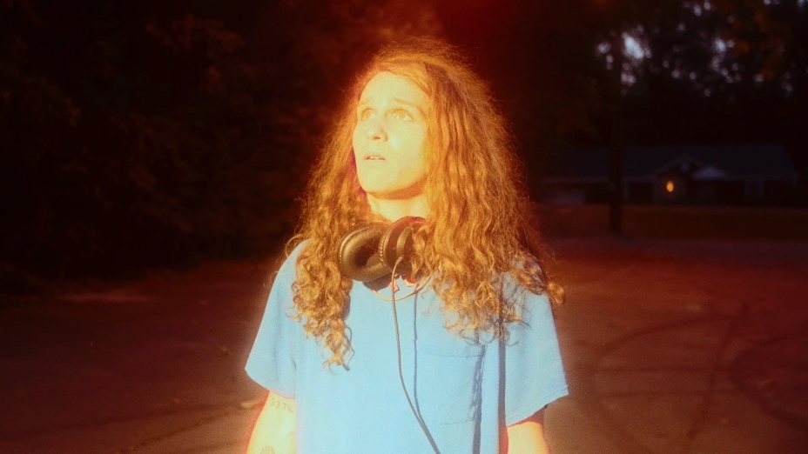
download hi-res thumbnail HERE

MADE NATIONAL TV DEBUT ON CBS SATURDAY MORNING LAST MONTH

2024 NORTH AMERICAN HEADLINE TOUR SELLING QUICKLY
BOSTON, DC, CHICAGO, SAN FRANCISCO + SEATTLE AMONG SHOWS ALREADY SOLD-OUT

MARONEY TOOK OVER BROOKLYN BOWL NASHVILLE FROM OCT 12-14 FOR HIS SECOND ANNUAL ‘PARADISE FESTIVAL’ – JOINED BY SAMIA, HOVVDY, CHARLIE BURG, SKULLCRUSHER + MORE

“Pretty flawless. Briston Maroney has pulled it off.”
ZANE LOWE

“Briston Maroney tells stories that feel personal without posturing. ‘Sunburn Fades’ is an example of the minimalist, home-spun sound the artist is continuing to craft…”
CONSEQUENCE

“Maroney manages to distinguish himself from the throes of indie-folk musicians by way of sheer and steadfast integrity, and a commitment to emotional honesty… His tender vulnerability offers a type of magnetism that is impossible to feign.”
PASTE

“Bursting at the seams with heart and passion, each song containing an entire world of emotion. The album covers relationships with parents, friends, partners, hometowns, and so much more. Without a doubt, this album is an 'ultra-pure' distillation of Maroney as a person.”
ONES TO WATCH

“…risen through the ranks to become a renowned alternative musician…”
THE TENNESSEAN

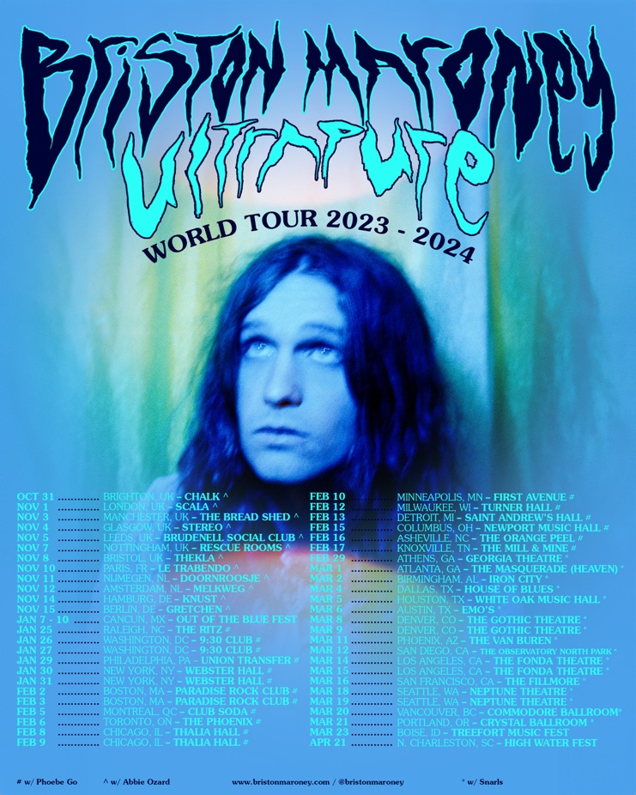
download hi-res admat HERE

BRISTON MARONEY | UPCOMING TOUR DATES
% festival performance
# w/ Phoebe Go
* w/ Snarls

OCTOBER
31 – Brighton, UK @ Chalk

NOVEMBER
1 – London, UK @ Scala – LOW TICKETS
3 – Manchester, UK @ The Bread Shed
4 – Glasgow, UK @ Stereo
5 – Leeds, UK @ Brudnell Social Club
7 – Nottingham, UK @ Rescue Rooms
8 – Bristol, UK @ Thekla
10 – Paris, FR @ Le Trabendo
11 – Nijmegen, NL @ Doornroosje
12 – Amsterdam, NL @ Melkweg OZ
14 – Hamburg, DE @ Knust
15 – Berlin, DE @ Gretchen

JANUARY 2024
7-10 – Riviera Cancún, Mexico @ Out of the Blue Festival %
25 – Raleigh, NC @ The Ritz # – LOW TICKETS
26 – Washington DC @ 930 Club # – SOLD OUT
27 – Washington DC @ 930 Club # – SOLD OUT
29 – Philadelphia, PA @ Union Transfer # – LOW TICKETS
30 – New York, NY @ Webster Hall #
31 – New York, NY @ Webster Hall #

FEBRUARY 2024
2 – Boston, MA @ Paradise Rock Club # – SOLD OUT
3 – Boston, MA @ Paradise Rock Club # – SOLD OUT
5 – Montreal, QC @ Club Soda #
6 – Toronto, ON @ The Phoenix #
8 – Chicago, IL @ Thalia Hall #
9 – Chicago, IL @ Thalia Hall # – SOLD OUT
10 – Minneapolis, MN @ First Avenue #
12 – Milwaukee, WI @ Turner Hall #
13 – Detroit, MI @ Saint Andrew’s Hall # – SOLD OUT
15 – Columbus, OH @ Newport Music Hall #
16 – Asheville, NC @ The Orange Peel # – SOLD OUT
17 – Knoxville, TN @ The Mill & Mine #
29 – Athens, GA @ Georgia Theatre * – SOLD OUT

MARCH 2024
1 – Atlanta, GA @ The Masquerade (Heaven) *
2 – Birmingham, AL @ Iron City *
4 – Dallas, TX @ House of Blues *
5 – Houston, TX @ White Oak Music Hall *
6 – Austin, TX @ Emo’s *
8 – Denver, CO @ The Gothic Theatre *
9 – Denver, CO @ The Gothic Theatre * – SOLD OUT
11 – Phoenix, AZ @ The Van Buren *
12 – San Diego, CA @ The Observatory North Park *
14 – Los Angeles, CA @ The Fonda *
15 – Los Angeles, CA @ The Fonda *
16 – San Francisco, CA @ The Fillmore * – SOLD OUT
18 – Seattle, WA @ Neptune Theatre * – SOLD OUT
19 – Seattle, WA @ Neptune Theatre *
20 – Vancouver, BC @ Commodore * – SOLD OUT
21 – Portland, OR @ Crystal Ballroom *
23 – Boise, ID @ Treefort Music Fest %

APRIL 2024
21 – North Charleston, SC @ High Water Festival %

###

CONNECT WITH BRISTON MARONEY:
OFFICIAL I INSTAGRAM I YOUTUBE I FACEBOOK I X I TIKTOK

FOR ALL PRESS INQUIRIES, PLEASE CONTACT:
Libby Kober (National) | Libby.Kober@AtlanticRecords.com
Gabby Reese (Tour) | Gabrielle.Reese@AtlanticRecords.com

