CATIE TURNER RELEASES DEEPLY CONFESSIONAL EP COMEDY & TRAGEDY: ACT 2

“I DON’T KNOW” VIDEO OUT NOW
WATCH HERE

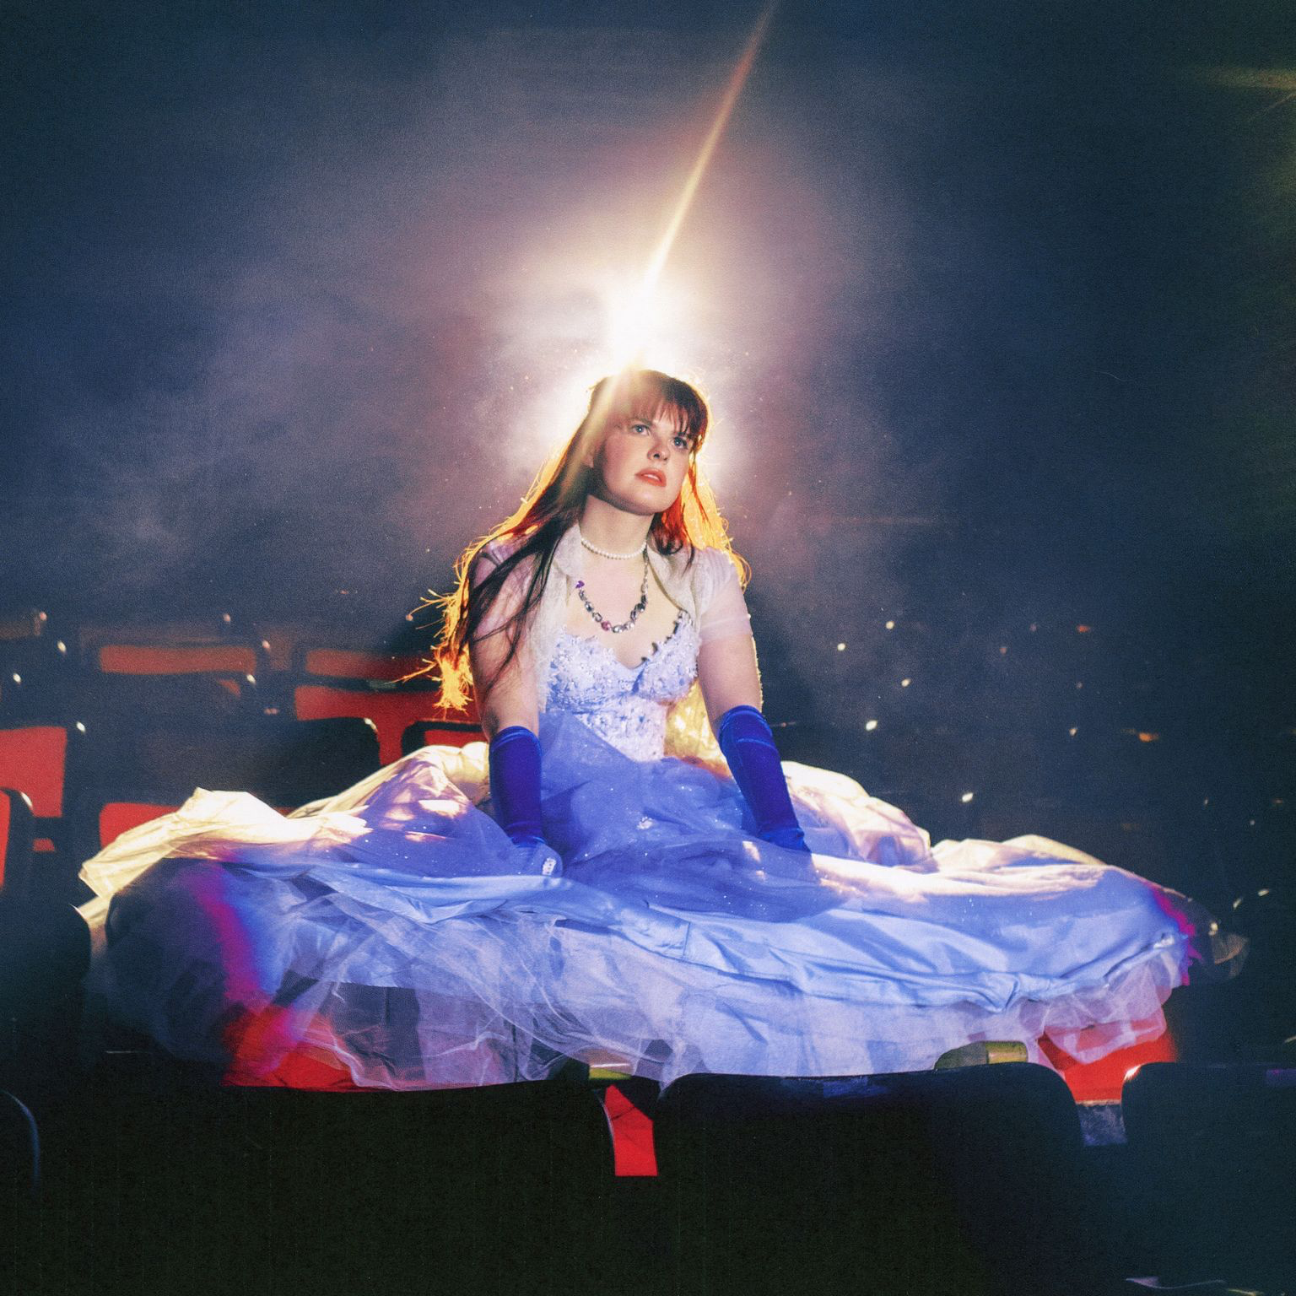
DOWNLOAD EP ARTWORK HERE

(Los Angeles, CA) October 27, 2023 - Today, acclaimed singer-songwriter Catie Turner releases Comedy & Tragedy: Act 2, the follow-up EP to her June release Comedy & Tragedy: Act 1. The finale of a two-part collection of songs and visuals, Comedy & Tragedy: Act 2, is accompanied by a music video for “I Don’t Know.”

LISTEN TO COMEDY & TRAGEDY: ACT 2 HERE
WATCH “I DON’T KNOW” HERE

The six-track EP shows Turner at her most vulnerable, navigating the complexity of life after grief and learning how to grow from it. The project’s opener, “Exist,” captures this perfectly – a quiet, instrumental start serves as a backdrop for reflecting on the past and quickly grows into a powerful anthem about persevering despite everything. Throughout the EP, Turner tackles the seemingly impossible task of articulating the ins and outs of mental health with ease through her boldly personal, confessional songwriting. Tracks such as “Empty” and “What If” give listeners an unfiltered look into her anxieties and doubts through ballads, while rock-leaning “Someone That I’m Afraid Of” sonically captures the experience of being almost painfully self-aware.

On the EP, Catie shares, “Act 2 is similar to its predecessor in its introspection & topics surrounding my mental health, but with bigger, more anthemic choruses that serve as a release during my period of grief and solitude. There’s anger and vulnerability that is stained with confoundment, but also, there is levity and self awareness that make it to the top. I hope you like it as much as I enjoyed making it!”

Directed by Joe Desantis, the music video for “I Don’t Know” is the last chapter of Comedy & Tragedy: The Musical: The Series, preceded by “Someone That I’m Afraid Of,” “Hometown,” and “Hyperfixations.” Turner, dressed in a gown, wanders through an abandoned scene as her mind reels, “I don’t know what’s real or idealization, I don’t know anything.” As she reaches the peak of her spiraling, familiar faces come to her rescue. The video’s conclusion serves as a reminder that despite uncertainty, there will be a fairy-tale ending.

“‘I Don’t Know’ is about the 3 am thought spiral I had about love & relationships,” explains Turner. “Do I love them, or do I love the idea? Can I selflessly love another being, and if so, how do you do that? How do I know if I’ve done it? You get the idea. The answer to all these questions: I don’t know. I don’t know anything.”

Download Press Photo Here | Photo Credit: Lissyelle

Comedy & Tragedy:
- Exist
- I Don’t Know
- Empty
- Someone That I’m Afraid Of
- Drunk
- What If

The Comedy & Tragedy EPs mark a new era for Turner, proving her gift for intense, introspective lyricism while demonstrating her new creative edge. At the heart of the project is Catie’s belief in the dichotomy of drama – that truth cannot exist without both comedy and tragedy. Released in June, Comedy & Tragedy: Act 1 is a cathartic act of expression and openness. The six-track project includes Turner’s breakthrough hit single, “God Must Hate Me,” which earned more than 1.2M streams in its first week and has since garnered almost 72.6M global streams. “God Must Hate Me” is joined by a powerful live performance video, filmed live at the historic St. Ann’s Church in Brooklyn, NY. In June, Turner brought Comedy & Tragedy: Act 1 on the road with her biggest US live run thus far, stopping at New York City’s Mercury Lounge and the Troubadour in Los Angeles.

Stay tuned for more from Catie Turner.

Follow Catie Turner:
Website | Spotify | Apple Music | Instagram | X | TikTok | YouTube | Facebook

About Catie Turner
You don’t ever have to worry about what Catie Turner is thinking. She’ll tell you within seconds. Besides being a singer and songwriter, she prides herself as “an overly emotional and anxious attachment-style musician with a lot of over-sharing to do. However, that over-sharing continues to click with listeners. The Langhorne, Pennsylvania native went from placing 7th on ”American Idol” in 2018 to releasing “teenage crisis” anthems such as “Prom Queen” and “i luv him.” in 2019. Beyond piling up over 120 million streams, she’s reeled in critical acclaim from TIME, Billboard, American Songwriter, People, and more. She took all of her heartbreak from a breakup and turned it into the bops, ballads and confessions on her 2021 EP, Heartbroken and Milking It, introduced by the single “Therapy.” She describes her ex’s response to these bops as “not appreciative.” Most recently, Catie has been touring the US with the likes of Valley and LEON and releasing music like high- energy bop “Nothing,” emotionally charged “God Must Hate Me” and the quirky and playful “Step Mom.” With new music on the way, she just hopes you think she’s pretty cool, because she doesn’t have a plan B.

