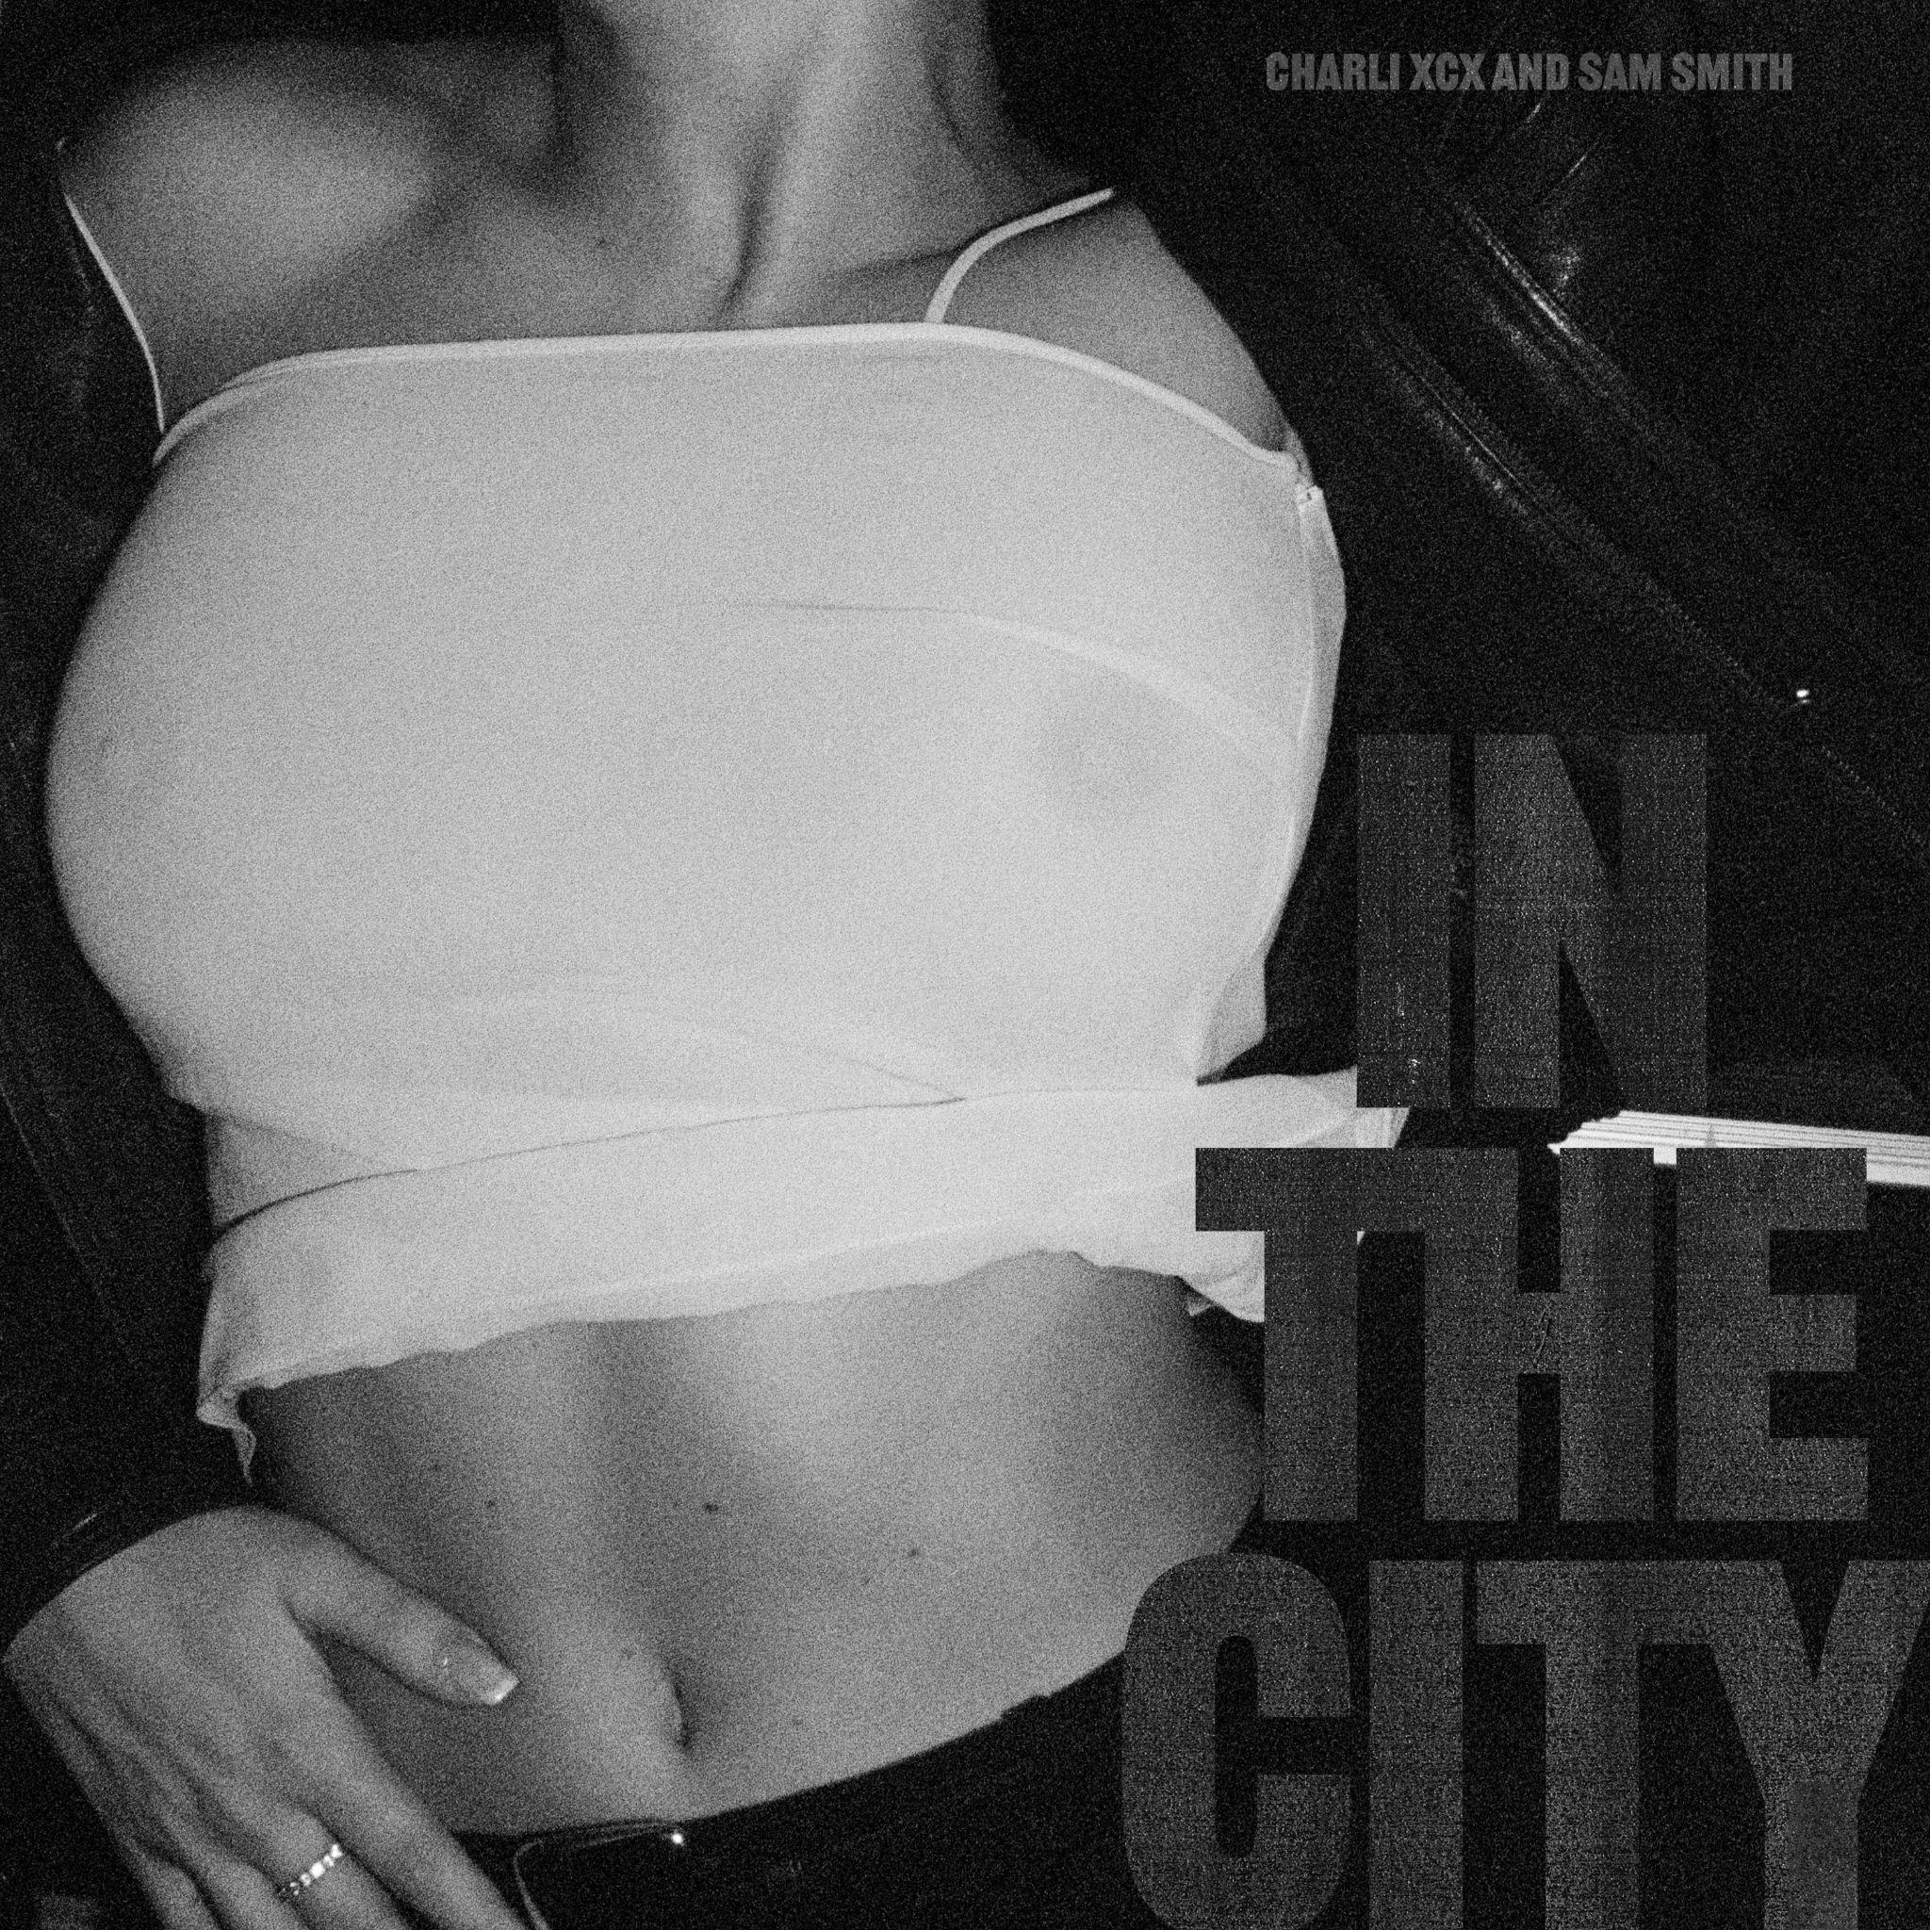

CHARLI XCX & SAM SMITH RELEASE NEW TRACK ‘IN THE CITY’

STREAM THE TRACK HERE
IMAGES HERE

Charli XCX & Sam Smith release ‘In The City’, a new standalone track and today’s BBC Radio 1 Hottest Record.

‘In The City’ is an unforgettable dance track produced by ILYA, A. G. Cook, Omer Fedi, George Daniel and Charli XCX.

"The song is about finding the people you truly love and connect with through wild nights out and partying in magical places. It’s about feeling accepted, the magnificence of being welcomed into queer spaces and those once in a lifetime people you get to meet when you’re there” - Charli XCX

Remixes will come from DJ Heartstring on 28th October with more to follow.

Charli XCX image assets here.
Follow Charli XCX here.

Charli XCX press enquiries:
Huxley: anna@huxley.world, nic@huxley.world, emily@huxley.world
Atlantic Records: Ted.Sullivan@atlanticrecords.com

