FOR IMMEDIATE RELEASE
SEPTEMBER 22, 2023

CHICAGO’S FINEST DCG BROTHERS RELEASE THEIR LATEST VISUAL FOR
“BODY COUNT” FEAT. ROB49

COMES ON THE HEELS OF THE VISUAL FOR “KNOW SUM”

VIRAL “ON THE RADAR FREESTYLE” AVAILABLE FOR STREAMING NOW

INCLUDED ON THE DUO’S LATEST MIXTAPE US, NEVER THEM

VISUAL ARRIVES AHEAD OF THE UPCOMING MIXTAPE RELEASE SHOW
IN CHICAGO ON SEPT 30

WATCH/SHARE “BODY COUNT”
DOWNLOAD/STREAM US, NEVER THEM

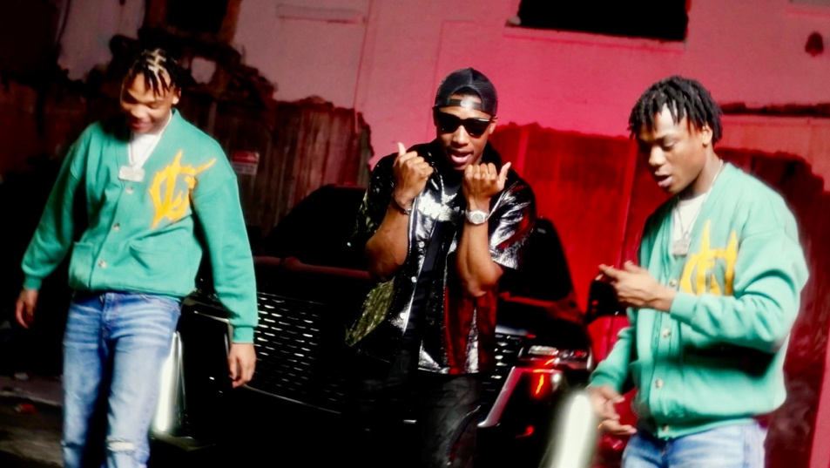

Chicago natives, DCG Brothers, have followed up the release of their second mixtape with a visual for “Body Count” featuring Rob49. “Body Count” is also featured on the fearsome twosome’s latest project, Us, Never Them. The 15-track mixtape also includes five previously released singles and includes appearances from 2Rare, Skilla Baby, Mello Buckzz, Rob49, and DCG MSavv. “Body Count” also comes on the heels of the visual for “Know Sum.”

Us, Never Them proves the DCG Brothers have no signs of slowing down. The mixtape's title speaks to their ability to stay true to their sound, energy, and brotherly bond as they continue to carve out space in today’s Drill/Chicago music scene. Upon its release, the mixtape came on the heels of, “Back Out,” their collab with fellow Chicago native Mello Buckzz and a string of sizzling singles. The flurry of freestyles and singles from DCG Brothers this year, includes “Thru The Town,” “Way Too Hot,” “Every Night” and “Leather Belt,” all accompanied by official visuals streaming now on YouTube

DCG BROTHERS
Known for injecting their hushed style of drill with an absurd, utterly idiosyncratic sense of humor, DCG Brothers have garnered over 25M global streams and close to 25M YouTube views with their unique flow and equally creative visuals. Though DCG Shun and DCG Bsavv are still only teenagers, DCG Brothers have been perfecting their craft for years. Chicago’s world-changing drill boom inspired Bsavv to begin rapping at just eight years of age, stirring his brother Shun to also learn to spit and establishing a symbiotic artistic relationship that has lasted over a decade. DCG Brothers quickly became known on the Chicago rap scene for their irrepressible personalities, drawing the attention of prolific music video collective No More Heroes, who paired the duo’s boisterous bars with eye-popping visuals to match. National attention soon followed, with Pitchfork praising 2020’s “Mmhmm (Feat. DCG Msavv)” as the start of “an astonishing singles run…(DCG Brothers) balance the brutality of Chicago drill with their dark and goofy sense of humor…You can’t find two rappers having more fun right now.”

DCG Brothers kept the momentum going with 2021’s Internet Money-produced “House Party,” earning over 2.3M views with an official video directed by Cole Bennett and streaming now via Lyrical Lemonade. 2022 saw the arrival of the duo’s eagerly anticipated debut mixtape, Jungle Life, highlighted by the hit single, “Stomp (Feat. G Herbo),” along with appearances from BIG30, B-Lovee, and frequent collaborator DCG Msavv. The remarkably accomplished, 14-track mixtape instantly affirmed DCG Shun and DCG Bsavv as one of the most exciting acts in their hometown, offering a raw, unfiltered look at their Chicago neighborhood while showcasing the percolating chemistry that helped them escape their circumstances. The DCG Brothers followed up with the release of their second mixtape, Us, Never Them. The 15-track project features appearances from 2Rare, Skilla Baby, Mello Buckzz, Rob49, and DCG Msavv.

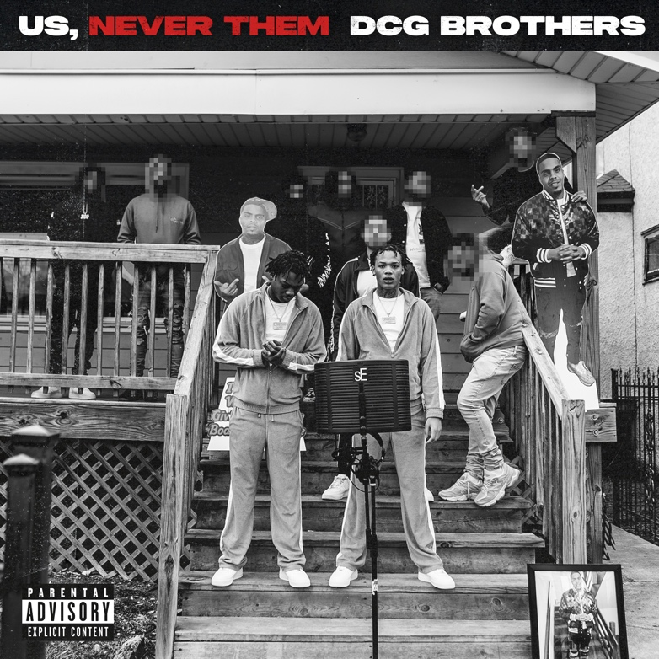
DOWNLOAD HI-RES ARTWORK

CONNECT WITH DGC BROTHERS
WEBSITE | FACEBOOK | YOUTUBE

CONNECT WITH DCG SHUN
INSTAGRAM | TWITTER

CONNECT WITH DCG BSAVV
INSTAGRAM | TWITTER

PRESS CONTACT
SELAM BELAY | Selam.Belay@atlanticrecords.com

