FOR IMMEDIATE RELEASE
AUGUST 18, 2023

DYNAMIC DUO DCG BROTHERS RELEASE THEIR SECOND PROJECT
US, NEVER THEM

COMES ON THE HEELS OF COMPANION VISUAL FOR “KNOW SUM”

THE 15-TRACK MIXTAPE INCLUDES FEATURES FROM 2RARE, SKILLA BABY, MELLO BUCKZZ, ROB49, AND DCG MSAVV

FEATURES THE EAGERLY AWAITED RELEASE OF THE DUO’S “ON THE RADAR FREESTYLE”

FOLLOW-UP TO THE PREVIOUSLY RELEASED VISUAL FOR “BACK OUT”

DOWNLOAD/STREAM US, NEVER THEM
WATCH/SHARE “KNOW SUM”

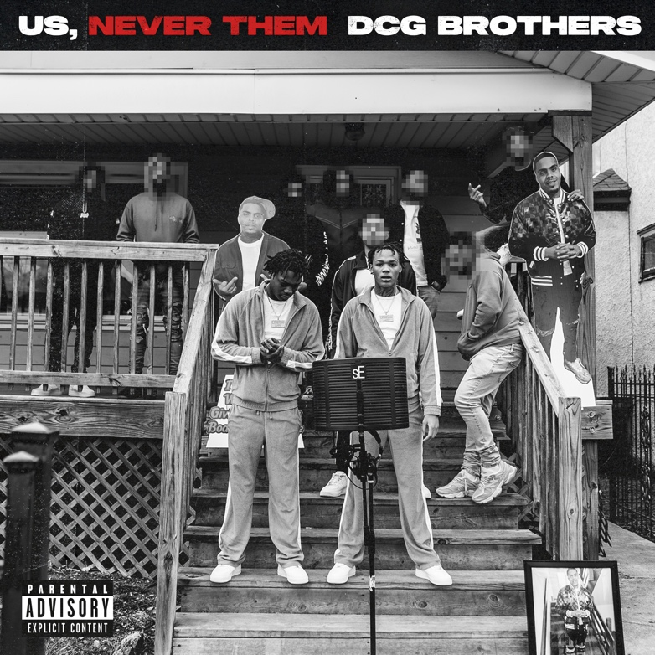
DOWNLOAD HI-RES ARTWORK

Today, the highly energetic, spitfire-rapping, Chicago duo, DCG Brothers, finally blesses fans with their mixtape, Us, Never Them. The mixtape release comes on the heels of the visual for the track “Know Sum.” The mixtape's title speaks to their ability to stay true to their sound, energy, and brotherly bond as they continue to carve out space in today’s Drill/Chicago music scene. The 15-track mixtape is the second project from the duo and includes five previously released singles that are available for streaming now. The mixtape also features the in-demand and eagerly awaited release of the duo’s “On The Radar Freestyle” that also aired on On The Radar Radio/Power 105.1 upon its premiere. Us, Never Them comes on the heels of, “Back Out,” their collab with fellow Chicago native Mello Buckzz.

Teaming up with rapstress Mello Buckzz on “Back Out” provided a twist on the duo’s recent streak of releases as the first woman they’ve collabed with this year. The flurry of freestyles and singles from DCG Brothers this year, includes “Thru The Town,” “Way Too Hot,” “Every Night” and “Leather Belt,” all accompanied by official visuals streaming now on YouTube. In addition to the string of releases, the duo has also done performances for From The Block and On The Radar.

US, NEVER THEM TRACKLIST
Leather Belt
Know Sum
And Is ft. SKilla Baby
Traded
Talk IT Out
Thru The Town
Back Out ft Mello Buckzz
Every Night
Body Count ft Rob 49
Ghetto Luv
Ashes
Way Too Hot ft DCG MSavv
Ghetto Alphabets
On The Radar Freestyle
Get Down ft. 2Rare

# # #

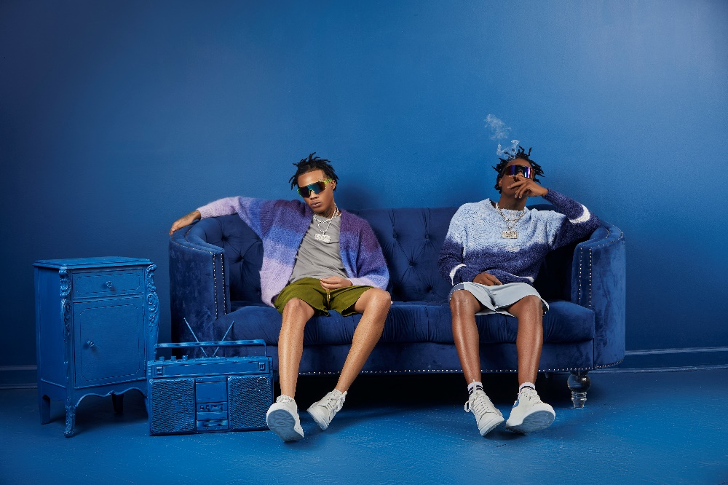
DOWNLOAD HI-RES PRESS PHOTO HERE

DCG BROTHERS
Known for injecting their hushed style of drill with an absurd, utterly idiosyncratic sense of humor, DCG Brothers have garnered over 25M global streams and close to 25M YouTube views with their unique flow and equally creative visuals. Though DCG Shun and DCG Bsavv are still only teenagers, DCG Brothers have been perfecting their craft for years. Chicago’s world-changing drill boom inspired Bsavv to begin rapping at just eight years of age, stirring his brother Shun to also learn to spit and establishing a symbiotic artistic relationship that has lasted over a decade. DCG Brothers quickly became known on the Chicago rap scene for their irrepressible personalities, drawing the attention of prolific music video collective No More Heroes, who paired the duo’s boisterous bars with eye-popping visuals to match. National attention soon followed, with Pitchfork praising 2020’s “Mmhmm (Feat. DCG Msavv)” as the start of “an astonishing singles run…(DCG Brothers) balance the brutality of Chicago drill with their dark and goofy sense of humor…You can’t find two rappers having more fun right now.”

DCG Brothers kept the momentum going with 2021’s Internet Money-produced “House Party,” earning over 2.3M views with an official video directed by Cole Bennett and streaming now via Lyrical Lemonade. 2022 saw the arrival of the duo’s eagerly anticipated debut mixtape, Jungle Life, highlighted by the hit single, “Stomp (Feat. G Herbo),” along with appearances from BIG30, B-Lovee, and frequent collaborator DCG Msavv. The remarkably accomplished, 14-track mixtape instantly affirmed DCG Shun and DCG Bsavv as one of the most exciting acts in their hometown, offering a raw, unfiltered look at their Chicago neighborhood while showcasing the percolating chemistry that helped them escape their circumstances.

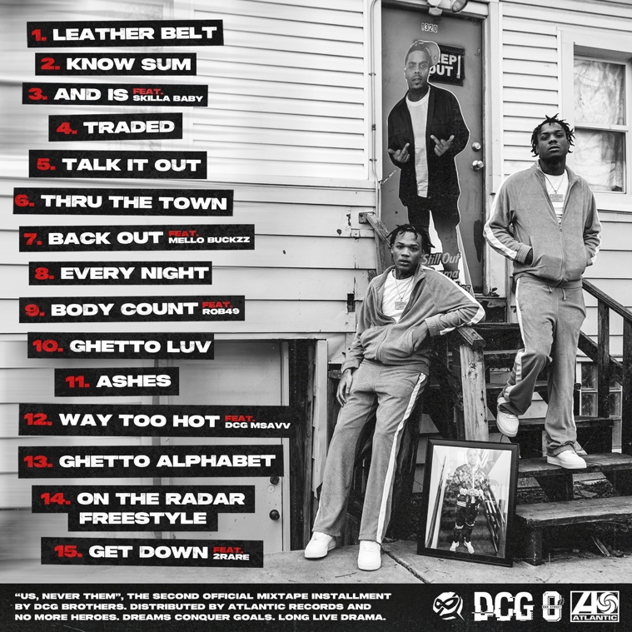

CONNECT WITH DGC BROTHERS
WEBSITE | FACEBOOK | YOUTUBE

CONNECT WITH DCG SHUN
INSTAGRAM | TWITTER

CONNECT WITH DCG BSAVV
INSTAGRAM | TWITTER

PRESS CONTACT
SELAM BELAY | Selam.Belay@atlanticrecords.com

