FOR IMMEDIATE RELEASE
MARCH 23, 2023

DCG BROTHERS ARE “WAY TOO HOT”

CHICAGO-BASED POP DRILL DUO DCG SHUN AND DCG BSAVV
UNVEIL LATEST IN STRING OF SINGLES

OFFICIAL MUSIC VIDEO PREMIERES TODAY AT YOUTUBE

STREAM/DOWNLOAD “WAY TOO HOT” | WATCH OFFICIAL MUSIC VIDEO HERE

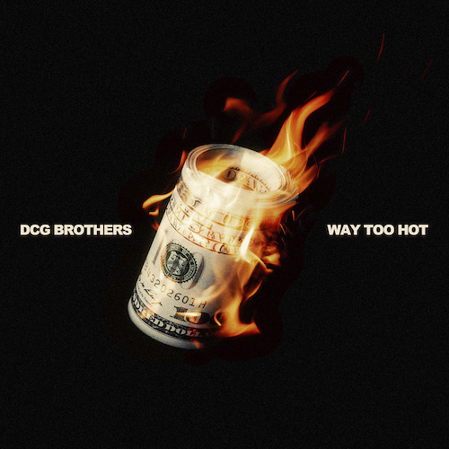
DOWNLOAD HI-RES IMAGE HERE

New York, NY – March 9, 2023 – “Pop Drill” maestros and Chicago’s brother rapper duo DCG Brothers release the incendiary single “Way Too Hot,” available today via No More Heroes/Atlantic Records at all DSPs and streaming services. A companion music video premieres today at DCG Brothers’ vastly popular YouTube channel HERE.

“Way Too Hot” continues a streak of singles from DCG Brothers, including “Every Night” and “Leather Belt,” both accompanied by official visual streaming now at YouTube.

Known for injecting their hushed style of drill with an absurd, utterly idiosyncratic sense of humor, DCG Brothers have garnered over 25M global streams and close to 25M YouTube views with their unique flow and equally creative visuals. Though DCG Shun and DCG Bsavv are still only teenagers, DCG Brothers have been perfecting their craft for years. Chicago’s world-changing drill boom inspired Bsavv to begin rapping at just eight years of age, stirring his brother Shun to also learn to spit and establishing a symbiotic artistic relationship that has lasted over a decade. DCG Brothers quickly became known on the Chicago rap scene for their irrepressible personalities, drawing the attention of prolific music video collective No More Heroes, who paired the duo’s boisterous bars with eye-popping visuals to match. National attention soon followed, with Pitchfork praising 2020’s “Mmhmm (Feat. DCG Msavv)” as the start of “an astonishing singles run…(DCG Brothers) balance the brutality of Chicago drill with their dark and goofy sense of humor…You can’t find two rappers having more fun right now.”

DCG Brothers kept the momentum going with 2021’s Internet Money-produced “House Party,” earning over 2.3M views with an official video directed by Cole Bennett and streaming now via Lyrical Lemonade. 2022 saw the arrival of the duo’s eagerly anticipated debut mixtape, Jungle Life, highlighted by the hit single, “Stomp (Feat. G Herbo),” along with appearances from BIG30, B-Lovee, and frequent collaborator DCG Msavv. The remarkably accomplished, 14-track mixtape instantly affirmed DCG Shun and DCG Bsavv as one of the most exciting acts in their hometown, offering a raw, unfiltered look at their Chicago neighborhood while showcasing the percolating chemistry that helped them escape their circumstances.

“Growing up in a real jungle around savage and seeing crazy things, basically meeting different types of people and associating them with animals,” says DCG Shun and DCG Bsavv. “RATS, SNAKES, GORILLAS, & EVERYDAY IT’S A SURVIVAL IN THE JUNGLE.”

DOWNLOAD HI-RES PRESS PHOTO HERE

CONNECT WITH DGC BROTHERS
WEBSITE | FACEBOOK | YOUTUBE

CONNECT WITH DCG SHUN
INSTAGRAM | TWITTER

CONNECT WITH DCG BSAVV
INSTAGRAM | TWITTER

PRESS CONTACT
JASON DAVIS | JASON.DAVIS@ATLANTICRECORDS.COM

# # #

