GUCCI MANE RELEASES HIS LATEST SINGLE “THERE I GO”
FEATURING J. COLE AND MIKE WILL MADE-IT

COMES ON THE HEELS OF THE ANNOUNCEMENT OF GUCCI’S ‘GUCCI MANE & FRIENDS’ CONCERT IN ATLANTA ON OCT 17

CONCERT WILL COME ALONGSIDE RELEASE OF UPCOMING ALBUM BREATH OF FRESH AIR

GUCCI MANE AUTOGRAPHED CDS AND VINYLS ARE ALSO AVAILABLE FOR PRE-ORDER

DOWNLOAD/STREAM “THERE I GO”
WATCH/SHARE “THERE I GO”

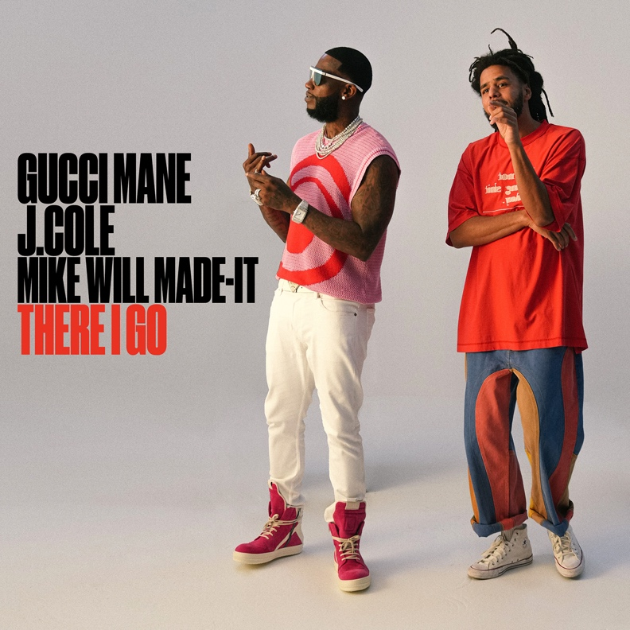

PRE-ORDER BREATH OF FRESH AIR
PRE-ORDER AUTOGRAPHED CDS AND VINYLS
TICKETS FOR GUCCI MANE & FRIENDS

# # #

ABOUT GUCCI MANE
Currently boasting over 14 billion global streams and more than 3.4 billion official views on YouTube, Gucci Mane wrapped up 2022 with his latest New 1017 compilation, SO ICY BOYZ: THE FINALE, available via Atlantic Records/The New 1017 Records. The 24-track collection sees Gucci joined by some of the most recent members of The New 1017 roster, including KATO2X, Li Rye, Mac Critter, Sett, And TLE Cinco, along with features from such certified R&B/hip-hop superstars as Jeremih, Trey Songz, 2 Chainz, and OJ Da Juiceman. Among the anthology’s undeniable highlights are such bangers as Gucci’s “Met Gala Remix (Feat. Offset, Sett, Mac Critter, KATO2X),” Li Rye’s “Too Many (Feat. Gucci Mane),” and TLE Cinco x Gucci Mane’s “Hitting,” all of which are joined by companion music videos streaming now via the official Gucci Mane YouTube channel HERE.
Widely regarded as one of the most influential rappers of the past decade, Gucci Mane has more top 10 albums on Billboard’s “Top Rap Albums” chart than any other hip-hop artist in history. Along with new releases from Gucci Mane himself, the seasoned A&R has taken his eye for the next big thing to his own record label, The New 1017, in partnership with Atlantic Records. The New 1017 showcases Gucci’s platinum-certified A&R skills with a roster that includes BiC Fizzle, Big Scarr, BigWalkDog, Enchanting, Foogiano, Hotboy Wes, KATO2X, Li Rye, Lil Zay, Mac Critter, Pooh Shiesty, Sett, and TLE Cinco. Earlier this month, Gucci announced his on-night-only concert, ‘Gucci Mane & Friends.’ The show will take place at The Tabernacle in Atlanta on October 17th; tickets are on sale now and can be purchased HERE. The show will come alongside the release of his upcoming album, Breath Of Fresh Air, which is available for pre-order now.
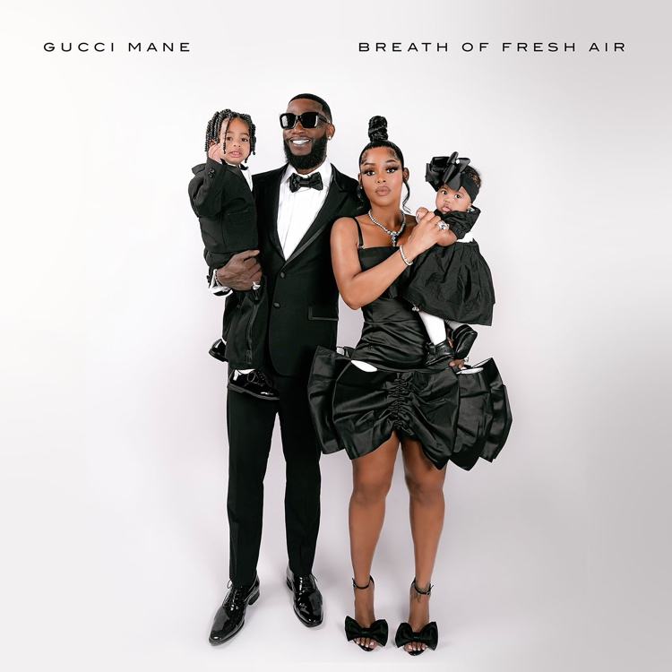
DOWNLOAD HI-RES ARTWORK

CONNECT WITH GUCCI MANE
OFFICIAL | INSTAGRAM | TWITTER I FACEBOOK I YOUTUBE

GUCCI MANE & THE NEW 1017 PRESS CONTACT
Ashley Kalmanowitz | Ashley.Kalmanowitz@atlanticrecords.com

