FOR IMMEDIATE RELEASE
OCTOBER 27, 2023

GALANTIS & NEON TREES MAKE A “DREAMTEAM”

FALL HEADLINE TOUR KICKS OFF NEXT WEEK,
INCLUDING STOPS IN CHICAGO, LOS ANGELES & MORE

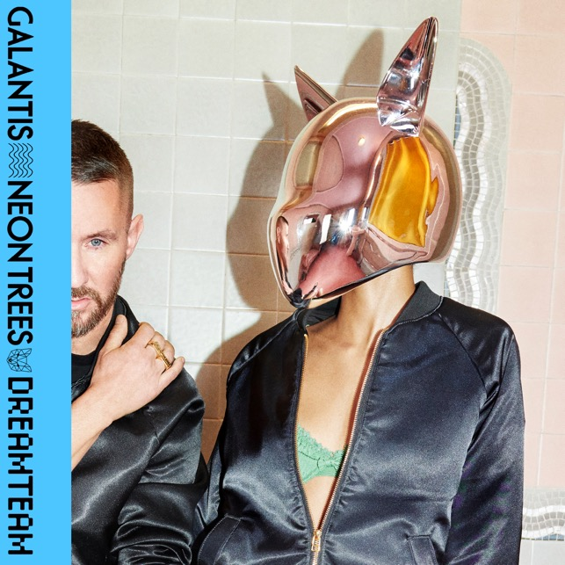
DOWNLOAD HIGH-RES IMAGES/ARTWORK

WATCH/STREAM “DREAMTEAM”: LINK

“one of the most influential and untamed voices in modern music” – GRAMMY.com

Internationally-acclaimed dance music powerhouse Galantis has joined forces with multi-platinum selling band Neon Trees on new single “Dreamteam” – available now via Big Beat Records alongside a Juan Fores Mena-directed visual starring Piiper as the focal point of an epic friends night out (watch here).

“Dreamteam” continues to usher in the hotly anticipated fourth Galantis album era, which will mark the first full-length since 2020’s Church. The single follows recently released tracks “Koala” which was declared “another dance hit” by American Songwriter and “BANG BANG! (My Neurodivergent Anthem)” which Rolling Stone praised as “an upbeat festival-ready banger.” The latter also exclusively premiered alongside candid statement from Christian Karlsson revealing his ADHD diagnosis and neurodivergent journey.

One of dance music's most dynamic and in-demand live performers, Galantis has sold out countless venues around the world and has thrilled crowds across the global festival circuit. Next week will see the kick off of their Fall headline tour, including stops at Salt Shed in Chicago on November 22nd & 24th and Shrine LA Outdoors in Los Angeles on November 25th. For full live routing and ticket information please visit wearegalantis.com/tour.

Galantis is the dance music project of Christian Karlsson (aka Bloodshy). Their RIAA gold-certified debut album Pharmacy reached No. 1 on the Billboard Dance album chart on the strength of gold-certified single “Peanut Butter Jelly” and 3x platinum certified smash “Runaway (U & I)” – the latter of which earned a GRAMMY nomination for “Best Dance Recording” – while 2017’s sophomore album The Aviary (featuring platinum-certified single “No Money”) saw a top 10 debut in 23 countries. The third Galantis album, 2020’s Church, featured the chart-topping gold-certified single “Faith” with country music icon Dolly Parton featuring Mr. Probz, which saw a #1 debut on Billboard’s Dance/Electronic Chart before quickly reaching #1 on the Dance/Mix Show Airplay Chart where it remained for 5 weeks. Meanwhile, gold-certified collaborative single “Heartbreak Anthem” with David Guetta & Little Mix proved a global sensation, spending 10 weeks on the Billboard Global 200 chart and 13 consecutive weeks in the top 10 on the UK Official Chart. Galantis has received over 5 billion cumulative worldwide streams and over 1.8 billion video views to date.

Karlsson has been at the helm of Galantis since 2009 before officially debuting the project at 2014’s Coachella Valley Music and Arts Festival. His career has spanned across the musical genres of punk-rock, hip-hop and pop – including work as one half of acclaimed production duo Bloodshy & Avant and one third of indie pop band Miike Snow. Karlsson’s songwriting/production credits have included the likes of Madonna, Kylie Minogue, Katy Perry and extensive work with Britney Spears (including “Toxic” which earned a GRAMMY for “Best Dance Recording” and her widely acclaimed 2007 album Blackout). As Galantis, he has crafted remixes for the likes of Coldplay, Selena Gomez, Ed Sheeran, Sam Smith & more. Declared “pop’s mastermind producer” by UPROXX, “eternally effervescent” by Billboard and “one of the most influential and untamed voices in modern music” by GRAMMY.com, the Swedish-born artist continues to evolve and push the boundaries of songwriting within the world of dance music and beyond.

ABOUT NEON TREES:
Neon Trees began a rapid ascent from the Provo, Utah pop punk scene to the forefront of popular culture fueled by their debut album Habits. Its lead single “Animal” scored a double-platinum certification from the RIAA and took home “Top Alternative Song” at the Billboard Music Awards. Success continued for the band with their sophomore album, Picture Show and its hit single, the 5x platinum “Everybody Talks.” The subsequent release Pop Psychology, bowed at #1 on the Billboard Top Rock Albums Chart and produced another hit, “Sleeping With A Friend.” Most recently, Neon Trees returned with their 4th studio album, I Can Feel You Forgetting Me, featuring the single, “Used to Like” which landed at #1 on the current Alternative chart. In addition to chart success, the multi-format band has amassed 1 billion streams and recently logged over 40 million views on TikTok, while garnering acclaim from Rolling Stone, Entertainment Weekly, and USA Today. Their live performance continues to electrify with over a decade of countless sold-out shows, marquee festival performances as well as appearances on Good Morning America, Conan, TODAY, The Ellen DeGeneres Show, Jimmy Kimmel Live!, America’s Got Talent, and LIVE! With Kelly.

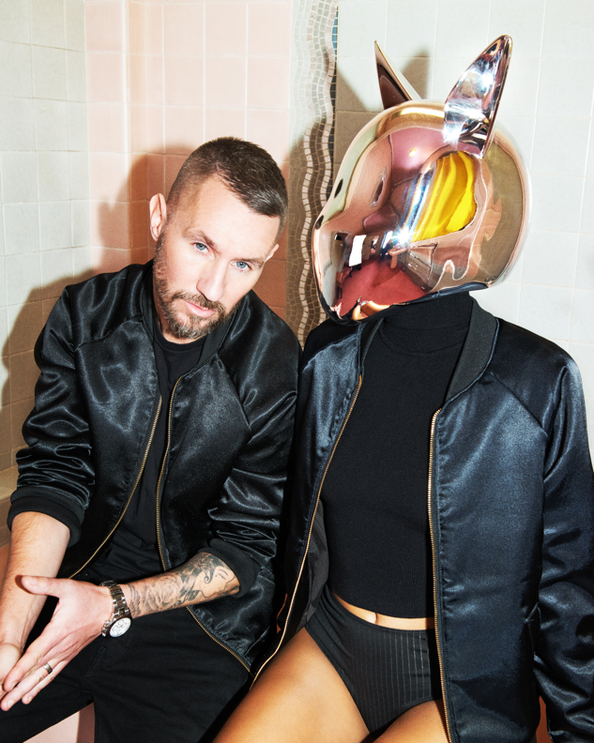
DOWNLOAD HIGH-RES IMAGES/ARTWORK (Photo credit: Tung Walsh)

GALANTIS LIVE:
Nov 4 – EDSea – Miami, FL
Nov 9 – Echostage – Washington, D.C.
Nov 10 – NOTO - Philadelphia, PA
Nov 11 – Big Night Live – Boston, MA
Nov 22 – Salt Shed – Chicago, IL
Nov 24 - Salt Shed - Chicago, IL
Nov 25 – Shrine LA Outdoors – Los Angeles, CA
Dec 8-10 – Djakarta Warehouse Project – Bali, ID
Dec 29 - Palace of Fine Arts - SF, CA
Dec 31 – Decadence NYE – Denver, CO

CONNECT WITH GALANTIS:
WeAreGalantis.com | Twitter | Facebook | YouTube | Instagram | Assets

CONTACT:
Ted Sullivan | Ted.Sullivan@atlanticrecords.com

