NEW JERSEY ALT ARTIST JOE P SHARES “GLASS HOUSE”

US HEADLINE TOUR BEGINS OCTOBER 16 IN SEATTLE

SPECIAL GUEST RUN ON COLD WAR KIDS’ 20 YEARS TOUR
BEGINS FEBRUARY 23, 2024 IN CHICAGO, IL

LISTEN TO “GLASS HOUSE” HERE

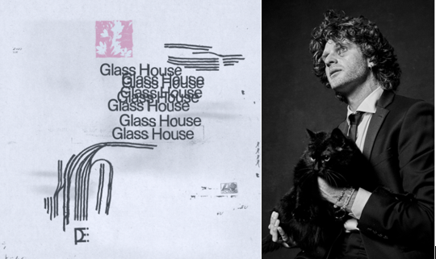
DOWNLOAD HI-RES ARTWORK // DOWNLOAD HI-RES IMAGE (credit Jimmy Fontaine)

Alt artist Joe P is back with his latest single, “Glass House,” available now via Neon Gold/Atlantic Records HERE.

“To me, this song is about the physical proof we leave behind in the wake of relationships,” says Joe P. “A lot of my friends talk about how they unfollow someone on socials because they don’t want to see them anymore. We have these little moments when we’re reminded of something/someone and that nostalgia can trick us into believing feelings still exist where they don’t.”

Joe P will celebrate “Glass House” and more new music to come with an eagerly anticipated US headline tour beginning October 16 in Seattle and culminating with a home state show at Jersey City’s historic White Eagle Hall on November 11. Next, Joe P will join Cold War Kids as special guest on their upcoming 20 Years Tour, with dates getting underway February 23, 2024 at Chicago, IL’s The Salt Shed and then continuing into early March. For complete details and ticket information, please visit joepthehyena.com.

“Glass House” marks the latest in a series of recent releases including the heartbreaking “Don’t Wanna Love U” and “Off My Mind (Feat. K. Flay),” a new version of joe p’s 20M-streaming, #1 Triple A hit single, “Off My Mind.”

JOE P
ON TOUR 2023-2024

OCTOBER
15 – Bellingham, WA – Bellingham Exit (The Blue Room)
16 – Seattle, WA – Madame Lou’s
17 – Vancouver, BC – The Wise
18 – Portland, OR – Polaris Hall
20 – San Francisco, CA – Café Du Nord
21 – Sacramento, CA – Harlow’s
23 – Santa Cruz, CA – The Catalyst
26 – Los Angeles, CA– Teragram Ballroom
27 – Anaheim, CA – House of Blues Anaheim
28 – San Diego, CA – House of Blues San Diego
29 – Phoenix, AZ – Valley Bar
31 – Flagstaff, AZ – Orpheum Theater

NOVEMBER
1 – Santa Fe, NM – Tumbleroot Pottery Pub
4 – Fort Worth, TX – Tulips FTW
5 – Houston, TX – White Oak Music Hall
6 – Austin, TX – Antone’s
8 – Nashville, TN – Exit/In
9 – Charlottesville, NC – The Southern Café & Music Hall
10 – Baltimore, MD – Ottobar
11 – Jersey City, NJ – White Eagle Hall

FEBRUARY 2024
23 – Chicago, IL - The Salt Shed *
24 – Minneapolis, MN – First Avenue *
26 – Cleveland, OH – House of Blues *
27 – Toronto, ON - The Phoenix Concert Theatre *
28 – Boston, MA – House of Blues *

MARCH 2024
1 – New York, NY – Webster Hall *
2 – New York, NY – Webster Hall *
3 – Philadelphia, PA – The Fillmore *
5 – Washington, DC – 9:30 Club *
8 – Raleigh, NC - The Ritz *
9 – Atlanta, GA – Buckhead Theatre *

* w/ Cold War Kids
# # #

ABOUT JOE P
When the onset of the pandemic brought about the dissolution of the band he’d fronted since eighth grade, Joe P found himself in isolation with time to step out and experiment on his own. From the refuge of his New Jersey basement studio, he threw himself into writing, recording and producing his most personal material to date. Posting homegrown ideas to TikTok, Joe P watched as his raw acoustic videos drew millions of views and over 300K followers in just a few months. Among those new fans was Apple Music’s Zane Lowe, who kicked Joe’s career into hyperdrive by duetting alongside his self-made “Fighting In The Car” video.
A deal with Neon Gold/Atlantic was quickly followed by the release of Joe P’s acclaimed debut EP, Emily Can’t Sing, highlighted by the viral hit singles, “All Day I Dream About (first introduced as “Adidases” in a hugely popular TikTok teaser) and “Off My Mind,” which spent 2 weeks at #1 and 9 weeks in the top 5 at Triple A radio and received a new version featuring K. Flay in February 2023.

Following Emily Can’t Sing, Joe P released his seven-song project, French Blonde, in October 2022. The official live performance video for “French Blonde” also serves as the opening scene of Joe P’s short horror film, “If We Run,” starring Michael Gandolfini (The Many Saints of Newark), Kevin Interdonato (The Sopranos), and Joe P as himself. Joe embarked on his debut headline tour this Spring, selling out venues throughout the East coast and Midwest. He recently performed at Maryland festival Oceans Calling in September and has headline dates on the West Coast this Fall. By the end of 2023 Joe will have headlined across the entire US.

# # #

CONNECT WITH JOE P
WEBSITE | FACEBOOK | INSTAGRAM | SOUNDCLOUD | TIKTOK | TWITTER | YOUTUBE

PRESS CONTACTS
corey.brewer@atlanticrecords.com
gabrielle.reese@atlanticrecords.com

