FOR IMMEDIATE RELEASE
OCTOBER 27, 2023

JAMES BLUNT RETURNS WITH BRILLANT NEW ALBUM WHO WE USED TO BE

DOWNLOAD HIGH-RES IMAGES/ARTWORK

STREAM WHO WE USED TO BE: https://JamesBlunt.lnk.to/WhoWeUsedToBe

James Blunt releases his brand-new album Who We Used To Be via Atlantic Records. The 10-track collection features the heartbreakingly raw new single “The Girl That Never Was” (watch video) and standout track “Dark Thought” dedicated to the late Carrie Fisher.

With “tunes that press emotional buttons with military precision” (Financial Times) and Retropop Magazine hailing it as “his best in a long time,” Who We Used To Be sees James working with a variety of acclaimed producers including Jonny Coffer (Beyoncé, Miley Cyrus), Red Triangle (Louis Tomlinson, Lukas Graham), Jack & Coke (Tove Lo, Charli XCX) and Steve Robson (Olly Murs, 5 Seconds of Summer).

Who We Used To Be is James’ first studio album since 2019’s Once Upon A Mind, which featured standout single “Monsters” – a heartfelt song for his father who was gravely ill with stage four chronic kidney disease. The song took on new life this year after a touching performance by American Idol winner Iam Tongi in dedication to his late father, with James joining for an incredibly emotional duet on the show’s season finale (watch here).

James Blunt has become something of a national treasure as he approaches the 20th anniversary of his 2004 debut album Back to Bedlam, named as one of the top 10 best selling albums of that decade. The album features singles “Goodbye My Lover” and the 4x Platinum, 3x GRAMMY-nominated #1 hit “You’re Beautiful.” His most recent release, 2021’s greatest hits collection The Stars Beneath My Feet, also features catalog highlights “1973,” “Bonfire Heart,” “Stay The Night” & more.

Over his two-decades in music, James has totalled over 24 million in record sales worldwide and has won two Brit Awards, two Ivor Novello Awards, two MTV Video Music Awards and received five GRAMMY nominations. He is respected for his honesty, wit, and charm as showcased on record, onstage (having toured extensively on both international headline runs and in support of Elton John, Ed Sheeran & more), and with his ever engaging Twitter account (where he has amassed a following of over 2 million and gone viral countless times over).

Who We Used To Be
1. Saving A Life
2. Some Kind Of Beautiful
3. Beside You
4. Last Dance
5. All The Love That I Ever Needed
6. The Girl That Never Was
7. Cold Shoulder
8. I Won’t Die With You
9. Dark Thought
10. Glow

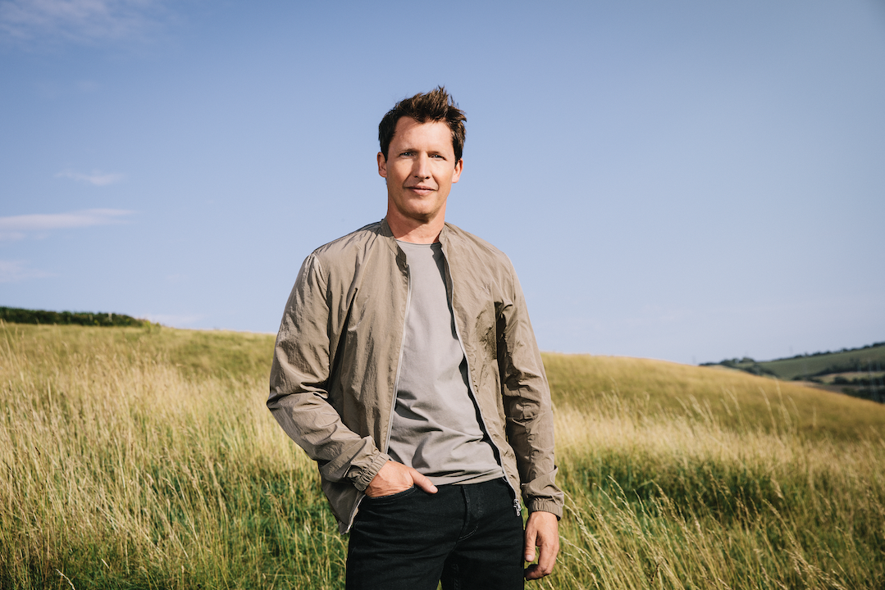
DOWNLOAD HIGH-RES IMAGES/ARTWORK

CONNECT:
JamesBlunt.com | Twitter | Instagram | YouTube | TikTok | Facebook | Press Assets

CONTACT:
Ted Sullivan | ted.sullivan@atlanticrecords.com

