MICHELLE ANNOUNCES NEW EP GLOW
﻿
SHARES DOUBLE SINGLE "GLOW" AND "AGNOSTIC" WITH ACCOMPANYING VISUALS

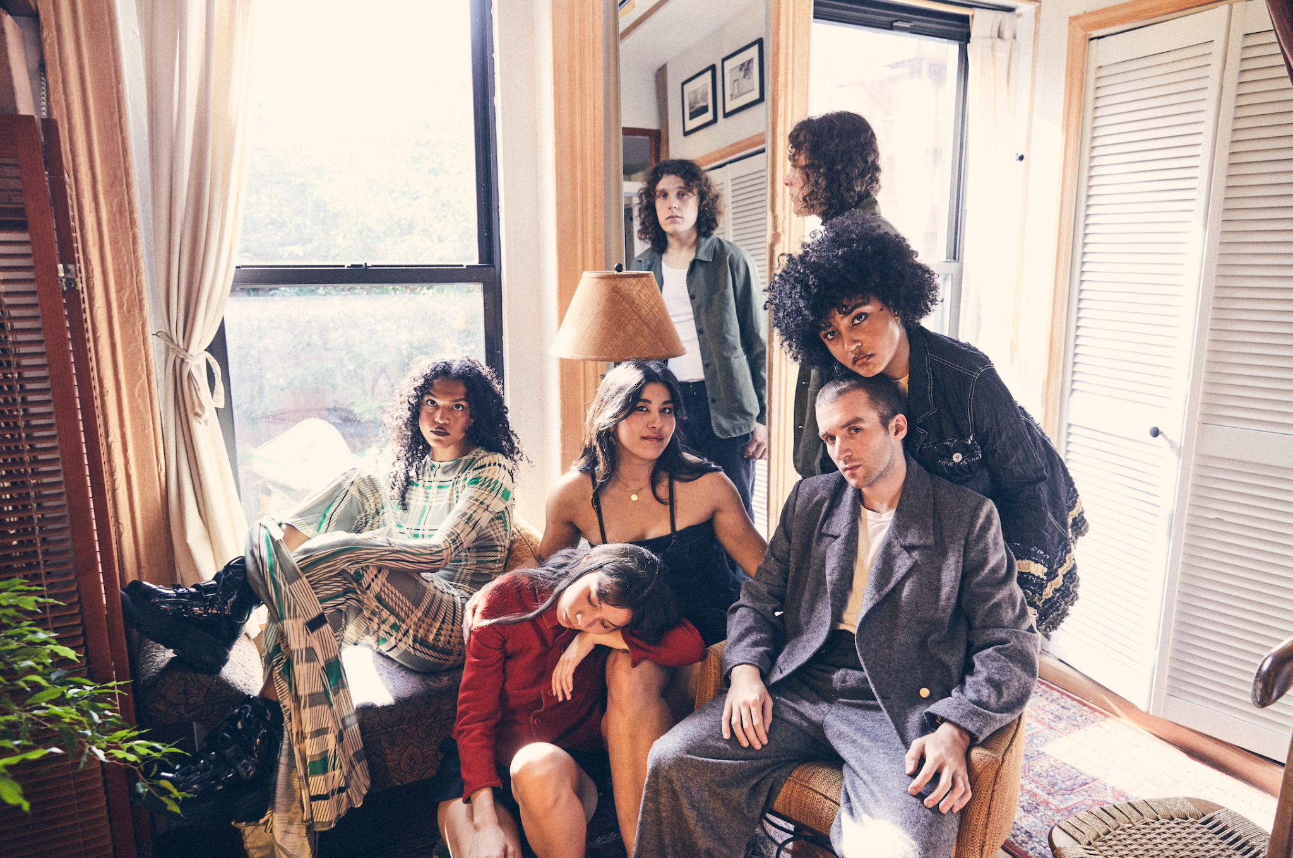

GLOW EP
PRE-SAVE/ORDER:
https://Michelle.lnk.to/glowep

"GLOW" + "AGNOSTIC"
LISTEN: https://michelle.lnk.to/glowagnostic
WATCH: https://Michelle.lnk.to/GLOWVisualizerPR; https://Michelle.lnk.to/AGNOSTICVisualizerPR

“An entirely new era of MICHELLE, emphasizing their creative maturity and growth as a collective"
V Magazine

"Plush R&B pop that feels wholly indebted to the flexuous city that surrounds them"
The FADER

"The kind of breezy, timeline-cleansing tunes our overstimulated brains are begging for right now"
Entertainment Weekly

"Crooning, dance-worthy tracks, euphoric R&B melodies, and sucker-punching lyrics"
Elle Magazine

(October 19th, 2023) - NYC-based collective MICHELLE are back to announce their forthcoming EP GLOW. Alongside the announcement, they share the project's first offering, a double single including the title track "GLOW" and a second single "AGNOSTIC."

The EP's title track is softly delivered by band member Jamee Lockard. The song fills the room with a bouncy, free-flowing incandescence. Slowly adding in contributions from the band's bass, synth keyboard, and drums, the song crescendos, creating an aura of a soft glow. The track is paired with a visual choreographed by the bands own Emma Lee featuring the six members dancing through the streets and parks of their hometown. "AGNOSTIC" sees a tonal shift from the collective as the song is introduced by a stripped-down acoustic guitar. The new singles offer a taste of the refined writing and musical style that will inform their forthcoming EP.

Born-and-bred New Yorkers, MICHELLE formed in 2018 and is comprised of Sofia D'Angelo, Julian Kaufman, Charlie Kilgore, Layla Ku, Emma Lee, and Jamee Lockard. The predominantly POC and queer collective mix and match the writing and production groups amongst the six of them.

The hallmarks of MICHELLE’s music—layered vocal harmonies, analog synthesizers, vibrant percussion, smoldering hooks—dominate the sonic landscape of their upcoming EP, with the four female vocalists pushing the boundaries of their considerable singing talents while Charlie and Julian fine-tune the production. Despite all the tinkering elsewhere, it is important to note that the vocals remain largely untouched and appear in their organic state. Songs hop across genres, from funky R&B to bedroom slow jams to amped-up beat-heavy anthems and more.

The forthcoming EP follows their critically acclaimed album AFTER DINNER WE TALK DREAMS, which was praised by Nylon as a band that "defies categorization" and MTV as "mesmerizing." The album included celebrated singles "MESS U MADE," "SYNCOPATE" and "POSE" and preceded their sold out headline shows across the US, UK, and Europe. MICHELLE has also toured alongside Mitski, Arlo Parks and Gus Dapperton in addition to performing recent festival sets at Governors Ball and Lollapalooza.

Listen to "GLOW" and "AGNOSTIC" above and stay tuned for more from the collective coming soon.
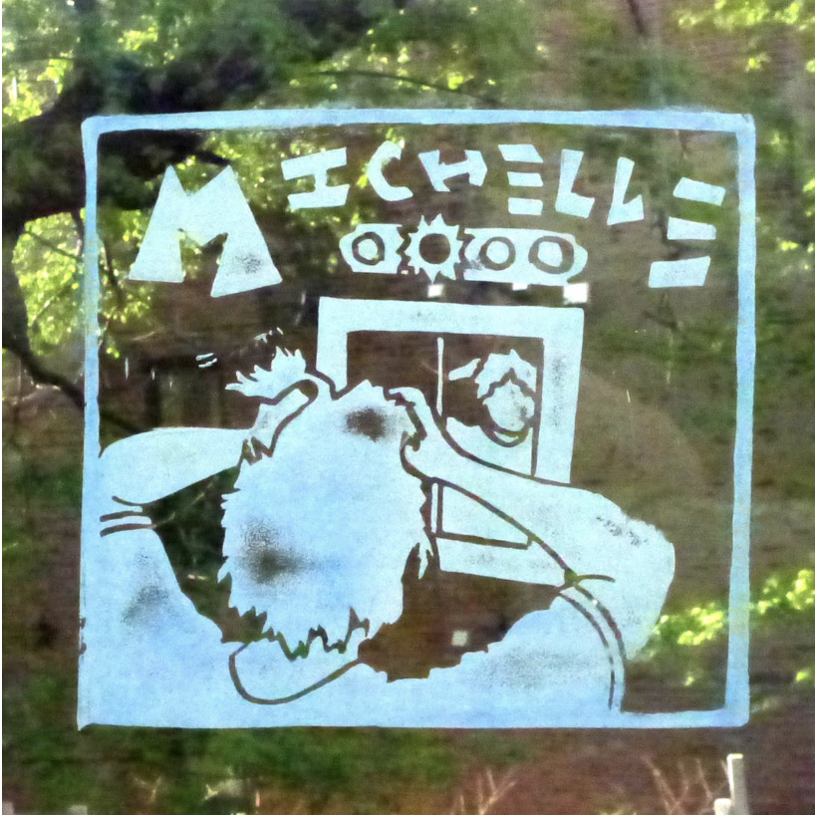

EP artwork

(Download Hi-Res assets HERE)

Connect with MICHELLE
Website | Instagram | Twitter | Facebook | YouTube

For all MICHELLE inquiries please contact Emily at Orienteer:
emily@orienteer.us

--
Emily Mullen
Orienteer
Los Angeles, CA | New York, NY

