FOR IMMEDIATE RELEASE
SEPTEMBER 29, 2023

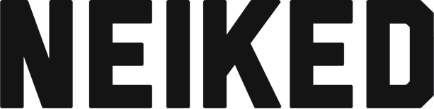

PLATINUM PRODUCER/ARTIST DUO NEIKED TEAMS UP WITH AYRA STARR ON NEW SINGLE “YOU’RE HIRED”

THE GENRE BLENDING TRACK IS ACCOMPANIED BY A GRAINY VINTAGE MUSIC VIDEO

DOWNLOAD/STREAM “YOU’RE HIRED” HERE | WATCH MUSIC VIDEO HERE

DOWNLOAD HI-RES ARTWORK

(NEW YORK, NY) — Swedish platinum-certified pop producer/artist duo, NEIKED returns with “You’re Hired” featuring Nigerian pop princess Ayra Starr – available everywhere now via Atlantic Records.

The new single invites Nigerian superstar Ayra Starr into the pop world of NEIKED, blending Afropop with NEIKED’s signature bassline grooves. The song is accompanied by a grainy vintage music video – watch here.

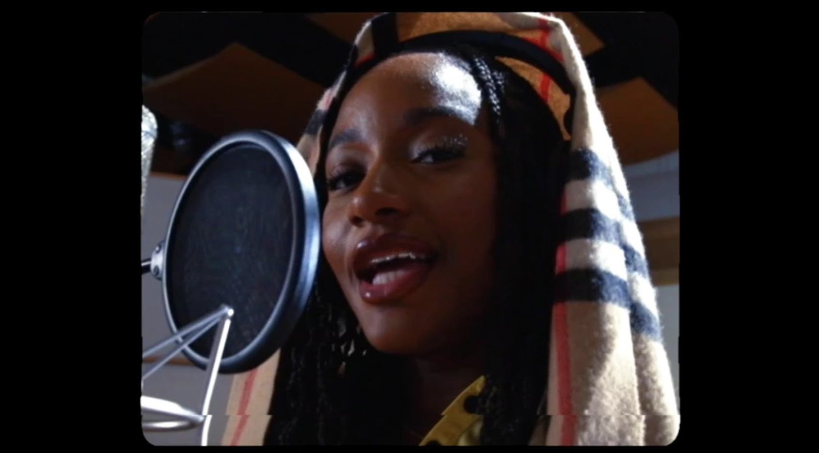
The producer and artist duo comprised of Victor Rådström and Mikael Rabus are best known for their 2X RIAA platinum-certified single, “Better Days” with Mae Muller and Polo G, the irresistibly wistful pop-funk bop that entered the top 20 of Billboard’s Hot 100 chart and amassed over 1.5 billion streams.

NEIKED’s breakthrough came in 2016 with their RIAA platinum-certified single, “Sexual” featuring English singer-songwriter Dyo that amassed over 1 billion streams and landed in the top 25 of Billboard’s Hot Dance/Electronic Song chart. The hit single is globally recognized with a 3X platinum-certification in the UK, 2X platinum-certification in Australia, platinum-certification in France and more. “Sexual” was featured on their 2019 debut album, Best of Hard Drive which housed new songs alongside previously released singles.

After producing Maroon 5’s 2X RIAA platinum-certified hit “What Lovers Do,” featuring SZA in 2018, NEIKED teamed up many well-known collaborators including Anne-Marie and Latto on single, “I Just Called” which includes an interpolation of a Stevie Wonder classic and has amassed nearly 90 million streams.

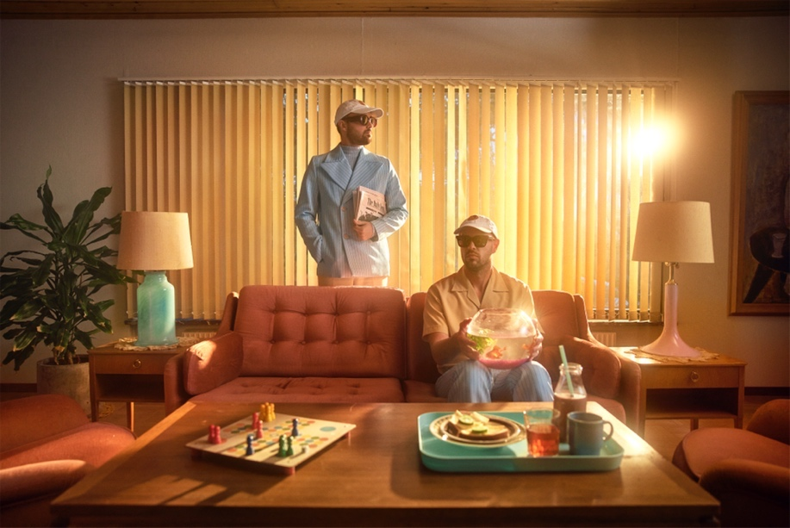
(Photo Credit: Fredrik Bengtsson)
DOWNLOAD HI-RES PRESS PHOTOS

CONNECT WITH NEIKED:
YOUTUBE | INSTAGRAM | X | TIKTOK | FACEBOOK

PRESS CONTACT:
TAYLOR APEL | TAYLOR.APEL@ATLANTICRECORDS.COM

