PORTUGAL. THE MAN RELEASE OFFICIAL MUSIC VIDEO FOR “ANXIETY:CLARITY (FT. PAUL WILLIAMS)”

MARKS THE SECOND RELEASE FROM THE BAND’S
CHRIS BLACK CHANGED MY LIFE MUSIC VIDEO TRILOGY

WATCH “ANXIETY:CLARITY” MUSIC VIDEO
WATCH “DOUBT” MUSIC VIDEO
LISTEN TO CHRIS BLACK CHANGED MY LIFE

FILMED IN ALASKA ON THE UNCEDED ANCESTRAL LANDS OF THE KNIK TRIBE
DIRECTED BY CINEMATOGRAPHER/FREQUENT COLLABORATOR MICHAEL RAGEN

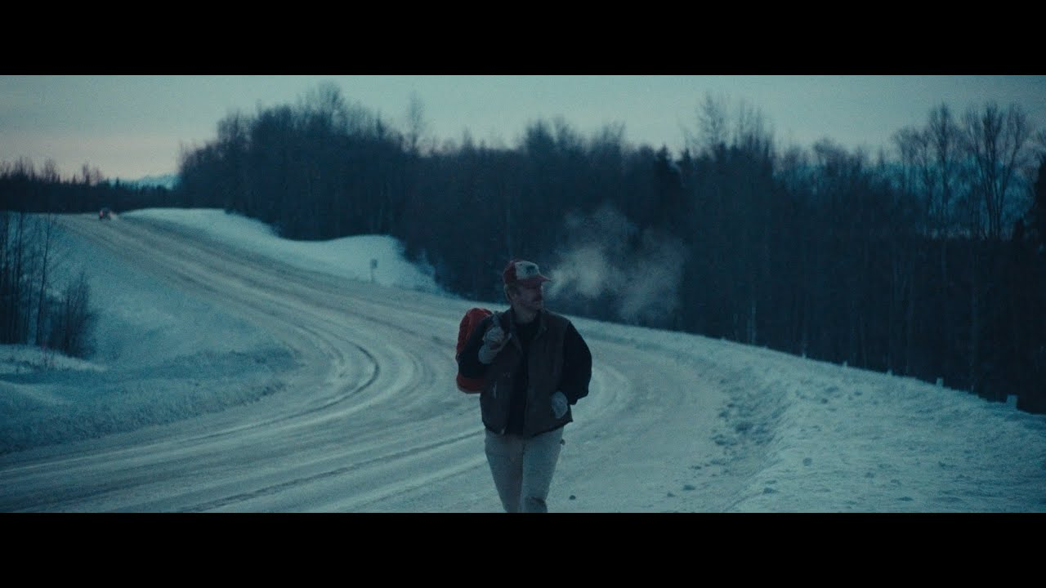

CURRENT SINGLE “SUMMER OF LUV (FT. UNKNOWN MORTAL ORCHESTRA)” TOP 15 + RISING AT ALT RADIO

LISTEN TO “SUMMER OF LUV”

(October 5, 2023) Multi-platinum, GRAMMY ® Award-winning rock band Portugal. The Man release the official music video for “Anxiety:Clarity (feat. Paul Williams)” – the second video release from the band’s Chris Black Changed My Life Music Video Trilogy.

Starring frontman John Gourley, the video was shot in the band’s home state of Alaska – where the band has filmed many videos throughout the course of their career – and filmed on the unceded ancestral lands of the Knik Tribe.

Today’s release follows the official video for “Doubt,” released last month. Both songs are standout tracks lifted off the band’s most recent album CHRIS BLACK CHANGED MY LIFE, which arrived to immediate acclaim upon release in June – download/stream HERE.

Both videos were directed by acclaimed cinematographer and frequent collaborator Michael Ragen, who has directed many of the band’s other visuals, including official videos for “Noise Pollution,” “Evil Friends,” “Sleep Forever,” and more, and served as DP on “Feel It Still,” among many other releases over the years.

"The videos are daydreaming … we're capturing the recklessness of us as kids where we can be creative in our own little worlds. We can be Alaskan creative, you can go big; as far as you can see there are no limits. I love it, because the people there are up for anything, and they know how to find the fun and humor. The humor in all of it…that is so stupidly Portugal. The Man. We make videos there because in Alaska, anything is possible -- that’s it, but also it's also about family and our community. I want to make art with the people I love. "
- John Gourley

“Filming PTM videos in Alaska has become tradition at this point. We’ve been filming there for the past four albums and I guess I can’t get enough of the subzero temperatures, but ultimately it’s an unmissable opportunity to escape the traditional structure and roles of filmmaking and just go experiment in the harshest possible environment during the coldest time of year with the coolest people."
- Michael Ragen

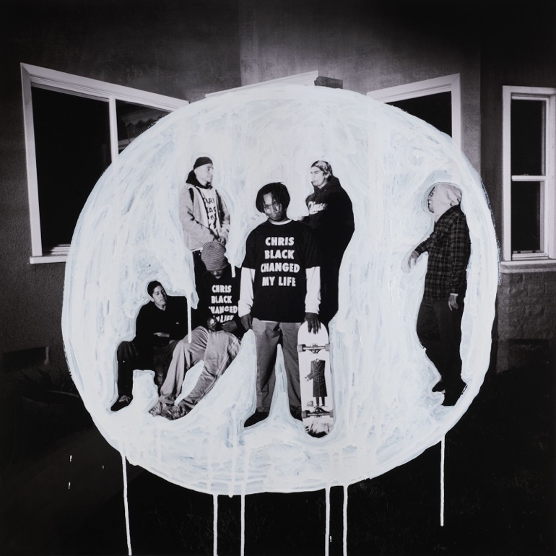
DOWNLOAD ALL PRESS ASSETS

CHRIS BLACK CHANGED MY LIFE was produced by the legendary Jeff Bhasker (Beyonce, Harry Styles, SZA, Mark Ronson) and features collaborations with Paul Williams (John Lennon, David Bowie, Mac Miller), Asa Taccone, Black Thought, Unknown Mortal Orchestra, Nick Reinhart, Homer Steinweiss, Natalia Lafourcade, and Bhasker.

CHRIS BLACK CHANGED MY LIFE marks the band’s first full-length since the release of their 2017 album Woodstock, which spurned the Platinum-certified smash “Feel It Still.” The album’s title pays homage the band’s late friend and honorary band member, Chris Black.

CHRIS BLACK CHANGED MY LIFE TRACKLIST:
Heavy Games II (feat. Jeff Bhasker)
Grim Generation
Thunderdome [W.T.A] (feat. Black Thought & Natalia Lafourcade)
Dummy
Summer of Luv (feat. Unknown Mortal Orchestra)
Ghost Town
Time’s a Fantasy (feat. Jeff Bhasker)
Doubt
Plastic Island
Champ (feat. Edgar Winter)
Anxiety:Clarity (feat. Paul Williams)

UPCOMING LIVE SHOWS
10/6 – Austin, TX @ Austin City Limits
10/7 – Dallas, TX @ Granada Theater
10/8 – Dallas, TX @ Granada Theater
10/13 – Austin, TX @ Austin City Limits
11/3 – Eugene, OR @ McDonald Theatre
11/4 – Boise, ID @ Knitting Factory
11/6 – Vancouver, BC – Orpheum
11/8 – Calgary, AB – Grey Eagle
11/9 – Edmonton, AB – Edmonton Convention Centre
11/11 – Winnipeg, MB – Burton Cummings Theatre
11/14 – London, ON – London Music Hall
11/15 – Toronto, ON – HISTORY
11/16 – Toronto, ON – HISTORY
11/18 – Ottawa, ON – Ey Centre
11/19 – Montreal, QC – MTELUS

DOWNLOAD ALL PRESS ASSETS

PRESS CONTACTS:
Jason Davis | Jason.Davis@atlanticrecords.com
Libby Kober | Libby.Kober@atlanticrecords.com

ABOUT PORTUGAL. THE MAN:
Over the past decade, Portugal. The Man has established themselves as one of rock’s most prized possessions and a live phenomenon, with over 1,600 shows under their belts and a storied reputation as festival favorites.

Originally heralding from Alaska, the Portland-based band soared to new heights in 2017 with the release of their now RIAA certified-Platinum album, Woodstock. The album was marked by the astounding success of their infectious single, “Feel It Still,” which earned the group a plethora of new accolades – including a GRAMMY for “Best Pop Duo/Group Performance,” a 7x RIAA Platinum certification, a record setting 20-week residency at #1 on alternative radio, and an inescapable presence on the Top 40 airwaves.

Alongside the shine of their myriad of musical accomplishments lies the group’s long-standing passion for social justice. In fact, this is precisely the intersection in which Portugal. The Man thrives; throughout their career, the band has consistently exemplified how to deeply commit to both artistry and activism. This ultimately inspired them to officially launch PTM Foundation in 2020, focused on universal issues related to human rights, community health, and the environment, with an emphasis on causes directly impacting Indigenous Peoples, including Alaska Native Health (providing the highest quality of health services for Alaska Native people) and Seeding Sovereignty (radicalizing and disrupting colonized spaces through land, body, food sovereignty work and more).

Portugal. The Man have also partnered with an array of organizations such as National Coalition Against Censorship, The Skatepark Project (helping communities build public skate parks for youth in underserved communities), March for Our Lives (Gun Reform), Keep Oregon Well (Mental Health), and Protect Our Winters (Climate Change), to name just a few. In 2022, the band furthered their passion for activism when they launched PTM’s NIGHT OUT initiative – supporting disabled fans requiring ADA access.

ABOUT CHRIS BLACK CHANGED MY LIFE:
We lost a very dear friend of ours on May 19, 2019. It shook us to our core. Chris was one of those people who was like glue; he brought everyone together. His passing really messed with us. The band was in shambles and this record is the first time I feel I made a complete record; a complete thought about our world crumbling around us and the journey back. While it is a very personal journey, I feel like everyone has a Chris Black in their life; at least I hope that everyone has a Chris Black in their life. That one friend who has a way of making everything right and making everything fun. The one who keeps you in check when you go off course and is always there to celebrate the good times and to support you in the bad times. Chris Black Changed My Life.

# # #

