PORTUGAL. THE MAN RELEASE “DOUBT – MIZMOR VERSION”

NEW REWORK ARRIVES ACCOMPANIED BY OFFICIAL MUSIC VIDEO STARRING THE ACCLAIMED BLACK METAL MUSICIAN ALONGSIDE P.TM’s JOHN GOURLEY + ZOE MANVILLE

WATCH “DOUBT – MIZMOR VERSION” MUSIC VIDEO

FILMED IN ALASKA ON THE UNCEDED ANCESTRAL LANDS OF THE KNIK TRIBE, YUHAAVIATAM, MAARENGA’YAM, CHUMASH, AND TONGVA (GABRIELENO)
DIRECTED BY CINEMATOGRAPHER/FREQUENT COLLABORATOR MICHAEL RAGEN

MARKS FINAL RELEASE FROM THE BAND’S
CHRIS BLACK CHANGED MY LIFE MUSIC VIDEO TRILOGY

WATCH “ANXIETY:CLARITY” MUSIC VIDEO
WATCH “DOUBT” MUSIC VIDEO
LISTEN TO CHRIS BLACK CHANGED MY LIFE

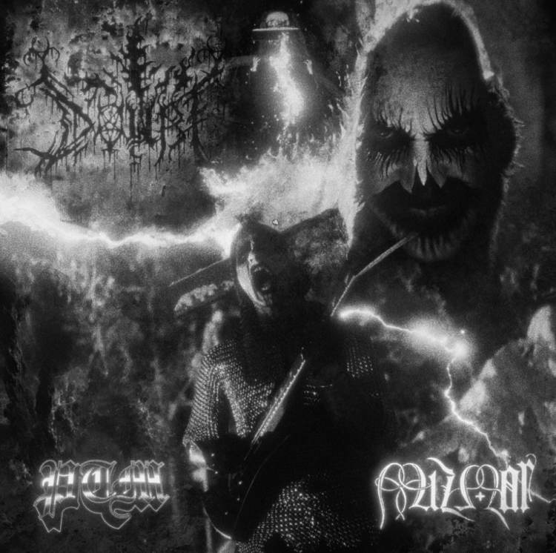
DOWNLOAD HI-RES SINGLE ARTWORK

CURRENT SINGLE “SUMMER OF LUV (FT. UNKNOWN MORTAL ORCHESTRA)”
TOP 15 + RISING AT ALT RADIO | LISTEN TO “SUMMER OF LUV”

(October 13, 2023) Multi-platinum, GRAMMY ® Award-winning rock band Portugal. The Man release “Doubt – Mizmor Version.” The new track marks a rework of “Doubt” (originally released on PTM’s June 2023 album Chris Black Changed My Life) courtesy of acclaimed, Portland-based metal musician Mizmor.

It arrives accompanied by an official music video – a haunting, slightly bloody, black-and-white visual which stars Portugal. The Man frontman John Gourley and vocalist Zoe Manville, as well as Mizmor himself. Listen to the single HERE + watch the video HERE.

The video was shot in the band’s home state of Alaska, where they’ve filmed most of the videos throughout the course of their career. Today’s release was specifically filmed on the unceded ancestral lands of the Knik Tribe, Yuhaaviatam, Maarenga’yam, Chumash, and Tongva (Gabrieleno).

It marks the third and final video release from Portugal. The Man’s Chris Black Changed My Life Music Video Trilogy. All three videos within the trilogy were directed by acclaimed cinematographer and frequent collaborator Michael Ragen, who has directed and/or served as DP on many of the band’s other visuals, including “Noise Pollution,” “Evil Friends,” “Sleep Forever” and “Feel It Still,” to name just a few.

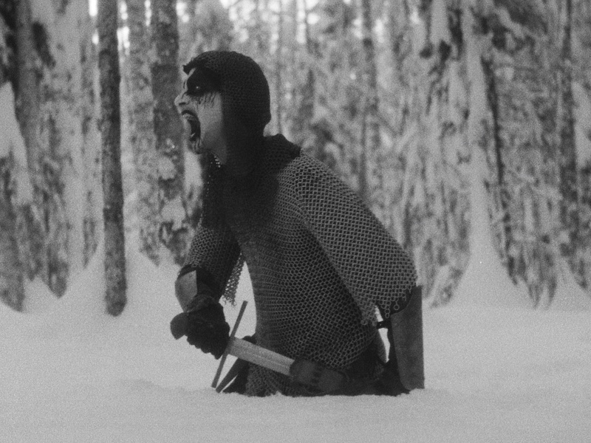
[video still]

Of the collaboration, Mizmor shares:
“Collaborating with John and Mike was a lot of fun. My brother, Ryan, used to play in Portugal. The Man, and I was the kid brother who played heavy music; I think John always thought that was kind of cool… but it wasn't until Mike's music video trilogy idea that it clicked on exactly how to meld the Mizmor sound with the PTM sound… Instead of stripping everything away and rebuilding from the ground up, like many remixes do, I was able to almost directly adapt the chords into my style. I also wrote a doom metal outro, to make sure we showcased the slower side of Mizmor, and I was able to put one of John's vocal melodies on top of it in the form of lead guitar (blended with one of Zoe's vocal takes). I'm really proud of how the song came out. It totally rips, and it's also really interesting to hear a more traditional pop structure (verse, chorus, verse, chorus, bridge, outro) behind a black metal song, because the genre doesn't typically do that. This results in a certain catchiness that, though most black metallers would be tempted to resist, I find undeniable in this context (since the song still shreds)… And I think a lot of non-metal artists either have a soft spot for metal, or are just intrigued by the genre, because it allows for a very cathartic expression of dark or negative emotions (like depression, anxiety, and existential dread), which ends up being therapeutic and positive for both the artist and their listeners.”

“Doubt – Mizmor Version” follows the official videos for “Anxiety:Clarity” and “Doubt,” which were released earlier this fall. Both songs are standout tracks lifted off the band’s most recent album, CHRIS BLACK CHANGED MY LIFE, which arrived to immediate acclaim upon release in June – listen HERE.

"The videos are daydreaming … we're capturing the recklessness of us as kids where we can be creative in our own little worlds. We can be Alaskan creative, you can go big; as far as you can see there are no limits. I love it, because the people there are up for anything, and they know how to find the fun and humor. The humor in all of it…that is so stupidly Portugal. The Man. We make videos there because in Alaska, anything is possible -- that’s it, but also it's also about family and our community. I want to make art with the people I love. "
- John Gourley

“Filming PTM videos in Alaska has become tradition at this point. We’ve been filming there for the past four albums and I guess I can’t get enough of the subzero temperatures, but ultimately it’s an unmissable opportunity to escape the traditional structure and roles of filmmaking and just go experiment in the harshest possible environment during the coldest time of year with the coolest people."
- Michael Ragen

CHRIS BLACK CHANGED MY LIFE was produced by the legendary Jeff Bhasker (Beyonce, Harry Styles, SZA, Mark Ronson) and features collaborations with Paul Williams (John Lennon, David Bowie, Mac Miller), Asa Taccone, Black Thought, Unknown Mortal Orchestra, Nick Reinhart, Homer Steinweiss, Natalia Lafourcade, and Bhasker.

CHRIS BLACK CHANGED MY LIFE marks the band’s first full-length since the release of their 2017 album Woodstock, which spurned the Platinum-certified smash “Feel It Still.” The album’s title pays homage the band’s late friend and honorary band member, Chris Black. The band will continue their marquee US tour dates in support of the album with a highly-anticipated set at weekend two of Austin City Limits later today, Friday, October 13.

--

CHRIS BLACK CHANGED MY LIFE TRACKLIST:
Heavy Games II (feat. Jeff Bhasker)
Grim Generation
Thunderdome [W.T.A] (feat. Black Thought & Natalia Lafourcade)
Dummy
Summer of Luv (feat. Unknown Mortal Orchestra)
Ghost Town
Time’s a Fantasy (feat. Jeff Bhasker)
Doubt
Plastic Island
Champ (feat. Edgar Winter)
Anxiety:Clarity (feat. Paul Williams)

UPCOMING PORTUGAL. THE MAN LIVE SHOWS
10/13 – Austin, TX @ Austin City Limits
11/3 – Eugene, OR @ McDonald Theatre
11/4 – Boise, ID @ Knitting Factory
11/5 – Seattle, WA @ Showbox
11/6 – Vancouver, BC – Orpheum
11/8 – Calgary, AB – Grey Eagle
11/9 – Edmonton, AB – Edmonton Convention Centre
11/11 – Winnipeg, MB – Burton Cummings Theatre
11/14 – London, ON – London Music Hall
11/15 – Toronto, ON – HISTORY
11/16 – Toronto, ON – HISTORY
11/18 – Ottawa, ON – Ey Centre
11/19 – Montreal, QC – MTELUS

DOWNLOAD ALL PRESS ASSETS

PRESS CONTACTS:

Portugal. The Man:
Jason Davis | Jason.Davis@atlanticrecords.com
Libby Kober | Libby.Kober@atlanticrecords.com

Mizmor:
Shannon Void | inaperfectworldproductions@gmail.com

ABOUT MIZMOR:
Following the band's critically acclaimed albums, “Wit’s End” and “Cairn,” Mizmor’s evolution reveals an ascension from the noose of past trauma. “Prosaic” transcends. Four new compositions of black doom, narrated by Mizmor mastermind and multi-instrumentalist, A.L.N., show him looking forward - forging a path of new perspective, self-acceptance, and confidently building a future, untethered. Written, performed, recorded, and produced by A.L.N., "Prosaic" redefines and surpasses modern American Black Metal and Doom. The landmark album reveals Mizmor's seismic labyrinths as vignettes of a life being lived - with breaths of hope where hope seemed lost before. Staying true to his vision of using art and music to process grief and life’s struggles through creating and sharing, A.L.N. 's evolution exposes the journey of breaking free from that which no longer serves us. "Prosaic" is available now through Profound Lore Records.

ABOUT PORTUGAL. THE MAN:
Over the past decade, Portugal. The Man has established themselves as one of rock’s most prized possessions and a live phenomenon, with over 1,600 shows under their belts and a storied reputation as festival favorites.

Originally heralding from Alaska, the Portland-based band soared to new heights in 2017 with the release of their now RIAA certified-Platinum album, Woodstock. The album was marked by the astounding success of their infectious single, “Feel It Still,” which earned the group a plethora of new accolades – including a GRAMMY for “Best Pop Duo/Group Performance,” a 7x RIAA Platinum certification, a record setting 20-week residency at #1 on alternative radio, and an inescapable presence on the Top 40 airwaves.

Alongside the shine of their myriad of musical accomplishments lies the group’s long-standing passion for social justice. In fact, this is precisely the intersection in which Portugal. The Man thrives; throughout their career, the band has consistently exemplified how to deeply commit to both artistry and activism. This ultimately inspired them to officially launch PTM Foundation in 2020, focused on universal issues related to human rights, community health, and the environment, with an emphasis on causes directly impacting Indigenous Peoples, including Alaska Native Health (providing the highest quality of health services for Alaska Native people) and Seeding Sovereignty (radicalizing and disrupting colonized spaces through land, body, food sovereignty work and more).

Portugal. The Man have also partnered with an array of organizations such as National Coalition Against Censorship, The Skatepark Project (helping communities build public skate parks for youth in underserved communities), March for Our Lives (Gun Reform), Keep Oregon Well (Mental Health), and Protect Our Winters (Climate Change), to name just a few. In 2022, the band furthered their passion for activism when they launched PTM’s NIGHT OUT initiative – supporting disabled fans requiring ADA access.

ABOUT CHRIS BLACK CHANGED MY LIFE:
We lost a very dear friend of ours on May 19, 2019. It shook us to our core. Chris was one of those people who was like glue; he brought everyone together. His passing really messed with us. The band was in shambles and this record is the first time I feel I made a complete record; a complete thought about our world crumbling around us and the journey back. While it is a very personal journey, I feel like everyone has a Chris Black in their life; at least I hope that everyone has a Chris Black in their life. That one friend who has a way of making everything right and making everything fun. The one who keeps you in check when you go off course and is always there to celebrate the good times and to support you in the bad times. Chris Black Changed My Life.

# # #

