FOR IMMEDIATE RELEASE
AUGUST 31, 2023

TION WAYNE RETURNS WITH NEW RAP TRACK “AMEN”

THE NEW SINGLE FEATURES BRITISH RAPPER NINES

ACCOMPANIED BY AN OFFICIAL COMPANION VISUAL

COMES ON THE HEELS OF PREVIOUSLY RELEASED SINGLE “HEALING”

WATCH/SHARE “AMEN”
DOWNLOAD/STREAM “AMEN”

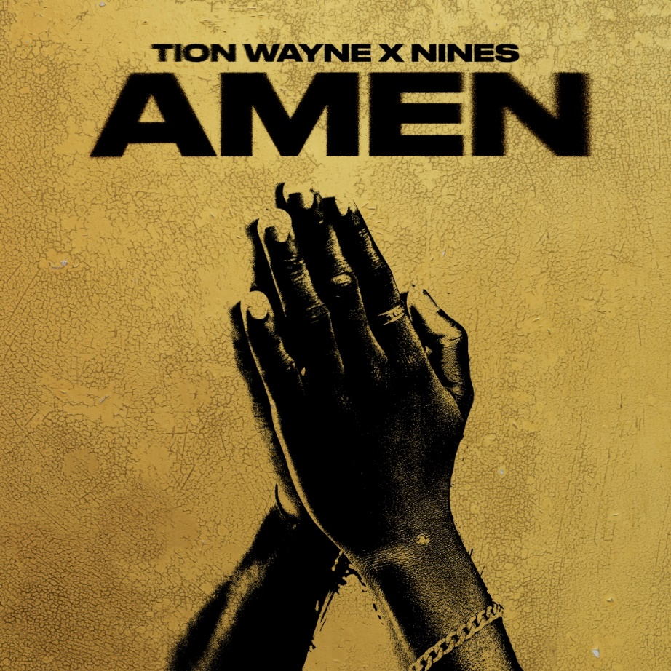

Today UK titan Tion Wayne, is back with his latest rap smash “Amen,” featuring Nines. The track produced by Smokey & Gusto is and is accompanied by an official companion visual.

Following up after his super smash “Healing” the MOBO-winning, Brit-nominated rapper teams up with celebrated rapper Nines to deliver a heavy-based track, which reminisces and reflects on the changes and experiences they’ve encountered; declaring it’s now time to heal. Supported by the charismatic and uplifting vocals of the House Gospel Choir.

Hailing from Northwest London, Nines first burst onto the scene in 2011 and has evolved into one of the UK’s rap powerhouses with his debut album One Foot Out, landing the number 4 spot in the UK official charts. After a slew of singles, September 2020 saw Nines release his album Crabs In A Bucket, landing him the number 1 spot on the Official Charts.
The visuals shot by WOWA [AJ Tracey, Aitch] take us into the world of extravagance with Tion and Nines surrounded by luxury supercars. The footage also celebrates Nines' first-ever appearance in another artist’s video.

With billions of streams, Tion’s epic track Body (featuring Russ Millions), was the first-ever drill track to reach No.1 in the UK, Ireland, Australia, and New Zealand and is one of the most viewed videos on YouTube and GRM Daily alongside one of the most used sounds on TikTok.

With 6 UK Top 10 hits to his name, a Top 5 debut album (Green With Envy) and a collaboration with Central Cee and Ed Sheeran on the “Bad Habits (Fumes The Engineer Remix),” Tion Wayne has morphed into one of the UK’s biggest stars, with sold shows across the UK and stellar support across BBC Radio 1 and 1Xtra, he’s also topped some of the Spotify top playlists like Hot Hits UK, Rap UK and Who We Be. Alongside co-signs and collaborations with the likes of Stormzy, Rema, Central Cee, Jack Harlow, D-Block Europe, NSG, and Rudimental to name a few. Tion Wayne continues to go from strength to strength.

FOLLOW TION WAYNE
TWITTER| INSTAGRAM | TIKTOK

PRESS CONTACT
SELAM BELAY | SELAM.BELAY@ATLANTICRECORDS.COM

