JULIE SHARES NEW SINGLE "CATALOGUE"

ANNOUNCES NORTH AMERICAN TOUR DATES INCLUDING CAMP FLOG GNAW

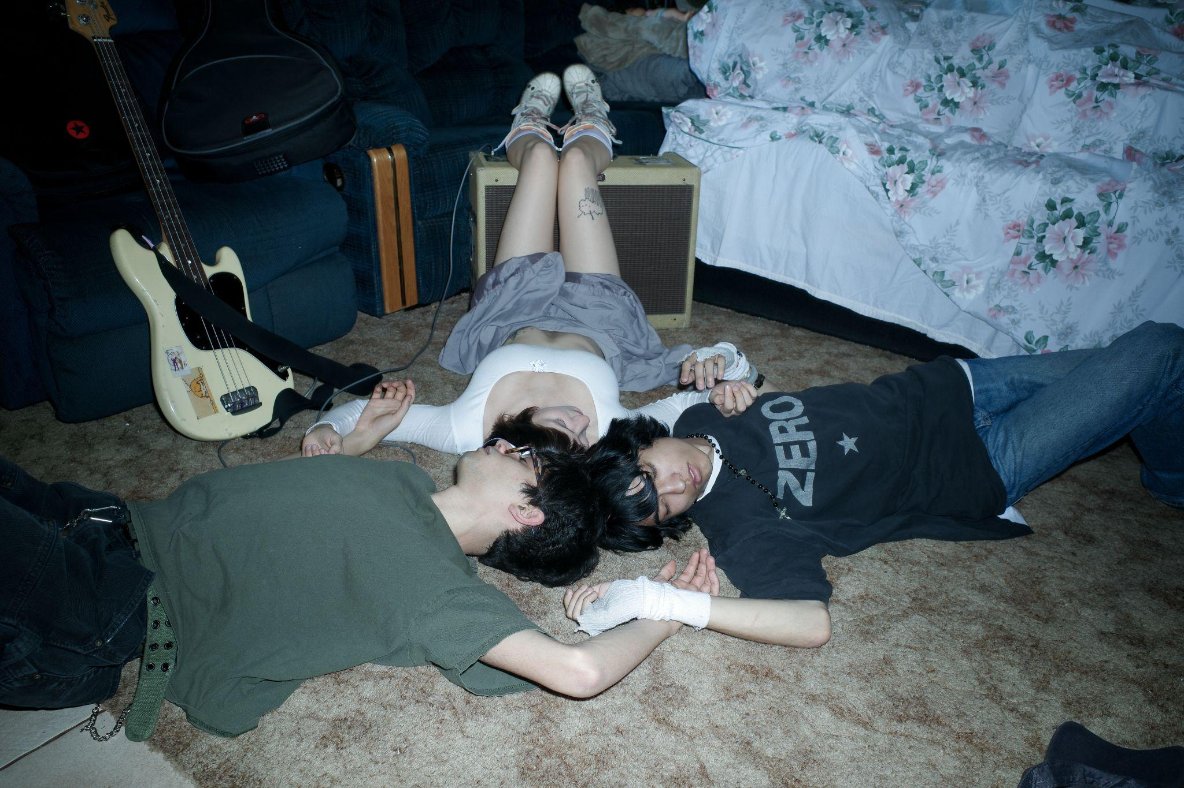
julie by maya spangler

"catalogue"
https://julie.lnk.to/catalogue

(September 29, 2023) - julie releases "catalogue," their first single of 2023. The song follows last year's double single "pg.4 a picture of three hedges" and "through your window" and arrives on the heels of the band announcing their fall North American tour. Nearly every date on the upcoming tour sold out upon tickets going on sale, prompting changes to larger venues in many markets. It continues the band’s impressive touring history despite not yet having a full length album released.

The band’s forthcoming North American run closes with three homecoming shows in Southern California, where the band will perform at Tyler, The Creator's Camp Flog Gnaw Carnival as well as two headlining shows at The Constellation Room in Santa Ana, CA. This fall's North American tour follows the band's European summer festival run that included sold-out headlining shows in London, Manchester, Glasgow, and Berlin. Remaining tickets for julie's North American tour are available HERE.

Listen to "catalogue" above now and stay tuned for more news from julie soon.

Upcoming Live Dates
10/23 - Tucson, AZ @ Club Congress (SOLD OUT)
10/24 - Austin, TX @ Parish (SOLD OUT)
10/25 - Houston, TX @ Bronze Peacock Room (SOLD OUT)
10/26 - Dallas, TX @ Club Dada (SOLD OUT)
10/28 - Nashville, TN @ drkmttr (SOLD OUT)
10/29 - Atlanta, GA @ Aisle 5 (SOLD OUT)
10/30 - Raleigh, NC @ Kings (SOLD OUT)
10/31 - Washington, DC @ Songbyrd (SOLD OUT)
11/1 - Philadelphia, PA @ Ukie Club (SOLD OUT)
11/3 - New York, NY @ Bowery Ballroom (SOLD OUT)
11/5 - Columbus, OH @ Ace of Cups (SOLD OUT)
11/6 - Chicago, IL @ Schubas Tavern (SOLD OUT)
11/8 - Denver, CO @ Larimer Lounge (SOLD OUT)
11/11 or 11/12 - Los Angeles, CA @ Camp Flog Gnaw (SOLD OUT)
12/1 - Santa Ana, CA @ Constellation Room (SOLD OUT)
12/2 - Santa Ana, CA @ Constellation Room (SOLD OUT)

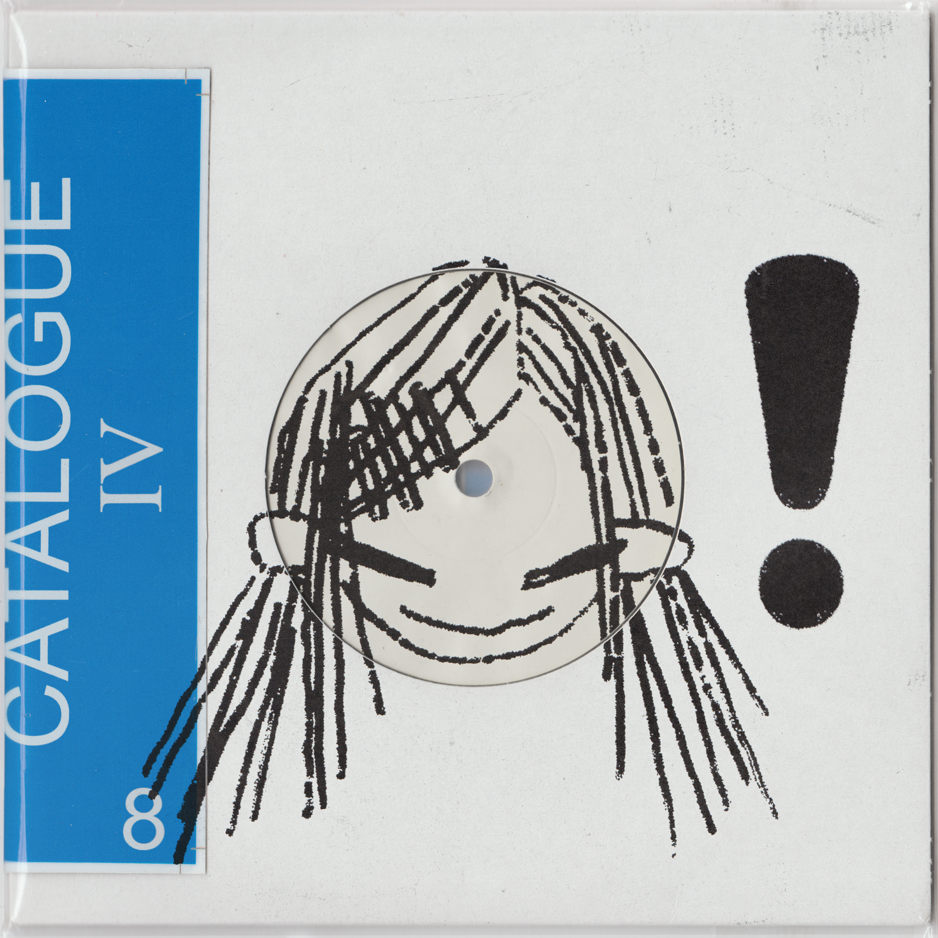
single artwork

﻿(Download hi-res assets HERE)

Connect with julie:
Instagram

For all julie inquiries please contact Nick at Orienteer:
nick@orienteer.us

