MARYJO CELEBRATES HER HOMETOWN WITH “CLEVELAND”

RISING SINGER-SONGWRITER RELEASES HEARTFELT NEW BALLAD

LISTEN | WATCH

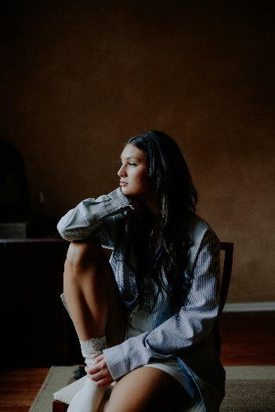
DOWNLOAD HI-RES IMAGES

Rising singer-songwriter maryjo is celebrating her hometown with her latest single, “Cleveland,” available today via Atlantic Records. Produced by David Alan Schaeman (Alex Warren), written by Mary Jo Young and co-written with Annika Wells (BTS, Illenium), Sierra Phuong Thao Deaton (5 Seconds of Summer, Luke Hemmings, Jamie Miller) the deeply earnest ballad is accompanied by an official music video showcasing fashion from several Cleveland-based vendors.

“Cleveland’s my favorite city ever,” says maryjo. “Every time I leave it’s always hard, but so much of my inspiration for music has come from there. That is why I wanted to write about Cleveland, missing my friends, and just about it in general. I’m grateful to have such amazing friends and family out there that make me miss it!”

“Don’t Call Me” marks the latest in a series of singles that have earned maryjo more than 4M worldwide streams and counting, including the high-spirited “Don’t Call Me” and the compelling “Traffic.”

This spring saw the arrival of maryjo’s label debut single, “Love Fools,” available now alongside an intimate music video that follows the highs and lows of a stormy relationship via her home security cameras. Hailed by Billboard as “a showcase for Cleveland singer-songwriter Maryjo, whose words tumble out with searing emotion and who untangles some knotty melodies on this beautifully rendered piano ballad... a great introduction,” the tender ballad features backing from GRAMMY® Award-nominated, 2x ACM Award-winning blind piano virtuoso Gordon Mote.

Currently boasting more than 1.3M TikTok followers and over 27.4M total likes, maryjo has the kind of phenomenal vocal command made for heart-melting piano ballads, often drifting from full-throated belting to a gorgeously fragile delivery inflected with cracks. Though it took years for the artist to overcome her fear of singing in front of others, she worked through her shyness by sharing videos on social media and quickly earned a devoted fan following for her singular and evocative vocal power. The 22-year-old artist continued to capture attention as a fan-favorite contestant on Season 19 of the landmark singing competition series, American Idol, earning praise for her unique renditions of songs by Ed Sheeran, James Bay, Tate McRae, and Jewel, teaming with the latter for a memorable duet performance of the classic “Foolish Games.” Now, with the sentimental “Cleveland” – and more new music on the way – maryjo remains steadfast in her goals, relating breathtaking emotion and musical artistry by simply staying true to her instincts.

“With every song I sing, I try to think about every single angle that people could hear it from and all the ways they could possibly connect to it,” says maryjo. “I’m already getting my therapy from the whole process of writing and recording, so I want to make sure that I’m giving people something that helps them tap into their own emotions and makes them feel better about whatever they’re going through.”

# # #

CONNECT WITH MARYJO
WEBSITE | INSTAGRAM | TIKTOK | YOUTUBE

PRESS CONTACT
Christina.Kotsamanidis@atlanticrecords.com

