FOR IMMEDIATE RELEASE
NOVEMBER 7, 2023
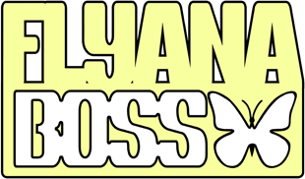

FLYANA BOSS SET TO EMBARK ON THE BOSSTANICAL GARDEN
HEADLINE TOUR IN 2024

DEBUT HEADLINE TOUR FOLLOWS SUCCESSFUL GUEST RUN ON JANELLE MONÁE’S
2023 THE AGE OF PLEASURE TOUR

TIKTOK PRESALE TICKETS AVAILABLE ON WEDNESDAY, NOVEMBER 8 AT 10AM LOCAL TIME HERE

GENERAL ONSALE BEGINS FRIDAY, NOVEMBER 10 AT 10AM LOCAL TIME

DOWNLOAD ADMAT HERE

Rising cute-girl rap duo Flyana Boss is on the road again, following their first tour run as support for Janelle Monáe’s “The Age Of Pleasure” Tour, this time with their own headlining show. The 18-city tour kicks off on February 24, 2024 at Schubas Tavern in Chicago, IL. The viral sensations will make stops in their home cities of Detroit and Dallas, in addition to Toronto, Brooklyn, Washington D.C., Denver, and more before wrapping the tour in their home-base, Los Angeles. Further ticketing information can be found HERE.

Flyana Boss burst onto the scene with their breakout single, “You Wish,” which debuted at # 1 on Spotify’s “Viral 100” amidst worldwide attention from hip-hop legends Missy Elliott and Timbaland as well as such high-profile media outlets as Variety, Complex, NYLON, Vulture, UPROXX, Ones To Watch, and Rolling Stone, among many others. Produced by hitmaker Marky Style, the track – featured on the two-track single “You Wish + Trashboi” – quickly proved a sensation, earning over 31M global streams to date while rocketing the duo into the spotlight (and kickstarting a spirited viral discussion regarding the word “Kanekalon”).

“You Wish” was joined by an official music video, directed by Brad Wong (IV Jay Feat. Pink Sweat$) and streaming now at YouTube HERE. The colorful new visual came to life earlier this summer after Flyana Boss posted a “You Wish” TikTok while riding DoorDash-branded bikes, earning more than 10M views and the attention of fans everywhere. DoorDash delivered (pun intended) on the public response, officially joining forces with Flyana Boss for the irresistible “You Wish” visual. Entertainment Tonight recently took an exclusive “Behind The Scenes” look at the making of “You Wish,” streaming HERE. As the duo manifested, they are quite literally swimming in brand deals, most recently collaborating with Pizza Hut and Converse.

Flyana Boss’s Black Girl Magic is further captured on a pair of spectacular “You Wish” remixes, including the star-studded “You Wish (with Missy Elliott & Kaliii) – Remix,” featuring brand new verses from Flyana Boss and their guest stars, streaming HERE. “You Wish – DJ Smallz 732 – Jersey Club Remix,” another spin on the hit track, is available HERE. Following the success of “You Wish”, the duo dropped two new singles, “Bitch Imma Star” and “Big One”.

Hailing from Detroit, MI and Dallas, TX respectively, Bobbi and Folayan met at a music college in Los Angeles where they immediately hit it off and began collaborating. The fierce duo adopted the name Flyana Boss (rhymes with Diana Ross), repping the Vagina Dynasty while simultaneously embodying the spirit of flyness and bossness. Together, Bobbi and Folayan form a formidable union that pushes the boundaries of contemporary hip-hop, seamlessly blending their individual strengths to create a sound that is distinctively Flyana Boss. Bobbi brings a knack for storytelling and infuses her music with authenticity and vulnerability as Folayan effortlessly switches between different styles and genres, adding depth and dimension to Flyana Boss’ one-of-a-kind music.

Increasingly known for their unforgettable live performances – including a spectacular set at New Orleans’s Essence Festival of Culture highlighted by a twerkable onstage moment with Megan Thee Stallion – Flyana Boss are focused on creating music that reflects their experiences and resonates with their listeners, embracing their uniqueness and uplifting others through their art. Following their special guest run on Janelle Monáe’s The Age of Pleasure Tour, Flyana Boss headed Down Under for Australia’s SXSW Sydney, the first-ever international edition of the famed Austin, TX music festival, which took place October 18-21.

With talent, ambition, and more impossible-to-resist tracks to come, Flyana Boss is poised to leave an indelible mark on the hearts and minds of music lovers worldwide.

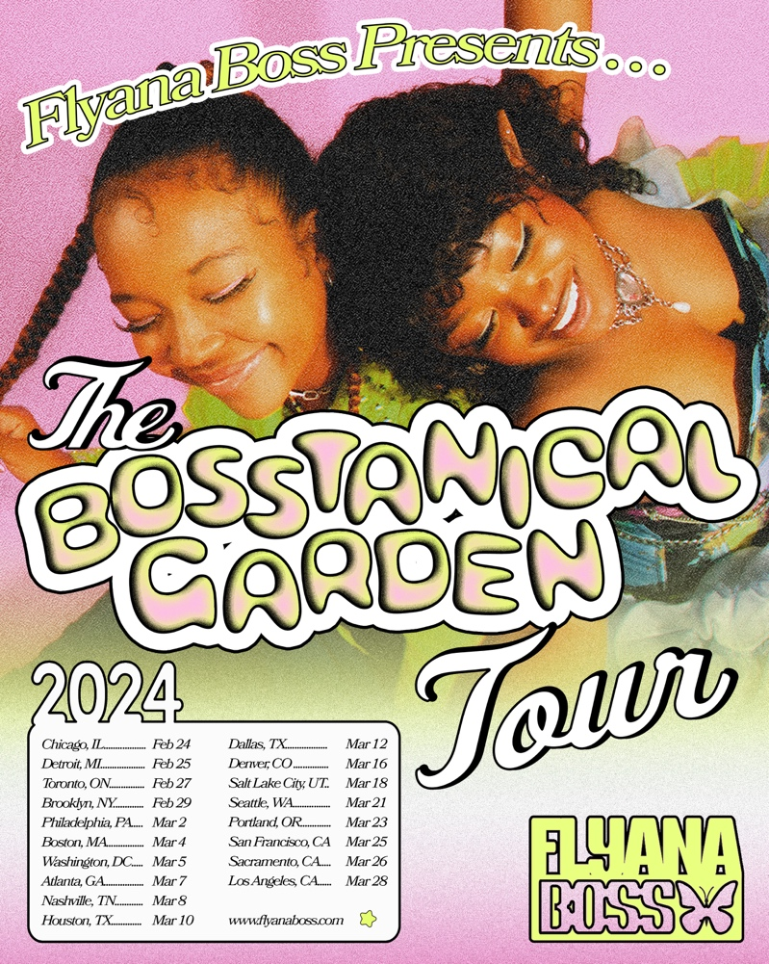
DOWNLOAD ADMAT HERE

FEBRUARY
24 – Chicago, IL – Schubas Tavern
25 – Detroit, MI – Shelter
27 – Toronto, ON – The Drake Underground
29 – Brooklyn, NY – Baby’s All Right

MARCH
2 – Philadelphia, PA – The Foundry at The Fillmore
4 – Boston, MA – Berklee College of Music – The Red Room at Cafe 939
5 – Washington, DC – The Atlantis
7 – Atlanta, GA – Aisle 5
8 – Nashville, TN – The Basement East
10 – Houston, TX – House of Blues Bronze Peacock
12 – Dallas, TX – House of Blues Cambridge Room
16 – Denver, CO – Meow Wolf
18 – Salt Lake City, UT – Kilby Court
21 – Seattle, WA – Barboza
23 – Portland, OR – Holocene
25 – San Francisco, CA – Cafe Du Nord
26 – Sacramento, CA – Harlow’s – The Starlet Room
28 – Los Angeles, CA – The Echo

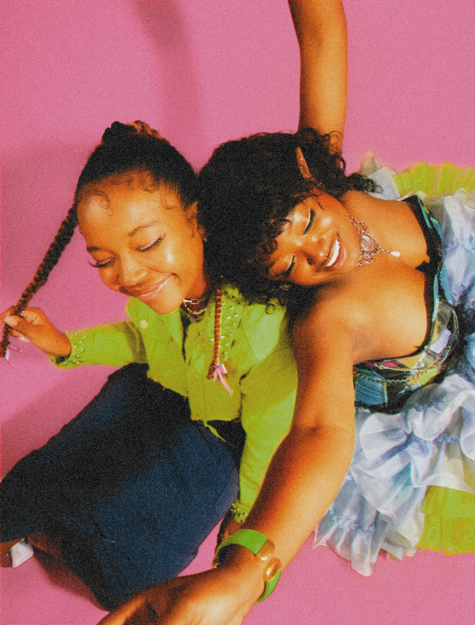
DOWNLOAD PRESS PHOTO HERE // PHOTO CREDIT: SJ SPRENG

CONNECT WITH FLYANA BOSS
FLYANABOSS.COM | INSTAGRAM | TIKTOK | TWITTER | YOUTUBE

PRESS CONTACT
FAIRLEY MCCASKILL | FAIRLEY.MCCASKILL@ATLANTICRECORDS.COM

