FOR IMMEDIATE RELEASE
NOVEMBER 10, 2023

OUT NOW: BRELAND PUTS A STUNNING VOCAL SPIN ON
“THE CHRISTMAS SONG”

COZY AND CALMING RENDITION CAPTURES A CHRISTMASTIME CLASSIC
IN NEW LIGHT

CROSS COUNTRY RECENTLY CERTIFIED GOLD

STREAM OR DOWNLOAD BRELAND’S “THE CHRISTMAS SONG” HERE

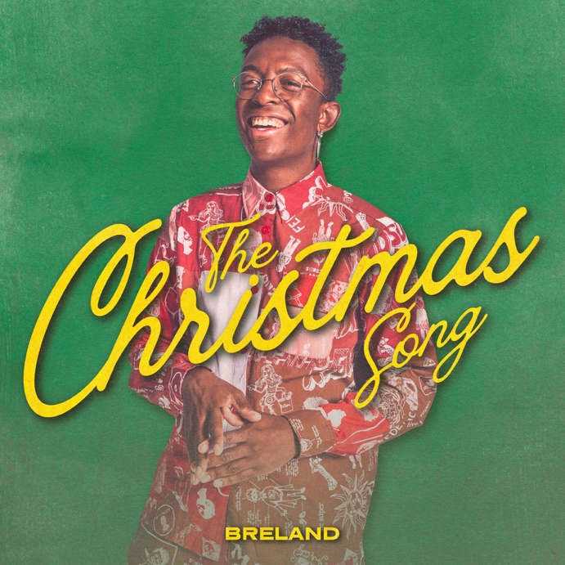
DOWNLOAD HERE
CREDIT: JAKE GERMANY / GOODCOPBADCOP LLC

NASHVILLE, TENN. – Continuing to make his presence felt in Country music, Bad Realm Records/Atlantic Records/Warner Music Nashville artist BRELAND puts his own spin on a Christmastime favorite today (11/10), sharing a vocally stunning rendition of “The Christmas Song” HERE.

Produced by Jacob Durrett and highlighting BRELAND’s one-of-a-kind voice – an electrifying fusion of fire and ice, made for the modern age – the new recording puts a fresh energy on a Classic-Pop standard, first made famous by Nat King Cole.

With a calming, sophisticated sound (more in line with a black-tie soiree than an ugly-sweater party), the track pairs twinkling piano runs and sweeping swells of orchestral strings with BRELAND’s cozy, tender presentation, helping capture the reflective nature of the holiday season. BRELAND first performed the song on ABC’s CMA Country Christmas in 2021, with fans praising his unique, warm vocal take.

BRELAND’s cover of “The Christmas Song” follows a continued stretch of milestones for the emerging star. His genre-defying debut album, CROSS COUNTRY recently earned GOLD-certification by the RIAA, while his fun-filled single “Cowboy Don’t” from the bonus edition, CROSS COUNTRY: THE EXTRA MILE, is gaining steam. A throwback video for the track also released in October. Watch the video here.

Meanwhile, BRELAND’s reputation as an onstage standout has only grown. The rising talent spent 2023 on the road as part of Shania Twain's QUEEN OF ME TOUR in the U.S. and U.K., and also made his international headlining debut with THE EXTRA MILE TOUR. The run made stops in the U.K., Germany, Netherlands, Denmark, Sweden, and Norway, and found a dedicated fanbase wherever it went. Find complete tour and ticket information here.

ABOUT BRELAND:
A boundary-shattering breakout star, BRELAND is pushing the possibilities of Country music on a global scale. Since the arrival of his PLATINUM-certified debut single “My Truck,” the New Jersey-bred singer/songwriter/producer has amassed over 1.1 BILLION career streams, brought his crowd-thrilling live show to an international headline tour, and gained acclaim from many of the world’s leading music publications (with Rolling Stone hailing him as “a symbol of Country music’s ongoing evolution” and Billboard calling him a “keen, visionary solo artist”). On his critically acclaimed 2022 debut album CROSS COUNTRY, the Bad Realm Records/Atlantic Records/Warner Music Nashville artist introduced a high-energy sound that blurs the barriers between Country, Pop, Hip-Hop, Soul, and Southern Gospel, offering up smash hits like the GOLD-certified “Praise The Lord (feat. Thomas Rhett).” A blockbuster year for BRELAND, 2023 has included such triumphs as teaming up with superstar Keith Urban to open the 16th annual Academy of Country Music Honors by performing their GOLD-certified collaboration “Throw It Back” and — immediately following the performance — receiving the ACM Lift Every Voice Award, recognizing his role in “elevating underrepresented voices throughout the Country music genre, transcending demographics and geography.” Released in September, CROSS COUNTRY: THE EXTRA MILE delivered a star-packed bonus version of his full-length debut, with the expanded album’s six fresh tracks including a brand-new feature with Brittney Spencer as well as longtime live favorite “Cowboy Don’t.” With his high-profile TV appearances to date including Good Morning America, Jimmy Kimmel Live!, The Voice, and TODAY, he also spent much of 2023 on the road as support for the legendary Shania Twain’s QUEEN OF ME TOUR in the U.S. and U.K. (with stops at iconic venues like Madison Square Garden), in addition to taking his THE EXTRA MILE TOUR across the U.K., Germany, Netherlands, Denmark, Sweden, and Norway. A truly magnetic live performer, BRELAND has also graced the stage at major festivals like Stagecoach and C2C: Country to Country Festival, fulfilling his mission of uniting audience members from all walks of life with his wildly joyful music.

# # #

DOWNLOAD HERE
CREDIT: JIMMY FONTAINE

CONNECT WITH BRELAND
WEBSITE | INSTAGRAM | FACEBOOK | X
AMAZON MUSIC | YOUTUBE | SOUNDCLOUD

MEDIA CONTACTS
Fairley McCaskill / Fairley.McCaskill@atlanticrecords.com
Jensen Sussman / Jensen@sweettalkpr.com
Kristi Bradshaw / Kristi.Bradshaw@wmg.com

