FOR IMMEDIATE RELEASE
NOVEMBER 10, 2023

JASON DERULO UNWRAPS EARLY HOLIDAY GIFT
WITH “CLOSER TO CHRISTMAS”

MULTIPLATINUM GLOBAL SUPERSTAR CELEBRATES THE SEASON
WITH FESTIVE NEW SINGLE

EPIC “NU KING WORLD TOUR” SET TO TRAVEL THROUGH JUNE 2024

IMMERSIVE NEW PODCAST SERIES, UNDERWATER,
CURRENTLY #1 ON APPLE PODCASTS STREAMING NOW
CO-STARRING AND FEATURING NEW ORIGINAL MUSIC FROM DERULO

LISTEN TO “CLOSER TO CHRISTMAS” HERE

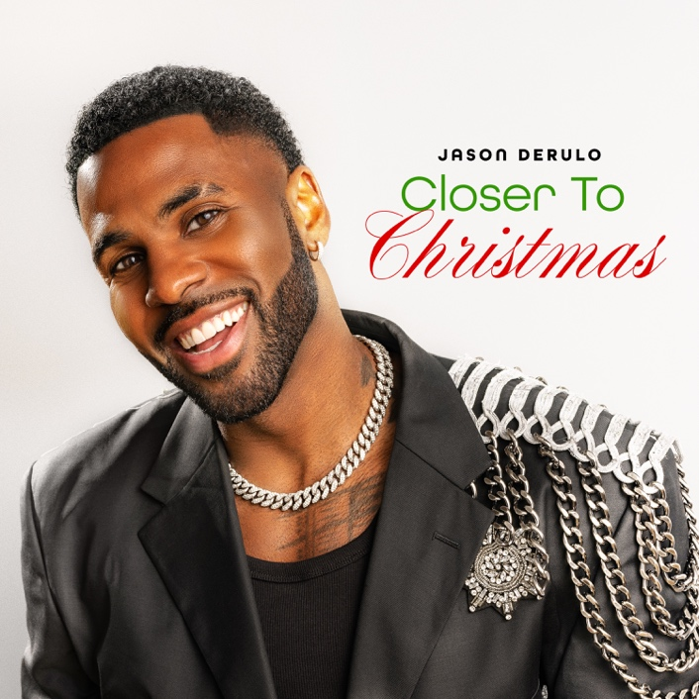
DOWNLOAD HI-RES IMAGE HERE

Jason Derulo is starting the holiday season early with his joyous new single, “Closer to Christmas,” available now via Atlantic Records HERE. The multiplatinum superstar celebrates his official transition from Halloween to the Christmas season HERE.

“Closer To Christmas” marks the latest in the indefatigable superstar’s non-stop series of releases, including his recent collaboration with fellow multiplatinum global superstar, GRAMMY® Award-winner Meghan Trainor, for the upbeat new single, “Hands On Me (Feat. Meghan Trainor),” available now HERE. The single was teased across social media by both artists – and showcased by Derulo with a spectacular live performance on NBC’s America’s Got Talent, streaming HERE. The track has amassed over 68k creates on TikTok and content using the song on platform has been viewed over 90M times. The ultimate showcase for both artists’ signature approach towards pop anthems, the irresistibly energetic track is joined by an official lyric video streaming at Derulo’s hugely popular YouTube channel HERE. “Hands On Me” was met by critical applause from the likes of American Songwriter, which raved, “Derulo has made a career of consistently switching up his sonic direction. Both artists seem in their element on this nostalgic song.”

Derulo is now embarking on the typically globe-straddling “Nu King World Tour,” kicking off tonight with a sold-out show at Melbourne, Australia’s Rod Laver Arena and followed by dates in Australia, New Zealand, Spain, Portugal, Kazakhstan, Sweden, Norway, Denmark, France, Netherlands, Luxembourg, Belgium, the United Kingdom, Ireland, Germany, Austria, Czech Republic, Italy, and Switzerland slated through June 2024. For complete details, please visit www.jasonderulo.com/tour.

The ever-active Derulo is following his recently wrapped first season as judge on The Voice Australia by co-starring alongside Alexandra Shipp (Barbie, X-Men: Apocalypse) in Underwater, a neo-noir romantic thriller presented by Interval Presents, Warner Music Group’s in-house podcast network. A rollercoaster love story told in the form of a narrative album, the series features brand new, original music from Derulo woven into the story and score, creating an innovative and immersive listening experience and making for a groundbreaking event at the cutting edge of audio entertainment. Underwater premiered October 31 on all major podcast platforms, with new episodes released weekly on Tuesdays HERE.

# # #

ABOUT JASON DERULO
Forward-thinking, genre-defying, and massively creative, Jason Derulo has staked his claim as one of the most dynamic forces on the global pop landscape. Since breaking through with his 5x RIAA Platinum-certified single, “Whatcha Say,” the award-winning singer-songwriter who has a net worth in excess of $100 million, has sold more than 250M singles worldwide and achieved 17 Platinum singles including “Wiggle“, “Talk Dirty“, “Want to Want Me,” “Trumpets,” “It Girl“, “In My Head,” “Ridin’ Solo,” “Don’t Wanna Go Home,” “Marry Me,” “ The Other Side,” “Get Ugly,” “Swalla,” “Savage Love” and “Take You Dancing.” Since the start of his solo recording career in 2009, he has earned over 18.2B worldwide streams, and built an unstoppable social media following of over 117M followers across all platforms. Now at work on his highly anticipated fifth album – and full-length debut for Atlantic Records – Derulo has delivered an ongoing series of smash singles that have drawn a stunning 500M+ views, including the irresistibly buoyant “Acapulco,” the RIAA platinum-certified “Take You Dancing,” and Jawsh 685 x Jason Derulo’s 3x platinum-certified chart-topper, “Savage Love (Laxed – Siren Beat).” The latter track – and its official BTS remix – proved an unstoppable international sensation upon its 2020 arrival, peaking at #1 on Billboard’s “Hot 100” as well as atop charts in 16 additional countries around the world.

A truly multi-dimensional creator, Derulo has also established himself as an actor and businessman, investing in enterprises like Catch L.A. and Rumble Boxing, becoming part-owner of Rocket Car Wash, Trio Fruit Water, and Pro Volleyball Federation, launching an innovation-minded podcast, and developing a line of supplements and fitness products with the Najafi Group and BodyBuilding.com. What’s more, Derulo unveiled Jason Derulo’s UZO, an immersive new graphic novel from Z2 Comics based on a TikTok character created by the artist himself.

With his TikTok regularly amassing over 10M views per post, Derulo notes that the platform has drastically reshaped his relationship with his fans. Derulo is now amongst TikTok’s biggest superstars, currently the 7th most followed male on the video-sharing platform. He continues to see his already astronomical TikTok presence growing daily, now boasting more than 58.2M followers worldwide and over 1.3B likes.

# # #

CONNECT WITH JASON DERULO
OFFICIAL | FACEBOOK | INSTAGRAM | TIKTOK | TWITTER | YOUTUBE

PRESS CONTACT FOR JASON DERULO
FAIRLEY MCCASKILL | FAIRLEY.MCCASKILL@ATLANTICRECORDS.COM

