FOR IMMEDIATE RELEASE
NOVEMBER 30, 2023

ARDEN JONES DROPS “parachute”

CALIFORNIA SINGER/SONGWRITER/RAPPER/MULTI-INSTRUMENTALIST
WRAPS YEAR WITH ONE LAST TRACK

SHARING FREE IYK-POWERED “TOP LISTENER” CARD WITH FANS
VIA SPOTIFY WRAPPED’S NEW INTEGRATION WITH SHOPIFY
ALLOWS THEM TO UNLOCK AN UNRELEASED CARD WITH THE TAP OF THEIR PHONE

UPCOMING LIVE SCHEDULE INCLUDES OPENING PERFORMANCE FOR LOUIS THE CHILD AND QUINN XCII SET FOR DECEMBER 2 AT CHICAGO’S NAVY PIER

PLUS TWO FRIENDS’ BIG BOOTIE LAND
SET FOR FEBRUARY 10 AT LOS ANGELES’ KIA FORUM

LISTEN TO “PARACHUTE”

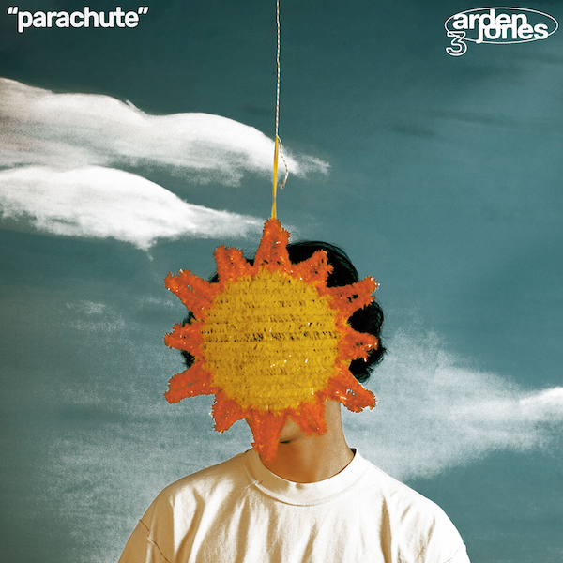
DOWNLOAD HI-RES IMAGE HERE

“Nobody keeps it real quite like Arden Jones.” – PEOPLE

Rising California singer/songwriter/rapper/multi-instrumentalist Arden Jones is wrapping up the year with explosive new single, “parachute,” available now via vnclm_ x Atlantic Records. Produced by Andrew Luce (iann dior, 24kGoldn, Bea Miller, HUDDY) and co-written by Jones, Luce, and David Alexander, the new track has been heralded in recent days with a series of teasers on Jones’ TikTok – Watch HERE.

“‘parachute’ is a song about someone who has your back at all times no matter what,” says Jones. “It’s full throttle the whole time and is meant to be blasted with the volume high. Hope you love it as much as I do.”

In addition, Jones is working with Spotify Wrapped’s new integration with Shopify this year and is rewarding fans with a free IYK-powered “Top Listener” card that will allow fans to tap their phone on the card to unlock an unreleased song.

“parachute” marks the end of a remarkable 2023, with Jones headlining a series of ‘age tape’ mini tours earlier this year. In addition, the 21-year-old Marin County, CA-born artist – who recently supported Laszewo at Los Angeles’ historic El Rey Theatre – will be among the stars performing at Two Friends’ third annual Big Bootie Land, set for February 10 at Los Angeles’ Kia Forum. Also just announced is Jones’ upcoming opening performance for Louis The Child and QUINN XCII at Navy Pier Chicago on December 2 – Additional information HERE. For updates and additional information, please visit www.ardenjonesmusic.com/tour.

“parachute” furthers a growing body of work from Jones that includes acclaimed singles like “careless 2.0” and “fvcked up” as well as his recent collaboration with producer/songwriter/DJ Dillon Francis, “I’m My Only Friend,” joined by an official music video starring iconic actor Billy Zane streaming now at YouTube.

Last year saw Jones make waves with his groundbreaking age tape series, a string of ten unique releases shared on the first Thursday of every month throughout 2022. The tenth and most recent release, age tape 0, brought together such popular favorites as “mr. sunshine,” “horror story,” “indifferent,” “serotonin highs (feat. Allen Haley),” and the viral hit “starstruck,” (the latter of which garnered Jones more than 20M views across TikTok and Instagram Reels) alongside five new tracks including the standout “not afraid at all.”

Known for an irresistible pop approach that bottles the sunshine of an endless California summer, Arden Jones has already earned over 160M worldwide streams, more than 15M video views, and 2.3M monthly Spotify listeners, jumpstarted by hugely popular tracks such as 2021’s acclaimed vnclm_ x Atlantic Records single, “SMILE,” as well as the viral hit, “Parallel Parking.” Named among PEOPLE’s 2022 “Talented Emerging Artists You Should Be Listening to All Summer Long,” Jones – who has shared stages with fellow breakout pop stars such as Tai Verdes, Thomas Headon, and Chelsea Cutler – has drawn a wide range of media attention throughout his ongoing career, spanning Teen Vogue, Pop Dust, Ones To Watch, Entertainment Tonight, and a cover appearance in Rival Magazine, to name but a few.

CONNECT WITH ARDEN JONES
WEBSITE | INSTAGRAM | SPOTIFY | TIKTOK | TWITTER | YOUTUBE

For press inquiries, please contact:
Jessica Nall // Jessica.Nall@atlanticrecords.com
Gabrielle Reese // Gabrielle.Reese@atlanticrecords.com

