OVER 120,000 FANS FROM 200 COUNTRIES ADD THEIR VOICES TO COLDPLAY’S UPCOMING ONE WORLD TRACK
FANS HAVE UNTIL MONDAY TO UPLOAD
THEIR SINGING AT ONEWORLD.COLDPLAY.COM

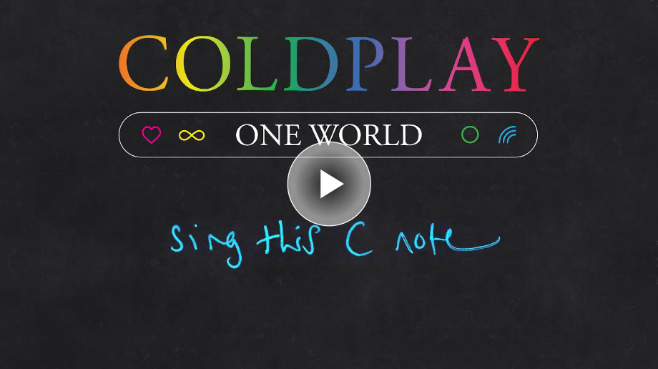

A week after Coldplay opened submissions at oneworld.coldplay.com, the band have revealed that more than 120,000 fans from 204 countries, states & territories have already uploaded their voices for their upcoming new song, One World, There are still four days left for fans to submit their singing before Monday’s deadline.

All of the voices will feature on the song, with fans also able to request a credit in a digital booklet to be released alongside the track.

One World will feature on Coldplay’s forthcoming Moon Music album, which, as the band have previously discussed in interviews, is set to be their tenth album release. No further information about Moon Music has yet been revealed.

Earlier this week, Coldplay’s record-breaking Music Of The Spheres World Tour returned for a sold out run of Asia / Australia stadium dates, beginning with two spectacular nights in Tokyo.

For more information please visit Coldplay.com or contact:
Sheila Richman | sheila.richman@atlanticrecords.com
Ted Sullivan | ted.sullivan@atlanticrecords.com

