FOR IMMEDIATE RELEASE
NOVEMBER 10, 2023

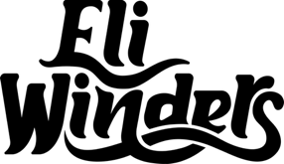

RISING COUNTRY STAR ELI WINDERS SHARES “CAROLINA BLUE”

19-YEAR-OLD SINGER-SONGWRITER DROPS TENDER NEW SINGLE

FOLLOWING DEBUT SINGLE “PACK MY HOMETOWN”
ALREADY AMASSING OVER 1.3M GLOBAL STREAMS

LISTEN HERE

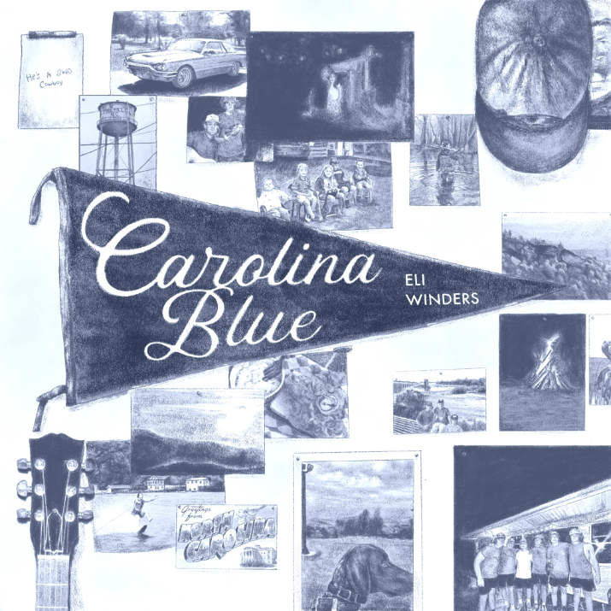
DOWNLOAD ASSETS HERE

“Eli Winders is destined for greatness” – COUNTRYPOLITAN MAGAZINE

Rising country singer-songwriter Eli Winders has shared his latest single, “Carolina Blue,” available now via Atlantic Records/Bad Realm Records HERE. The tender, heartwarming track was originally teased on TikTok – Watch HERE. A stripped down, acoustic version of the track is set to release in December.

“I think ‘Carolina Blue’ builds off of my first song, ‘Pack My Hometown,’ both sonically and lyrically, in a way that feels really natural,” says Winders. “I've been in Nashville for six months now, and my life is totally different than it was a year ago when I was living in North Carolina working 7-5 pm in a feed mill. I've learned so much as a writer and been able to experiment with different sounds and production – there are so many songs I'm excited to share in 2024, and ‘Carolina Blue’ really starts to widen that range of music that everyone will get to hear soon!”

As noted, this summer saw Winders making his Atlantic/Bad Realm debut with the bittersweet “Pack My Hometown.” Recorded in Nashville with producer/co-writer Eric Arjes (Tim McGraw, Kane Brown, Eli Young Band), the deeply moving track – which was heralded in a series of TikTok teasers HERE that have amassed over 2.5M views – is joined by an official music video streaming now HERE. “Pack My Hometown” was met by instant applause from such outlets as Countrypolitan Magazine, which raved, “‘Pack My Hometown’ has all the hallmarks of a great song: heartfelt lyrics, rich acoustic foundation, and an emotive, moving vocal performance. There’s no telling what else Eli Winders has in store, and we just can’t wait to hear what he does next.”

Born and raised in the heartland of North Carolina, 19-year-old Eli Winders is a classic yet fresh voice in country music. After only having access to music through the radio until his teens, Winders’ musical exploration truly began when he received a phone for his 16th birthday – a gift that opened the door to streaming music for the first time. As he delved into a rich tapestry of melodies and lyrics, he found himself captivated by the timeless sounds of country music’s golden era and wanting to write songs of his own.

Throughout 2022, Winders dedicated his days to working in a feed mill, attending college classes at night, and scribbling song ideas between it all. His first breakthrough arrived when he began sharing his musical talents online. By posting heartfelt covers and soul-stirring original songs, Winders quickly gained an enthusiastic following, drawing in listeners with his genuine artistry and Carolina charm. Recognizing the young artist’s exceptional talent and commitment to his craft, Atlantic/Bad Realm Records fulfilled a dream for Winders, swiftly signing him to their roster. Now, with “Carolina Blue”” and the promise of more music to come, Eli Winders’ musical journey has truly begun in earnest.

# # #

DOWNLOAD ASSETS HERE
PHOTO CREDIT: BENJAMIN DANIELS

CONNECT WITH ELI WINDERS:
INSTAGRAM | TIKTOK | YOUTUBE

CONTACT:
Jessica Nall // jessica.nall@atlanticrecords.com

