FOR IMMEDIATE RELEASE
OCTOBER 13, 2023

KALIII KICKS OFF FCK GIRL SZN WITH NEWEST EP

FCK GIRL SZN INCLUDES FEATURES FROM YOUNG NUDY, GLORILLA, AND NLE CHOPPA

FOLLOW-UP TO KALIII’S “PEACHES AND EGGPLANTS” FREESTYLE

CURRENTLY DIRECT SUPPORT ON A BOOGIE WIT DA HOODIE’S ME VS. MYSELF TOUR

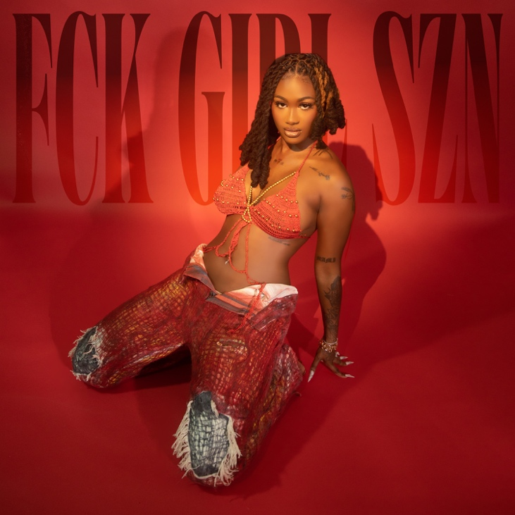
DOWNLOAD HI-RES ARTWORK
DOWNLOAD FCK GIRL SZN

Atlanta’s bright light, Kaliii, releases her second EP of the year, FCK GIRL SZN. The 4-track EP includes Young Nudy, GloRilla, and NLE Choppa features, highlighting female autonomy and women reigning supreme. She is currently serving as direct support for A Boogie wit da Hoodie’s Me vs. Myself Tour. The EP serves as the follow-up to Kaliii’s “Peaches and Eggplants” freestyle released earlier this week.

Rap’s it-girl is reaching new heights in 2023. Igniting her groundbreaking year with her viral single “Area Codes,” (36M views) the Atlanta native has shown no signs of slowing down. She followed up with a Best New Artist nomination at the 2023 BET Awards along with her performance on the BET Amplified Stage. Kaliii was also recently nominated for Best Breakthrough Hip Hop Artist at this year’s BET Hip Hop Awards. FCK GIRL SZN also comes on the heels of her recent single release “K Toven” and the official DJ 809 remix.

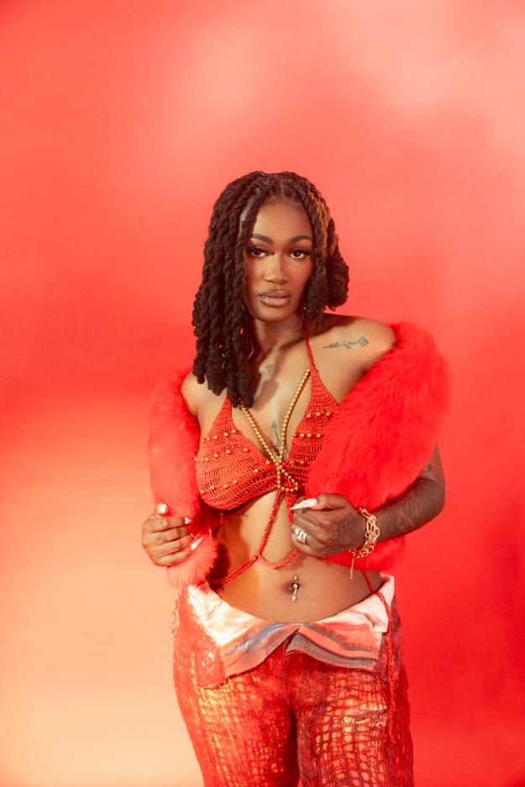

ABOUT KALIII
Kaliii’s has had a landmark year in 2023. Kaliii kicked off the year with her explosive viral hit “Area Codes” which has now spawned several regional remixes. The remixes are a part of Kaliii’s #ToxicThursday release series and have thus far included New York’s Kenzo B on the “718 Remix,” The Bay Area’s Lil Kayla on the “415 Remix,” St. Louis’s Sexyy Red on the “314 Remix,” and Tallahassee’s Luh Tyler on the “850 Remix.” She followed up by releasing the remixes as a combined pack aptly titled, Area Codes: The Remixes and a visual for “Area Codes (718 Remix)” featuring Kenzo B. Kaliii continued her “Area Codes” reign with the release of the project Toxic Chocolate: Area Codes Edition. Rap’s it-girl has stayed quite active since with her inclusion on the Barbie soundtrack, her nomination for ‘Best New Artist’ at the 2023 MTV Video Music Awards, and the release of her follow-up hit “K Toven.”

Making her label debut with the release of her highly acclaimed EP Toxic Chocolate, Kaliii was admitted into the XXL 2022 Freshman Class and created the foundation for her now monumental success. She continued her run with the release of the singles “FNF (Freestyle)” and “Wet” with each visual at over a combined 1M views via YouTube. Toxic Chocolate – available now at all DSPs and streaming services – arrived earlier in 2022 amidst both popular and critical acclaim, with Hot New Hip Hop simply declaring her “Rap's Next ‘It’ Girl.” The EP is highlighted by the incendiary singles, “UonU (Feat. Yung Bleu)“ and “Standards,” the latter of which had its exclusive premiere – alongside Kaliii’s debut interview – on Apple Music’s New Music Daily Radio with Zane Lowe. Kaliii then increased the power of Toxic Chocolate with the surprise addition of the fan favorite “Chainzzz (Feat. Muni Long)” as well as a revised sequence.

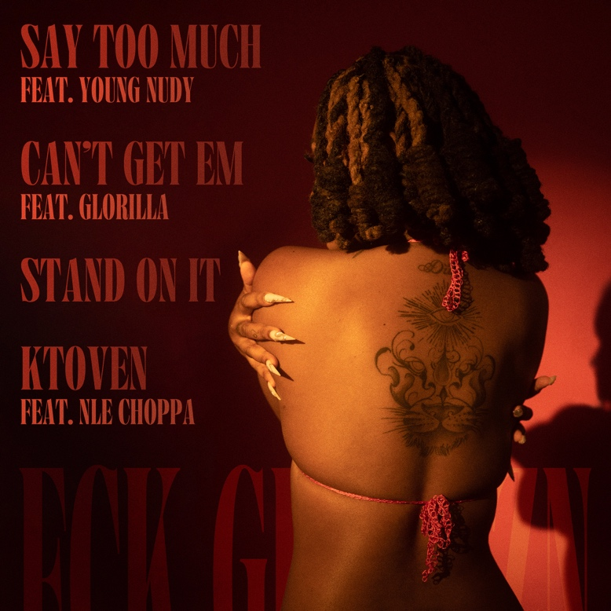

CONNECT WITH KALIII
TIKTOK | TWITTER | INSTAGRAM | FACEBOOK | YOUTUBE

PRESS CONTACT
Ariana White | Ariana.White@AtlanticRecords.com

