FOR IMMEDIATE RELEASE
NOVEMBER 9, 2023

THE GENERAL RETURNS WITH HIS LATEST SINGLE “YONCE FREESTYLE”
FEATURING SEXYY RED AND BG

SINGLE ARRIVES ALONGSIDE OF PRE-ORDER OF UPCOMING ALBUM THE CEREMONY
RELEASING ON DECEMBER 1ST

COMES ON THE HEELS OF RECENT SINGLE AND VISUAL FOR “GOD SLIPPERS”

CURRENTLY ON HIS ONLY THE GENERALS NATIONAL TOUR WITH
NEXT STOP IN FAYETTEVILLE, AR

DOWNLOAD HI-RES ARTWORK
DOWNLOAD “YONCE FREESTYLE” | PRE-ORDER THE CEREMONY

RIAA multi-platinum certified rap superstar, Kevin Gates, returns with his latest single “Yonce Freestyle” featuring Sexyy Red and BG. The single is all about how much he loves partying at Beyonce concerts with none other than Sexyy Red and BG along for the ride. Sexyy Red, one of rap’s dominating femcees - is the ideal addition to infuse a touch of feminine energy into this predominantly male-driven song. Additionally, Cash Money’s BG has just emerged from a 12-year sentence, with “Yonce Freestyle” as his first feature.

To accompany the release, Kevin just announced the official pre-order for his new upcoming album, The Ceremony releasing on December 1st. The album is centered around Kevin's spiritual growth and personal development through religious ceremony. Kevin is currently on his ‘Only The Generals’ national tour with his next stop in Fayetteville, AR on December 7th. The tour will span 30 shows and kicked off in Portsmouth, VA with direct support from BigXthaPlug on select dates and Hosted by DJ Chose across all dates. Tickets are now on sale at kvngates.com.

KEVIN GATES ONLY THE GENERALS TOUR

DECEMBER
7 – Fayetteville, AR – JJ’s Live
8 – Nashville, TN – Bridgestone Arena
9 – Little Rock, AR – Simmons Bank Arena
14 – Tampa, FL – Yuengling Center
15 – Augusta, GA – James Brown Arena
16 – Greensboro, NC – Greensboro Coliseum

JANUARY
12 – Albuquerque, NM – Revel Entertainment Center

~Without BigXthaPlug

ABOUT KEVIN GATES
Kevin Gates transformed into one of the game's most impactful and inimitable rappers by simply being Kevin Gates. Nearly 15 years into an unbelievable career, he doesn’t chase trends. He doesn’t censor himself. He doesn’t hold back. Instead, he speaks his mind and fulfills every promise. It’s why the Baton Rouge, LA native has racked up over 6 billion streams, 6 billion views, and dozens of multiplatinum, platinum, and gold certifications. It’s why his 2013 song “Thinking With My Dick” reached Billboard’s Hot 100 for the first time in 2022 and became #1 overall sound on TikTok. It’s why he’s logged four Top 5 entries on the Billboard Top 200 in addition to seven Top 5 entries on both the Top Rap Albums Chart and the Top R&B/Hip-Hop Albums Charts. It’s why he’s sold-out successive headline tours, delivered show-stopping sets at Rolling Loud and JMBLYA, and ignited arenas with Cardi B. It’s why he’s received various high-profile award nominations. It’s why he’s reached rarified air, emerging as the second best-selling hip-hop artist of 2016 only behind Drake. It’s why he’s also spawned countless think pieces. Among those, Pitchfork described 2019’s gold-certified I’m Him as “another showcase for the Baton Rouge rapper’s fully formed and gloriously weird personality” and praised, “The hooks are magnificent, his most boisterous and fine-tuned since Islah.” As always, he doesn’t compromise on 2021’s Only The Generals Part II [Bread Winner Alumni/Atlantic Records] and more music on the horizon. He’s only gotten better at being Kevin Gates. Kevin continues his reign with the release of his third full-length LP, KHAZA. Since the album’s release Kevin has released several singles to keep the momentum building including: “Big Lyfe,” “Bad For Me,” “Intro,” “Metro,” “Major League,” and his explosive “Super General (Freestyle).” His KHAZA national tour supported the album with several sold-out dates across the country first kicking off in Dallas, TX. Kevin is now currently on his latest national tour, Only The Generals Tour.

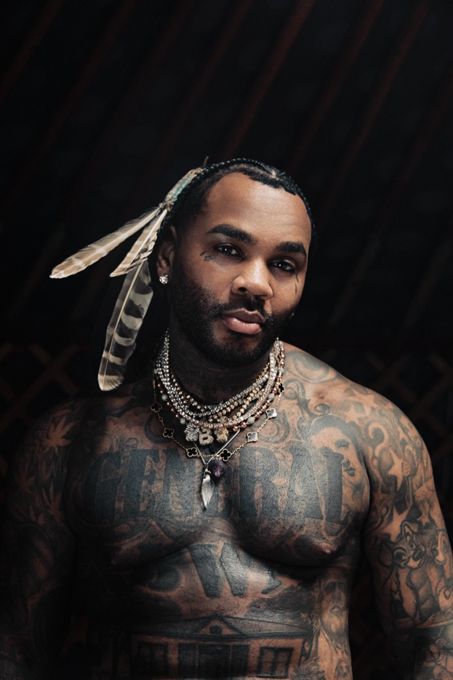

CONNECT WITH KEVIN GATES
WEBSITE | TWITTER | TIKTOK | INSTAGRAM | FACEBOOK | SOUNDCLOUD | YOUTUBE

FOR KEVIN GATES INQUIRIES, CONTACT
ARIANA.WHITE@ATLANTICRECORDS.COM

