MELANIE MARTINEZ RELEASES OFFICIAL VISUALIZER FOR “EVIL”
WATCH HERE

DUE TO DEMAND, 7 NEW ARENA SHOWS ADDED TO THE TRILOGY TOUR
INCLUDING ANAHEIM (HONDA CENTER) AND 2ND DATE IN NYC (MADISON SQUARE GARDEN)

NORTH AMERICAN ARENA TOUR BEGINS MAY 10TH

THE TRILOGY TOUR TO SHOWCASE EVOLUTION OF MARTINEZ’S ALTER EGO “CRY BABY” PERFORMED LIVE, INCLUDING HITS FROM ALL THREE OF HER GROUNDBREAKING TOP 10 ALBUMS: CRY BABY, K-12, AND PORTALS

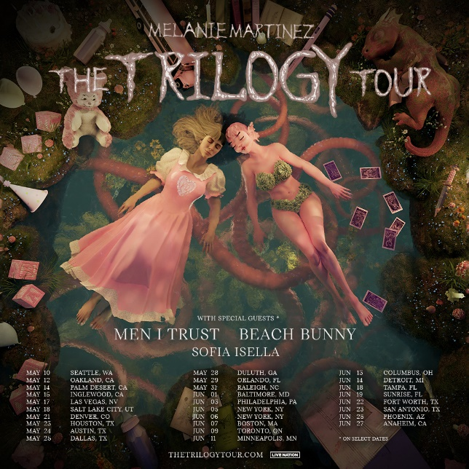
DOWNLOAD HI-RES ADMAT + PRESS PHOTOS

Multiplatinum alternative-pop phenom Melanie Martinez has shared the official visualizer to her new single, “EVIL,” premiering today here.

In addition, due to high demand Martinez announced a number of additional dates to her upcoming North American arena run, The Trilogy Tour. Newly announced dates include a 2nd show at New York, NY’s Madison Square Garden (June 6), Anaheim, CA’s HONDA Center (June 27), Tampa, FL’s Amalie Arena (June 18), Sunrise, FL’s Amerant Bank Arena (June 19), Fort Worth, TX’s Dickies Arena (June 22), San Antonio, TX’s Frost Bank Center (June 23), and Phoenix, AZ’s Footprint Center (June 25). Presale tickets for 6 of the newly added shows will be available starting today at 9am PT/12 noon ET, with general ticket sales commencing on Wednesday, November 22 at 10:00 am local time. Tickets for the 2nd Madison Square Garden show are on sale now. For details, please see www.thetrilogytour.com.

Martinez’s most ambitious concert tour to date, The Trilogy Tour will see the evolution of her alter ego “Cry Baby” performed live. It will include hits from all three of her Top 10 groundbreaking albums: Cry Baby, K-12, and Portals which have collectively amassed over 14B streams worldwide. Dates get underway on May 10, 2024 at Seattle WA’s Climate Pledge Arena and then makes stops at arenas across North America through mid-June. Highlights include such historic venues as Inglewood, CA’s Kia Forum (May 15), New York City’s Madison Square Garden (June 5 & 6), and Toronto, ON’s Scotiabank Arena (June 9). Special guests throughout the tour include Men I Trust, Beach Bunny, and Sofia Isella.

Martinez is currently traveling the globe on the European leg of her blockbuster PORTALS Tour, including upcoming visits to Warsaw, Berlin, Dusseldorf, Paris, Madrid, and Lisbon. Martinez will then bring the tour to Asia and Australia, beginning January 19, 2024, at Tokyo, Japan’s Toyosu Pit.

The PORTALS Tour – which played to sold-out houses across North America though the summer – celebrates the arrival earlier this year of Martinez’s new album, PORTALS, available now in an expanded deluxe digital edition featuring three additional tracks HERE. Hailed by Rolling Stone as an “effortlessly inventive, mature record” from “an artist unafraid to start from scratch and tackle complex, difficult ideas,” the album proved Melanie’s highest charting debut on the Billboard 200 upon its March 2023 release, arriving at #2 with 142,000 equivalent album units earned in its first week – Martinez’s third consecutive Billboard 200 Top 10 album debut. PORTALS further debuted at #1 on Billboard’s “Current Alternative Albums,” “Current Pop Albums,” “Top Album Sales,” “Current Album Sales,” “Internet Albums,” “Digital Albums,” and “Top Alternative/Rock Albums” charts, along with a #2 debut on the “Top Vinyl Albums” chart. An instant global sensation, the album proved Martinez’s first #1 album debut in Australia, also landing at #1 in New Zealand, #2 in the UK, #3 in Canada and Ireland, and top 10 chart placements in Germany, The Netherlands, Belgium, and Spain.

PORTALS includes the brand new single, “EVIL,” as well as the hits, “VOID” and “DEATH,” both of which made history as Martinez’s first original songs to debut on the Billboard “Hot 100.” “DEATH” is joined by a cinematic companion video – directed, conceived, and costume designed by Martinez herself – which trended #1 on YouTube’s Trending “Top Music Videos” chart and now boasts over 31M official views. The song was first teased with a series of eerie clips revealing the rebirth of Martinez’s character “Cry Baby,” quickly sparking a frenzy of theories and garnering over 115M views across all socials. The track and its compelling companion visual earned praise from the likes of Billboard, which raved, “The avant-garde pop auteur creates bold, expansive worlds with each project…While the dramatic five-minute track can be connected to her artistic reawakening, the kinetic drums and electronic elements will also make listeners feel reborn, too.”

Martinez recently partnered with boutique fragrance company Flower Shop Perfumes Co. to launch a new four-fragrance collection, Portals Parfums. With pre-sales launched at 11:00 a.m. on November 1, the direct-to-consumer scents completely sold out in less than 48 hours. Portals Parfums follows Martinez’s wildly successful 2016 debut fragrance, Cry Baby Perfume Milk, which quickly sold out and can now be found only on reseller platforms for up to $2,000 a bottle. Working with IFF perfumers Natasha Côté, Patty Hidalgo, and Laurent Le Guernec, Martinez was deeply involved in all aspects of development for the new fragrance collection. Much like Cry Baby Perfume Milk, which arrived creatively packaged in a replica vintage baby bottle, Portals Parfums comes in a striking art sculptured bottle at a full one-foot tall, with a many-eyed creature head that opens like a nesting doll to reveal four glass vials inside. Transporting the wearer to different worlds with just a little spritz, each unique scent is designed to reflect the four classical elements: Water of Intuition, Air of Clarity, Fiery Passion, and Earthy Abundance. Portals Parfums is available as a four-fragrance set, 60 ml total (15 ml each of four scents) in Eau de Parfum spray. Individual refill vials (15 ml) and full-sized bottles (50 ml each) in Eau de Parfum will follow in 2024. The Portals Parfums fragrance collection will serve as a foundation for other Portals products, including a broad collection of scented candles. To be informed of a restock and other product launches visit PortalsParfums.com.

# # #

MELANIE MARTINEZ
THE PORTALS TOUR 2023-2024

NOVEMBER 2023
22 – Warsaw, Poland – COS Torwar
23 – Berlin, Germany – Verti Music Hall
24 – Dusseldorf, Germany – Mitsubishi Electric Halle
26 – Paris, France – Zenith Paris - La Villette
28 – Madrid, Spain – WiZink Center
30 – Lisbon, Portugal – Sagres Campo Pequeno

JANUARY 2024
19 – Tokyo, Japan – Toyosu Pit
21 – Seoul, South Korea – KBS Arena
23 – Manila, Philippines – World Trade Center Hall A
25 – Singapore, Singapore – Singapore Expo
28 – Auckland, New Zealand – Spark Arena
30 – Sydney, Australia – Aware Super Theatre

FEBRUARY 2024
2 – Brisbane, Australia - Riverstage
5 - Melbourne, Australia – Margaret Court Arena
6 – Melbourne, Australia – Margaret Court Arena

***THE TRILOGY TOUR 2024***

MAY 2024
10 – Seattle, WA – Climate Pledge Arena
12 – Oakland, CA – Oakland Arena
14 – Palm Desert, CA – Acrisure Arena at Greater Palm Springs
15 – Inglewood, CA – Kia Forum
17 – Las Vegas, NV – MGM Grand Garden Arena
18 – Salt Lake City, UT – Delta Center
21– Denver, CO – Ball Arena
23 – Houston, TX – Toyota Center
24 – Austin, TX – Moody Center
25 – Dallas, TX – American Airlines Center
28 – Duluth, GA – Gas South Arena
29 – Orlando, FL – Amway Center
31 – Raleigh, NC – PNC Arena

JUNE 2024
1 – Baltimore, MD – CFG Bank Arena
3 – Philadelphia, PA – Wells Fargo Center
5 – New York, NY – Madison Square Garden
6 – New York, NY – Madison Square Garden *
7 – Boston, MA – TD Garden
9 – Toronto, ON – Scotiabank Arena
11 – Minneapolis, MN – Target Center
13 – Columbus, OH – Nationwide Arena
14 – Detroit, MI – Little Caesars Arena
18 – Tampa, FL – Amalie Arena *
19 – Sunrise, FL – Amerant Bank Arena *
22 – Fort Worth, TX – Dickies Arena *
23 – San Antonio, TX – Frost Bank Center *
25 – Phoenix, AZ – Footprint Center *
27 – Anaheim, CA – HONDA Center *

* NEWLY ANNOUNCED DATES

# # #
About Live Nation Entertainment
Live Nation Entertainment (NYSE: LYV) is the world’s leading live entertainment company comprised of global market leaders: Ticketmaster, Live Nation Concerts, and Live Nation Sponsorship. For additional information, visit www.livenationentertainment.com.

MEDIA CONTACTS:

Melanie Martinez
Christina Kotsamanidis | Christina.Kotsamanidis@atlanticrecords.com
Gabrielle Reese | Gabrielle.Reese@atlanticrecords.com

Live Nation Concerts
Monique Sowinski | moniquesowinski@livenation.com
Nadine Peña | nadinepena@livenation.com

To apply for media credentials for show coverage:
livenation.com/pressrequests

CONNECT WITH MELANIE MARTINEZ
OFFICIAL | FACEBOOK | INSTAGRAM |TIKTOK | TWITTER | YOUTUBE

